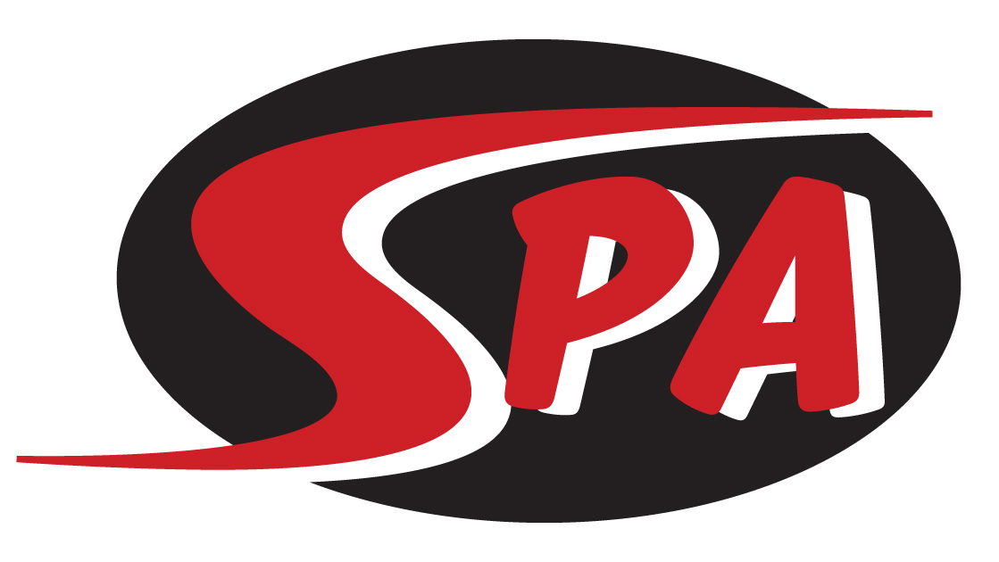
Gold Group

The Gold group will consist of 11-14-year-old swimmers, not yet in high school. The goal of this group is to master stroke technique and add advanced techniques to improve speed. This group utilizes a progressive training plan coupled with regular dry land training. Gold swimmers will also become more goal-oriented. Short term (next meet), mid-term (mid-season or end of season, short course or long course championship meet) and long term (yearly) goals will be addressed and tracked with their coach.

Practice & Meet Commitment
Gold group workouts are offered 6 days a week. Workouts are 1.5-2 hours Monday-Saturday during the school year. For best results we recommend swimmers attend at least 5 practices a week. Dry land training will be an integral part of the Gold group training plan with focuses on core and overall strength, flexibility and coordination. Swim meets are an important part of training, and all meets are posted on the SPA website under the “Meets” tab and are typically 1-2 times per month. Gold swimmers are expected to attend all meets recommended by their coach, as well as the highest-level championship meet for which they qualify.

Group Expectations
Swimmers placed in Gold will be able to:
- Show an IMX or IMR score from previous competitions
- Complete 5 x 100 Free on 1:45 interval
- Complete 5 x 100 Kick on 2:15 interval
- Show a commitment to training/competition through regular and stable practice/meet attendance

Swimmers in Gold are expected to:
- attend 5-6 practices per week.
- work toward achieving “A” and “AA” National Motivational times as well as Gulf Age Group time standards
- compete in Gulf Championship meets in December, February and July as well as any other championship meets for which they qualify

Next Steps
From Gold swimmers will be moved to the Senior Prep or Senior groups depending on age and ability.
Training Equipment - Required
- Mesh Equipment Bag
- Goggles (two pairs)
- Pull Buoy
- Kick Board
- Ylon Snorkel
- Red Strokemaker Paddles
- Fins
- Practice Suit – No board shorts or two-piece suits
- Water Bottle
- Athletic Shoes and Clothes for Dry Land

Competition Apparel - Required
- SPA Racing Suit
- SPA Swim Cap
- SPA T-shirt and/or SPA warm ups.

($175 per Month includes facility fee)

