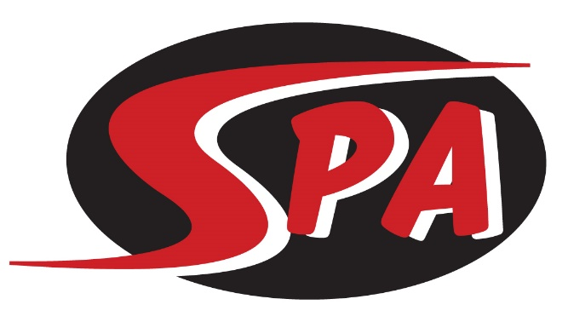
High School Conditioning

The High School Conditioning group is a competitive training group for high school age swimmers. This group offers a great compliment to high school swimming and a way to improve performance in all areas of the sport. The goal of this group is to give high school age swimmers a chance to compete and grow in the sport with a smaller commitment that allows for other sports and activities.

Practice & Meet Commitment
For the Swimming Conditioning group workouts are offered 4 days a week, and run 1.5 hours, including dry land. Swimmers are encouraged to attend as many practices as possible. Swim meets can be an important part of training. All meets are posted on the SPA website under the “Meets” tab and are typically 1-2 times per month. HS Conditioning swimmers may attend any meets open to their group, and are encouraged to attend championship meets in December, February, and July. There is no requirement that High School Conditioning swimmers participate in any meets with SPA.

Group Expectations
Swimmers placed in the Swimming Conditioning group will be:
- in high school (or of high school age)
- able to swim 4 x 100 @ 1:45
- able to kick 4 x 100 @ 2:15

Swimmers in the Swimming Conditioning group are expected to:
- attend as many practices as possible
- work toward achieving their goals in swimming

Training Equipment - Required
- Mesh Equipment Bag
- Goggles (two pairs)
- Pull Buoy
- Kick Board
- Green Strokemaker Paddles
- Fins
- Ylon Snorkel
- Practice Suit – No board shorts or non-competitive suits
- Water Bottle
- Athletic Shoes and clothes for Dry Land

Competition Apparel – Required to Participate in SPA Meets
- SPA Racing Suit
- SPA Swim Cap
- SPA T-shirt and/or SPA warm ups

($145 per month includes facility fee)

