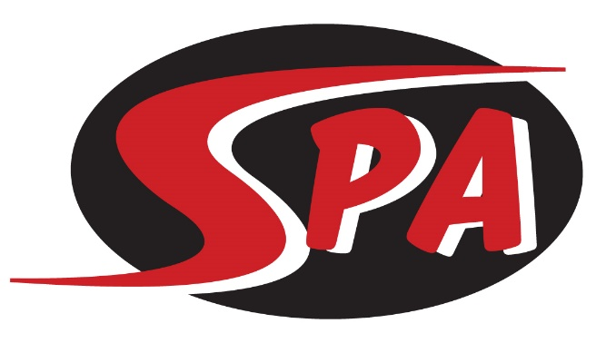
Senior

The Senior group is the highest level of progression for all swimmers on SPA. Senior group swimmers will be currently in high school. The purpose of this group is to develop a cohesive training group that will assist swimmers in reaching their ultimate swimming goal. The swimmers in this group have a focus of being competitive at the LSC, State, Zone, Sectional, and National levels. They are also expected to display leadership qualities and characteristics that will properly represent SPA at all times. Training will focus on proper technique and swimming at race speed in practice every day. Along with the in-water training there will also be a dry land training program focusing on core strength, coordination, flexibility and explosive power. Senior swimmers are goal-oriented with a focus on working towards swimming at the next level (National Level or College).

Practice & Meet Commitment
For the Senior Group workouts are offered 6 days a week with 8 training sessions offered each week. Workouts vary from 1.5-3 hours Monday-Saturday, including dry land. Each swimmer is expected to attend all practice sessions, unless excused by the Head Coach.
Swim meets are an important part of training. All meets are posted on the SPA website under the “Meets” tab and are typically 1-2 times per month. Senior Prep swimmers are expected to attend all meets recommended by their coach when possible, and the highest-level championship meet for which they qualify.

Group Expectations
Swimmers placed in the Senior group will:
- have a current IMX or IMR score from previous competition
- be able to swim 8 x 100 @ 1:30
- be able to kick 8 x 100 @ 2:00
- be committed to achieving their personal best during their high school years

Swimmers in the Senior group are expected to:
- attend all scheduled practices
- work toward achieving “A” and “AA” (or higher) National Motivational times as well as Speedo Sectional and National level time standards
- Compete in the highest-level championship meet for which they qualify each SC and LC season

Training Equipment - Required
- Mesh Equipment Bag
- Goggles (two pairs)
- Pull Buoy
- Kick Board
- Yellow Strokemaker Paddles
- Fins
- Ylon Snorkel
- Athletic Shoes – To go in the water every day
- Practice Suit – No board shorts or non-competitive suits
- Water Bottle
- Athletic Shoes and Clothes for Dry Land

Competition Apparel - Required
- SPA Racing Suit
- SPA Swim Cap
- SPA T-shirt and/or SPA warm ups.

($210 per month includes facility fee)

