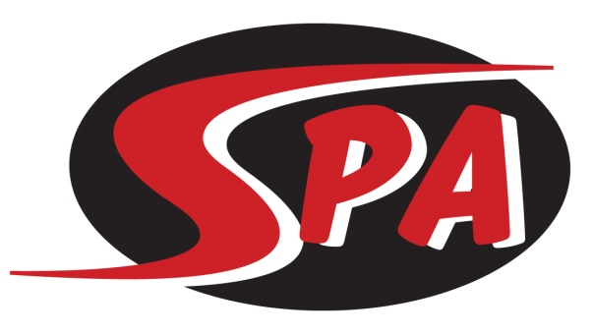
Senior Prep Group

The Senior Prep Group is swimmers ages 11–14 years old, and not yet in high school that have demonstrated the desire and ability to take their swimming to the highest level. The goal of swimmers in this group will be to maximize their competitive potential while maintaining focus on proper technique. We encourage swimmers in the group to take responsibility for their own personal success while encouraging teammates to do the same. The Senior Prep group is goal oriented with the desire to compete at qualifying-time only championship meets. Short-, Mid- and Long-term goals will be a focus for all Senior Prep swimmers with their coach.

Practice & Meet Commitment
Senior Prep workouts are offered 6 days a week for 1.25-3 hours including dry land during the school year, including one morning practice. For best results swimmers should attend all scheduled practices. Dry land training is a daily focus with emphasis on gaining strength, increasing coordination and flexibility, and preventing injury for sustained growth. Swim meets are an important part of training. All meets are posted on the SPA website under the “Meets” tab and are typically 1-2 times per month. Senior Prep swimmers are expected to attend all meets recommended by their coach, and the highest-level championship meet for which they qualify.

Group Expectations
Swimmers placed in Senior Prep will be able to:
- Show an IMX score from previous competition
- Complete 4 x 100 Free on 1:20
- Complete 6 x 100 kick on 1:50
- Show a commitment to training/competition through regular and stable practice/meet attendance

Swimmers in Senior Prep are expected to:
- sign a group commitment agreement with their coach
- attend all scheduled practices
- work toward achieving “A” and “AA” National Motivational Times as well as Gulf Age Group and TAGS time standards
- compete in all championship meets for which they qualify

Next Steps
From Senior Prep, swimmers will move to the Senior group when they enter high school.

Training Equipment – Required
- Mesh Equipment Bag
- Goggles (2 pairs)
- Pull Buoy
- Kick Board
- Ylon Snorkel
- Green Strokemaker Paddles
- Fins
- Practice suit – no board shorts or two-piece suits
- Water Bottle
- Athletic Shoes and Clothes for Dry Land

Competition Apparel – Required
- SPA Racing Suit
- SPA Swim Cap
- SPA T-shirt and/or SPA warm ups.

($185 per month includes facility fee)

