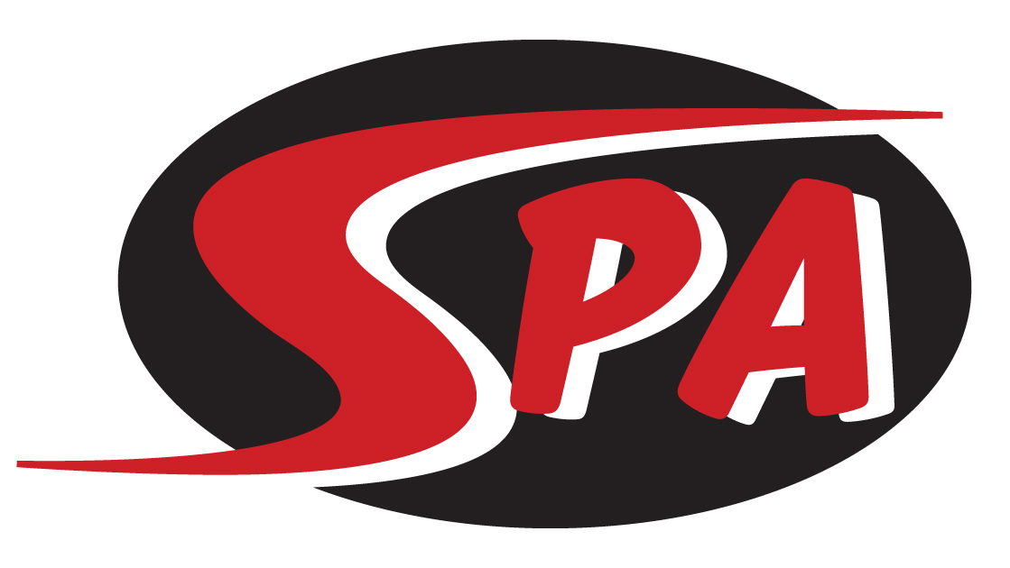
Silver 1 Group
The Silver 1 group is for swimmers ages 10-12 years old. The goal of this group is to continue their development as a year-round competitive swimmer. The primary focus will be on continuing development of proper stroke technique while increasing swimmer IQ as we introduce them to interval training, purposeful drilling and training sets to prepare them for competition and advancement. Silver 1 swimmers will also work on progressive short- and long-term goals with their coach.

Practice & Meet Commitment
Silver 1 Group workouts are offered 5 days a week. Workouts are 1.5 hours on weekdays. For best results we recommend swimmers attend at least 4 practices per week. Silver 1 group will also utilize dry land training as part of their regular practice training. Dry land will focus on coordination, core strength, body weight exercises and flexibility. Swim meets are a key part of the growth of the Silver 1 group swimmer. All meets are posted on the SPA website under the “Meets” tab and are typically 1-2 times per month. Silver 1 swimmers are expected to attend all meets recommended by their coach, as well as the highest-level championship meet for which they qualify.

Group Expectations
Swimmers placed in Silver 1 will be able to:
- Complete 8 x 50 Free on 1:10 interval
- Complete 8 x 50 Kick on 1:30 interval
- Show a commitment to training/competition through regular and stable practice/meet attendance.

Swimmers in Silver 1 are expected to:
- attend 4-5 practices per week.
- work toward achieving “BB” and “A” National Motivational Times as well as Gulf Age Group time standards.
- compete in Gulf Championship meets in December, February and July as well as any other championship meets for which they qualify.

Next Steps
From Silver 1 swimmers will be placed in the Gold group as they progress.

Training Equipment - Required
- Mesh Equipment Bag
- Goggles (two pairs)
- Pull Buoy
- Kick Board
- Fins
- Ylon Snorkel
- Practice Suit – No board shorts or two-piece suits
- Water Bottle
- Athletic Shoes and Clothes for Dry Land

Competition Apparel - Required
- SPA Racing Suit
- SPA Swim Cap
- SPA T-shirt and/or SPA warm ups.

($150 per month includes Facility Fee)

