2016 Swim Meet Sanction Application(s) 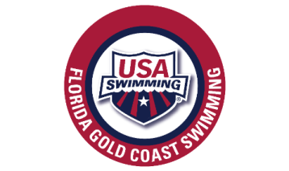
2016 Meet bids must be received by May 1st, with a $75.00/ ($25 Sizzlers) deposit per meet requested, by either check or credit card on file with the treasurer
Meet Bid # | Meet Bid # | Meet Bid #
Name of Meet: | Name of Meet: | Name of Meet:
Date of Meet: | Date of Meet: | Date of Meet:
Host Team: | Host Team: | Host Team:
Meet Location: | Meet Location: | Meet Locations:
Meet Director:  Email:  Phone #: | Meet Director:  Email:  Phone #: | Meet Director:  Email:  Phone #:
Length Course: | Length Course: | Length Course:
Amount of Racing Lanes: | Amount of Racing Lanes: | Amount of Racing Lanes:
Meet Format: Timed Finals _____Finals ______ | Meet Format: Timed Finals _____ Finals ______ | Meet Format: Timed Finals _____Finals _____
Participants: Age Group ____ Seniors ____ Both ____ | Participants: Age Group ____ Seniors ____ Both ____ | Participants: Age Group ____ Seniors ____ Both ____
Meet Type: Open ____ Invite ____ Closed_____ | Meet Type: Open _____ Invite _____ Closed _____ | Meet Type: Open ____ Invite ____ Closed ____
Time Standard: | Time Standards: | Time Standards:

The host team confirms that the meet(s) will be conducted in accordance with the requirements of Article 202 of USA Swimming Rules & Regulations, specific reference to 202.2.8 (sanction) or 202.4.6 (approval) thereof which provides that:” In granting this sanction(s) it is understood and agreed that USA Swimming/ Florida Gold Coast Swimming shall be free from any liabilities or claims for damages arising by reason of injuries to anyone during the conduct of the event(s)”
___________________________________ ___________________ Date Rec _______________ Amount owed____________
(Applicant) (Date)

Swim Meet Sanction application(s) to: Jim McCombs at: mccombj@martin.k12.fl.us: 2801 S Kanner Hwy, Stuart, FL 34994 Paying with Ck or CC (circle one)

