FOR YOUTH DEVELOPMENT
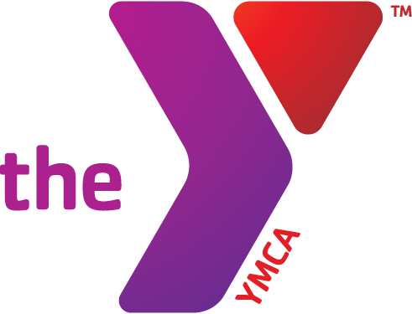
FOR HEALTHY LIVING
FOR SOCIAL RESPONSIBILITY

YMCA OF SOUTH FLORIDA
Weston YMCA Family Center ▪ 20201 Saddle Club Road ▪ Weston, Florida 33327 ▪ P 954-424-9622
www.ymcasouthflorida.org

Swim Coach
Full Time – Non Exempt
Weston, Florida
YMCA of South Florida, Florida

YMCA of South Florida is currently seeking interested candidates with Senior Level or Head Age Group coaching experience for its YSF Barracudas Swim Team.

The YSF Barracudas Swim Team is a year-round, competitive, YMCA and USA Swimming Team. This position is based out of the Weston YMCA Family Center of Weston, Florida just west of Ft. Lauderdale, Florida. The YMCA of South Florida has five pools including a outdoor Olympic 50 meter pool with capability of 18 short course lanes.

The ideal candidate will possess the following characteristics: Bachelor’s degree in recreation or related field; or equivalent combination of education and experience. Documented swim coach experience required, preferably three or more years. Must have current CPR, First Aid and USA Swimming Coaches certifications and with certifications current throughout employment. Ideal candidate will demonstrate knowledge of sound competitive swimming skills, stroke mechanics, and the ability to implement and teach these skills in a positive, healthy manner. Also must be willing to be a strong team player with the management team of the YMCA, have strong leadership skills, and bring a creative and positive attitude to grow the team into the future. This position will assist the Director of Competitive Aquatics in handling all aspects of the team: organization, public relations, recruiting, administration, fundraising, setting seasonal competition schedules, etc. The Senior Coach also may be involved in supervising the Masters Coaches in planning their workouts and participating in the coaching of the Masters group.

The Senior Coach reports to the Director of Competitive Aquatics, is expected to attend monthly team management meetings, communicate effectively with all staff members, and be efficient with administrative duties that relate to the Swim Team and the overall YMCA. Please contact John Spire, Director of Competitive Aquatics, 20201 Saddle Club Road, Weston, Florida 33327 or email at jspire@ymcasouthflorida.org. John may be reached at 954-557-8177 (Cell and text).

Please apply on: https://ymcasouthflorida.org/careers/

All inquiries will be held in the strict confidence.

