Charlotte County Swimming Social Distance Guidelines

Proposed Practice Groups and Times:
Monday – Friday 8:00AM-9:00AM
- Each swimmer will come to the pool in full uniform so that locker rooms are not necessary
- The team will be made aware that there is one single stall bathroom for use on deck and for emergencies only
- Each swimmer will bring their equipment bags in/out of the facility instead of storing them to avoid contact
- Each swimmer will need to bring their own water or form of hydration to avoid any use of the facilities water fountains/ice etc.
- No parents or spectators on deck. Coaches only.
- Parents will be required to wait in the parking lot for their swimmer to get done practice in case of inclement weather to avoid any crowding in the front lobby/facility.
- If anyone at any time is exhibiting any signs or symptoms of the virus (or any illness), they will no longer be able to participate until cleared by a physician and must provide a note from their doctor to return to activity (Coaching staff included).

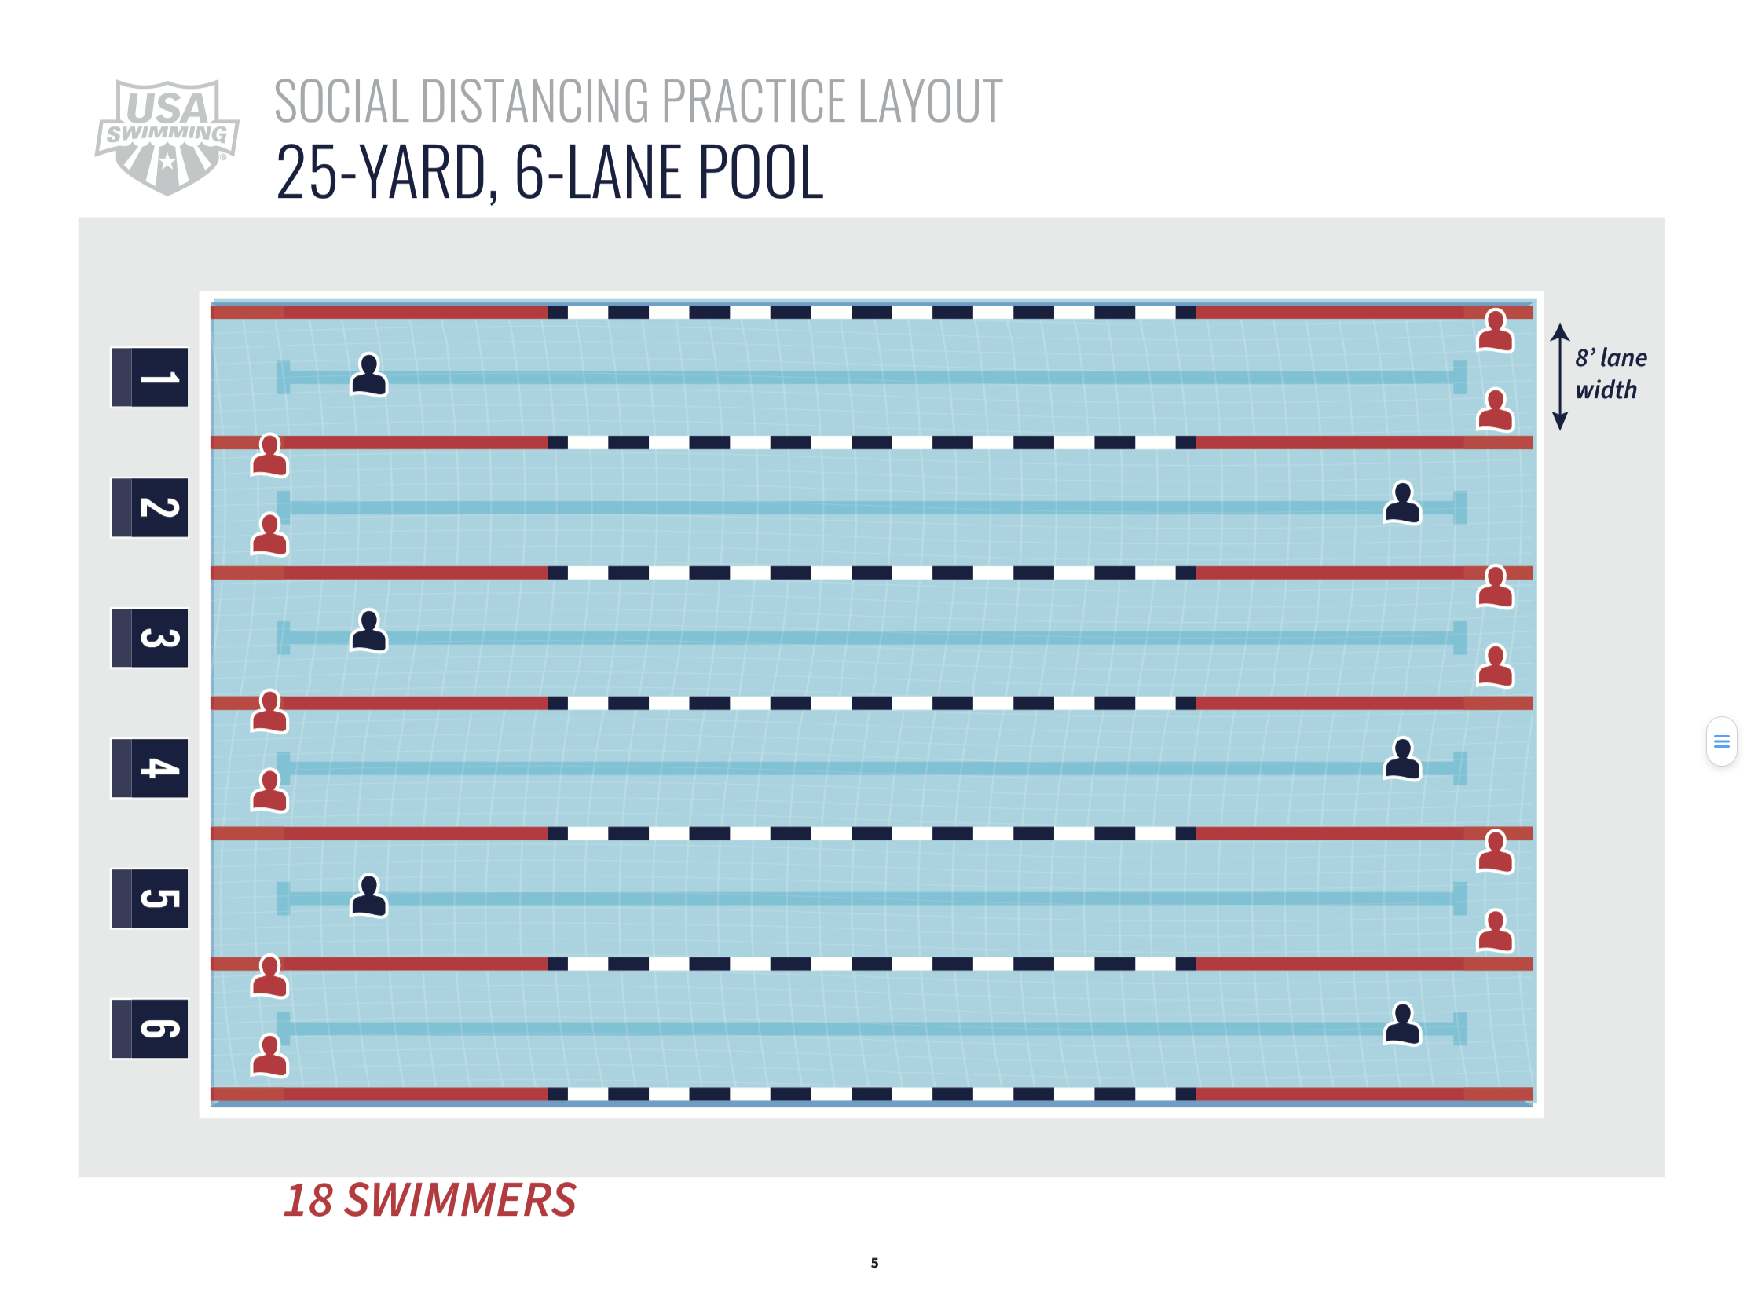
Model of Facility and Athlete Distribution for Distancing

