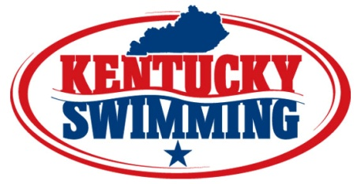

KENTUCKY SWIMMING INC.
MEET APPROVAL APPLICATION

APPROVAL – a number issued by KY Swimming to a KY Swimming member club to conduct a meet in conformance with all USA Swimming technical rules, but not all participants will be members of USA Swimming. Insurance for members is in place and times still are valid, but non-members have no insurance and their times are not maintained by the USA Swimming national database.

Meet Name: _________________________________________ Meet Location: ____________________________

Meet Date: _____________________ Sponsoring Club or Organizations: __________________________________

______________________________________________ ___________________________ _______ ___________
Address City State Zip

Meet Director (MD) |  | Referee
MD Phone # |  | Referee
MD Email |  | Starter
MD Address |  | Stroke & Turn
MD City, State, Zip |  | Stroke & Turn
Referee |  | First Aid:

Attach one copy of meet information which must include a list of events and nature of prizes to be awarded.

The following clause must appear on all forms:

“In granting this approval it is understood and agreed that USA Swimming shall be free and held harmless from any liabilities or claims for damages arising by reason of injuries to anyone during the conduct of the event.”

As authorized agent, I apply on behalf of the above named organization for an approval to hold a swim meet. As a condition of obtaining such an approval, the above organization and I agree to abide and govern this meet according to the rules and regulations of KY Swimming, Inc. and USA Swimming.

_______________________________________________ __________________________________
Organization Representative Date

Mail complete copy of meet information and approval application to along with a check for $150 to:

Kentucky Swimming
c/o Maureen McDonald
PO Box 630
Versailles, KY 40383

