You can clone a set of jobs from a prior event instead of creating them all from scratch. These set of steps assume the event in question has the "Job Signup Deadline" in step 4 filled out.
- Go to the Events page
- Click the Job Signup or Edit Job Signup button under the desired event
- Click Setup Event Jobs tab
- Click Copy & Append From Other Event button, then click OK to confirm
  - If you don't see a new window or tab after clicking OK, make sure your popup blocker is turned off
- Enter the event name from which you want to clone jobs and click Search, or click Display ALL
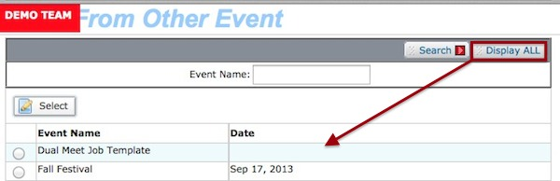
- Click the radio button next to the event from which you want to clone jobs and click Select
- If the dates/times of the jobs are not correct,
  - Select the jobs under "Time Periods Setup" that have all the same dates/time (only click the Time Periods Setup check box if ALL the jobs have ALL the same dates and times, which is rare)
  - Click Edit Time Period, then click OK to confirm
  - Enter the starting and ending dates and times you want to change the job(s) TO
  - Click Save Changes, then click OK to confirm
  - Repeat for all remaining jobs
- If you are ready for people to signup for the jobs, click the Job Name check box and click Allow Signup, then click OK to confirm

