KY USA SWIMMING
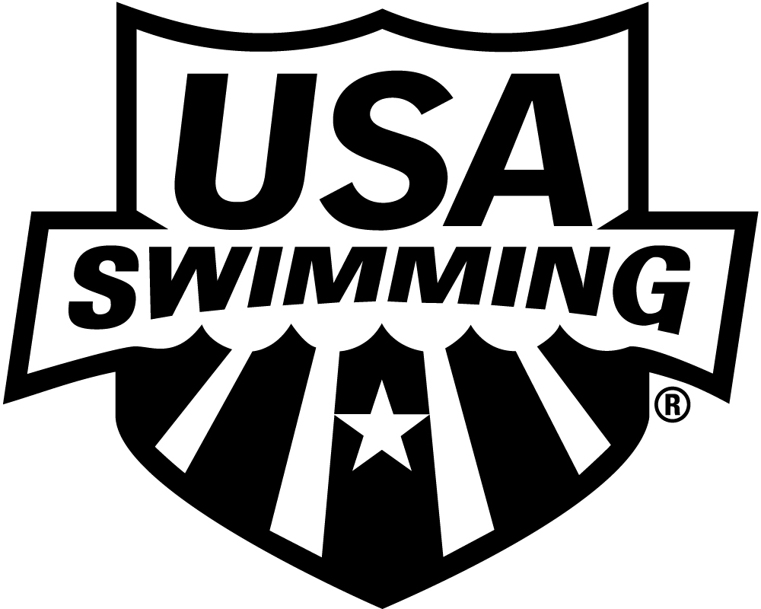

2020 APPRENTICE OFFICIAL APPLICATION INITIAL TRAINING

LSC: KY SESSION DATE:

PLEASE PRINT LEGIBLY  COMPLETE ALL INFORMATION TO ENSURE THAT CONTACT INFORMATION IS CORRECT AND UP TO DATE:

LAST NAME LEGAL FIRST NAME MIDDLE NAME

Have you ever been a member of USA Swimming under a different last name? If yes, please provide that name:

Previously registered with USA Swimming. □ Yes □ No If registered in a different LSC, which LSC:

PREFERRED NAME DATE OF BIRTH (MO/DAY/YR) SEX (M/F) CLUB CODE CLUB NAME

(Bill, Beth, Scooter, Liz, Bobby) If not affiliated with a club, enter “Unattached”

MAILING ADDRESS

CITY STATE ZIP CODE

–

AREA CODE TELEPHONE NO. AREA CODE TELEPHONE NO. E-MAIL ADDRESS

HOME MOBILE

THIS APPRENTICE OFFICIAL STATUS EXPIRES 60 DAYS FROM THE DATE OF THE INITIAL TRAINING SESSION. CONTACT YOUR LSC OFFICIALS CHAIR FOR FURTHER INSTRUCTIONS.

I acknowledge that I have reviewed and agree to abide by rules and regulations of the Minor Athlete Abuse Prevention Policy and I have completed Athlete Protection Training.

MAIL OR EMAIL APPLICATION TO:
LSC OFFIICIALS CHAIR:

LSC Registrar Contact Info: LSC Officials Chair Contact Info:

kyswim@kylsc.org

**Italicized areas are editable for your current LSC information. You may use the remainder of the form for instructions specific to your LSC.

