CLUB NAME AND/OR FACILITY NAME Health & Wellness Re-Entry Protocol
Club Contact
Club Contact Email
Club Contact Address
Club Contact Phone Number

Center for Disease Control and Prevention
There is no evidence that the virus that causes COVID-19 can be spread to people through the water in pools, hot tubs, spas, or water play areas. Proper operation and maintenance (including disinfection with chlorine and bromine) of these facilities should inactivate the virus in the water.

A MESSAGE FROM USA SWIMMING
We believe swimming, like walking, hiking, running, and cycling, is a critical healthy activity within our communities. Swimming does not require direct contact between teammates or coaches and social distancing can be maintained throughout practice. As with all exercise and activity at this time, swimming must comply with standards for social distancing and safety within aquatic facilities. We know, with collaboration between USA Swimming coaches, public health officials, and facility operators we can create safe plans for using aquatic facilities to promote physical and mental health opportunities compliant with public health directives. The CDC has indicated that there is no evidence the disease spreads through treated water. Proper operation and maintenance (including disinfection with chlorine and bromine) of these facilities should inactivate the virus in the water.

A MESSAGE FROM KENTUCKY SWIMMING

Kentucky Swimming recognizes that swimmers can continue to train and compete safely in accordance with appropriate safety protocols. While the safety of our swimmers will always be of paramount importance, we also recognize the importance of resuming swimming to promote health and fitness, as well as to ensure that swimmers seeking to compete at the college and national levels have an opportunity to pursue their goals. Based on guidance from health officials, the CDC, and USA Swimming, we are providing this re-entry protocol to our member teams. We recognize that each team may need to modify this protocol slightly based on the facility in which it trains, but we believe this protocol should be followed as closely as possible to ensure that appropriate safety measures are in place for our swimmers.

Effective May 4, 2020

PRACTICE SCHEDULING
- Lane reservation: A schedule will be established for practices that will control the number of people present in the facility.
- Number of Participants: Based on current state and CDC policy, a set number of swimmers per practice session will be identified and enforced – see charts below.

ENTRY and EXIT PROCEDURES
- Locker rooms will be closed. Athletes must arrive with their swimsuits on.
- Athletes may not enter the facility early.
- When entering and exiting, all individuals must maintain appropriate social distancing of at least six feet.
- Athletes will enter and exit through designated areas.
- Entries and exits will be marked with signs reminding all individuals to maintain appropriate safety protocols.
- An assigned coach or staff member shall survey athletes and coaches entering the facility. If they are symptomatic in any way, the athlete or coach will not be permitted to enter the facility. Symptoms include mild to severe respiratory illness with fever, cough and difficulty breathing, or other symptoms identified by the CDC – see daily entry survey.
- Athletes must leave with swimsuit on.
- Athletes must shower at home.
- Athletes may not congregate after practice.
- A 15-minute block between sessions will be scheduled. The 15-minute block will be designated to disinfect the area before the next group of swimmers enters the facility.

PARENT PROTOCOL
- One parent per swim family may enter the facility.
- Parents must maintain proper social distancing protocol.
- Parents may not use locker rooms or water fountains.
- Parents who do not enter the building may not exit their cars and congregate in the parking lot.

PPE FOR COACHES AND STAFF
CLUB NAME will
- provide coaches with appropriate PPE equipment and
- provide coaches with up-to-date education and training on COVID-19 risk factors and protective behaviors (e.g., cough etiquette and care of PPE).
PPE will be
- consistently and properly worn when required,
- regularly inspected, maintained, and replaced, as necessary, and
- properly removed, cleaned, and stored or disposed of, as applicable, to avoid contamination of self, others, or the environment.

PREPARING TO SWIM
- Swimmers and coaches must wash their hands with a disinfectant soap and water (for 20 seconds or longer) or use a hand sanitizer if soap and water are not readily available, upon entering the facility.
- Swimmers may not share equipment.
- Swimmers must bring a full water bottle labeled with his/her name. Water fountains will not be accessible to anyone.
- Swimmers must use their personal equipment only.
- Avoid touching gates, fences, benches, etc. if possible.
- Swimmers must maintain 6’ distance between each other.

DURING PRACTICE
- Swimmers and coaches must follow directions for spacing and stay at least six feet apart. On-deck instruction and discussions are prohibited if appropriate distancing may not be maintained in doing so.
- All parties on deck must not make physical contact with others, such as shaking hands or giving a high five.
- Athletes must avoid sharing drinks or towels.
- Athletes and coaches must maintain social distancing when taking a break.
- Athletes/coaches who begin to cough/sneeze for any reason, must move away from others until coughing/sneezing dissipates.

PRACTICE STRUCTURE
- The number of practice sessions per week for each group is dependent on each club and its agreement with its facility.
- Social distancing layouts - see attached.
Examples: staggered starts, opposite ends, number of swimmers per lane, communication with athletes, stations, markers visible to athletes for start and stop points, (e.g., visible spacing marks on pool deck, on lane lines, etc.), coaches on both ends of the pool if feasible.

DISINFECTING
The pool water is constantly being disinfected by chlorine, but extra disinfecting of items outside of the pool, such as
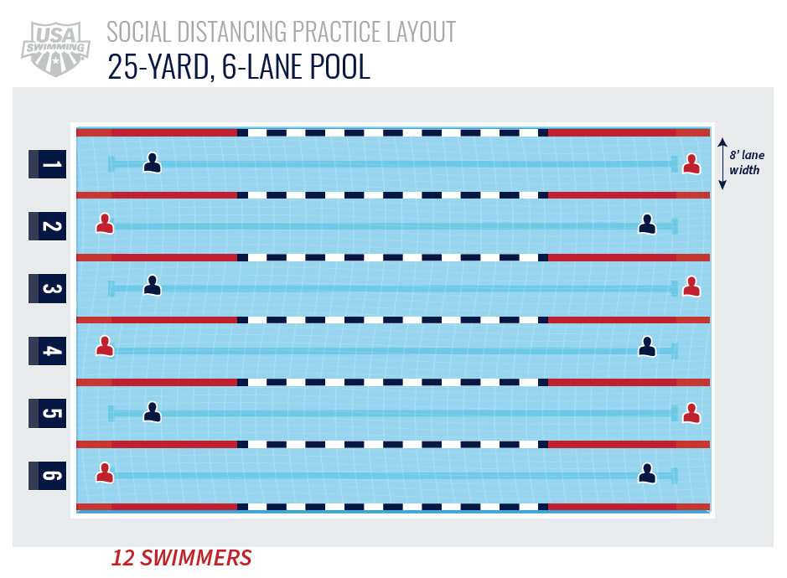
door handles (inside and outside), handrails and pool ladders will be maintained.

