MISSISSIPPI SWIMMING, INC.
SURVEY
Coaches, Officials, Parents, Volunteers and Swimmers, please take the time to list the top five things Mississippi Swimming could do to help your program. What would help you increase the size of your team. Number 1 being the most important and so on to number 5. Thanks for your time in completing this survey.
1)
2)
3)
4)
5)
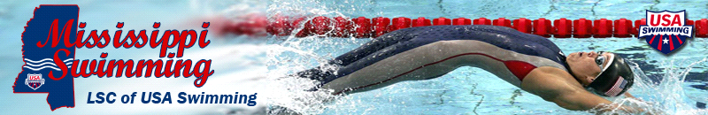
Please return this survey to Chris Chain at scsocoach@yahoo.com.
Thank you.

