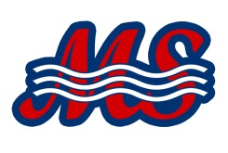

To Whom It May Concern,
Please excuse _____________________ from class. He/she will be attending the ____ USA Swimming Southern Zone Age Group Swimming Championships. This swim meet will be held in ______ from ___________.
It is an honor to represent Mississippi Swimming. They have been working hard to all year long to swim at this meet that is offered once a year. Our swimmers will be competing against teams from West Virginia to Texas with ten states competing. This will be a great opportunity to represent Mississippi and their local swim clubs in our own backyard.

Thank you for your attention. If you need any additional information, please feel free to reach out to me.
Sincerely,

Mississippi Swimming
General Chair

