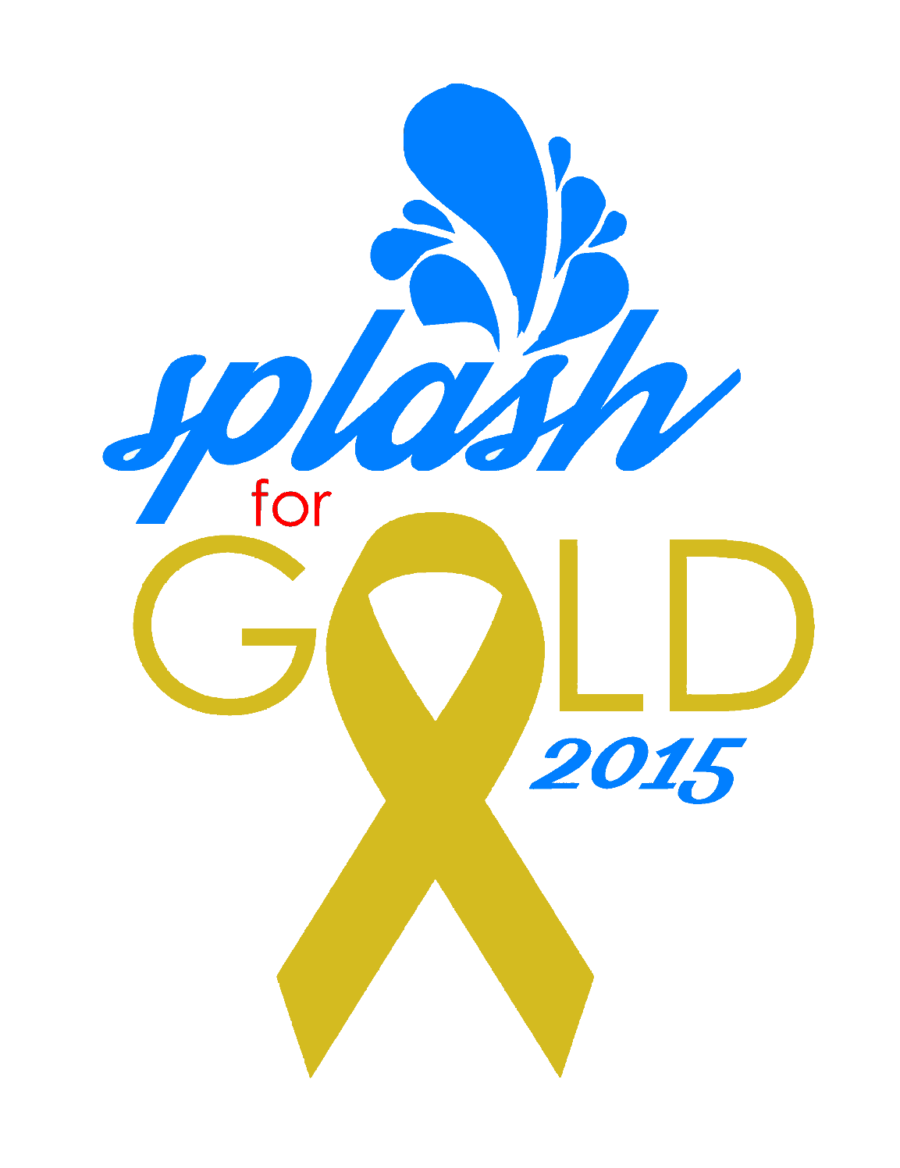
The #AftonStrong Splash for Gold Coast to Coast Swim Meet Benefiting Pediatric Cancer Research
HOST: Anyone who is #AFTONSTRONG
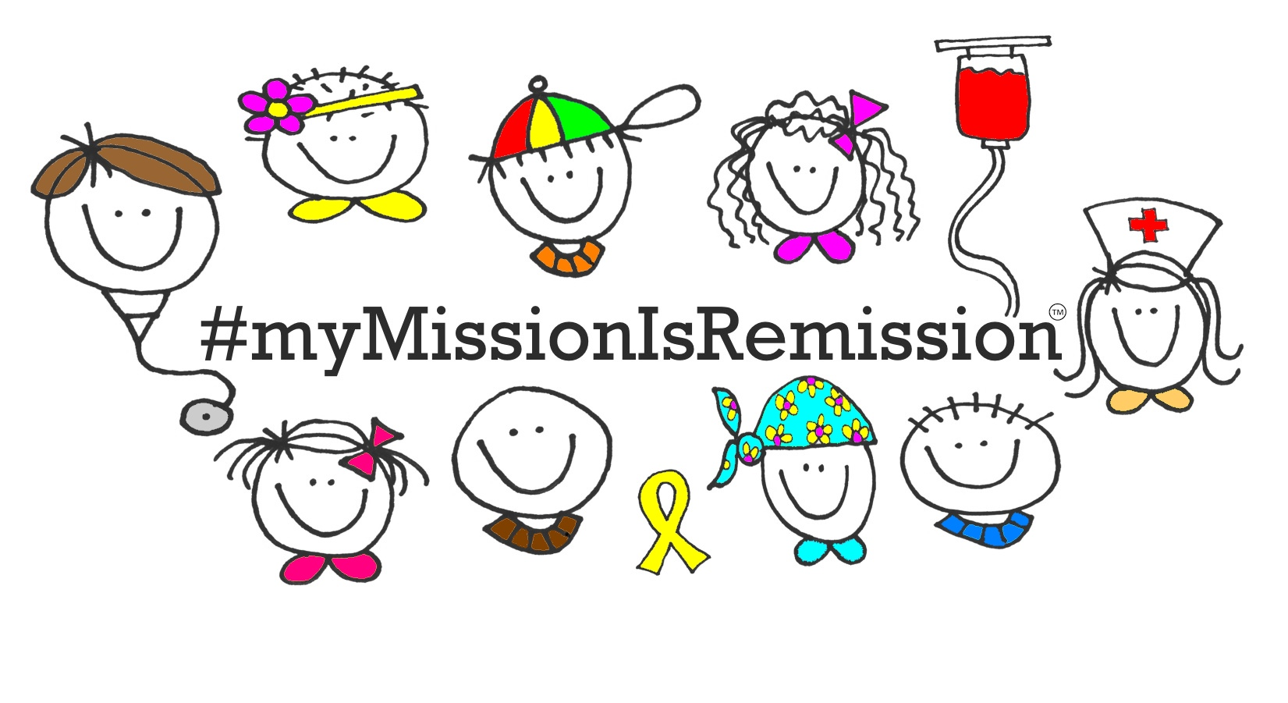
LOCATION: Postal Meet, any pool with a minimum distance of 25 yards

SPONSOR: The My Mission is Remission Foundation for Pediatric Cancer

TYPE OF COMPETITION: Postal Swim Meet. Swimmers are coach timed and results are “posted.” Proceeds benefit Pediatric Cancer Research.

PURPOSE: During her short 18-year life, and despite her yearlong battle with cancer, Afton Wallace never lost her desire to improve. A competitive swimmer from age 10, Afton’s always tried to be better. This attitude of continual improvement propelled her to swim among the top swimmers in the state of Mississippi. On May 24th 2015 Afton’s body could no longer fight the cancer that consumed her, but true to her nature, only three weeks before she passed away and with her body racked with cancer, she swam over 700 yards, simply because she felt she needed to keep improving. Her motto before and during her fight with cancer was “AftonStrong!” In that same spirit and in order to honor Afton’s continual desire to improve, the My Mission is Remission pediatric cancer foundation is sponsoring this coast-to-coast meet. Proceeds from will be used to help improve the fate of those who are afflicted with pediatric cancers. Specifically, these funds will be given to researchers in the form of grants and students in the form of scholarships who wish to pursue the use of high performance computing in pediatric cancer research.

ENTRIES: The competition will consist of Afton’s favorite events, listed below. All entrants may submit times for one or all the events listed. Timing is by hand and results are submitted on the honor system. Results and registration fee should be submitted to www.splashforgold.org by September 30, 2015 for rankings. Final rankings will be posted on www.splashforgold.org on October 5, 2015. An option to not disclose the age or gender of the athlete and/or their times will be available for those interested in swimming anonymously.
Competition Period opens September 1, 2015 and closes September 30, 2015.
LIMIT OF EVENTS: 4 individual events.
ENTRY FEE: Entry fee must be submitted with results
Individual Entry: $30.00
Non Participant Fee: $20.00

Payments to be made on website through paypal

SCORING & AWARDS: TBD by age and gender

AFTON’S FAVORTIE EVENT LIST:
#1 100 BACK
#2 50 FREE
#3 100 IM
#4 100FREE

