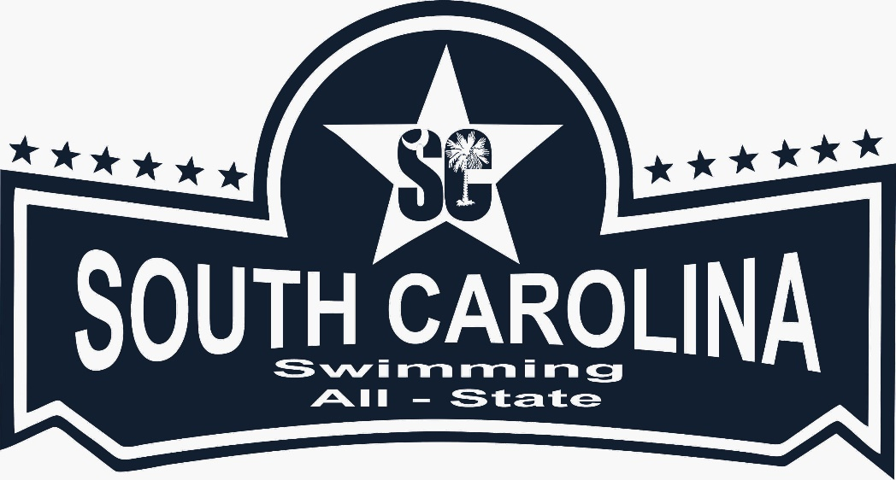

***Book a room or suite at Wild Dunes Resort and get 15% discount – see information below: 888-343-930 (reference South Carolina Swimming All State Banquet, code #3HG7YD)***

Deadline 4/9!!!

*Coming in Friday night? Chris Wolford, the Sports Performance Director for SC Swimming will have Saturday swim practice 6:30am at Wild Dunes pool – 55 Plantation Drive.*

Athlete’s Retreat

Enjoy a free lunch and get more involved in SC Swimming! Register at [www.sc-swimming.org](http://www.sc-swimming.org)

Afternoon Activity

Enjoy kayaking, paddle-boarding or playing games on the beach – *more information TBD*

***2018 All State Banquet and Awards Ceremony***

***When:*** *Saturday April 20-22*

***Where:*** *Wild Dunes Resort, Palms Ballroom, Isle of Palms*

***Time:*** *6:00-9:00pm*

*Go to the* ***registration*** *link: www.sc-swimming.org*

Athletes Retreat/Luncheon

Saturday April 21 12:00-1:30pm

Wild Dunes, Palmetto Hall

Swimmer afternoon activity:

Go to this link and sign up

Deadline is April 9