South Carolina Diversity/Inclusion Committee Diversity Select Camp
May 2014 - News Letter
SC Swimming First Ever Diversity Camp
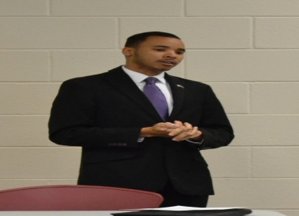
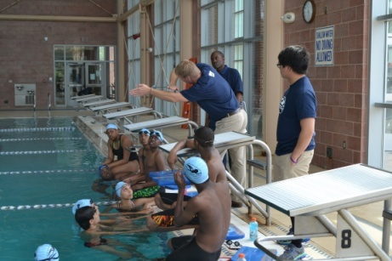
The camp was an outstanding success. The Aquatic Director at the Drew Wellness Center, began the camp with the opening address and tour. He gave a tour of the center showing pictures of African-American competitive swimmers in the 1950's to 1972. The motivational speaker, Christopher Sullivan, inspired the athletes with words of wisdom. Mr. Sullivan, who is a 26 years old entrepreneur, discussed the importance of setting goals. He told them the importance of setting a goal, making a plan and working the plan. He used himself, a young business owner, as an example of what can happen when you set goals and work hard. The new women’s swim coach at Columbia College, Jason Gallaher, addressed the athletes. He spoke to the athletes about the Clearing House, SAT, ACT and encouraged them to search college websites and fill out their swim team department questionnaire. He coached the swimmers in the first pool session with some college practice sets. The afternoon session began with Coach Shawn Hendrix swim coach at North Carolina A&T. She started talking with athletes about education and college swimming with right attitude. Then she did a dry land exercise session that included Yoga and stretches. After the dry land session, she had the swimmers in the pool and had them perform various drills. She explained the importance of the drills and the need for proper conditioning.
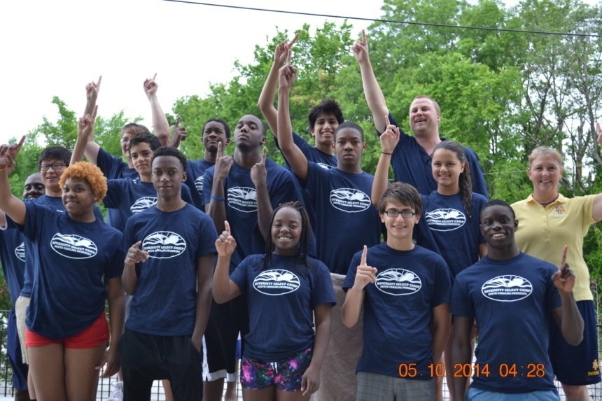

We closed out the camp with a goal setting session with the athletes and their parents. They discussed the importance of the family unit, with both the athlete and the parents working toward achievable athletic goals. The athletes were reminded of the importance of respect for adults and the need to develop a good moral character and roses for each mother!

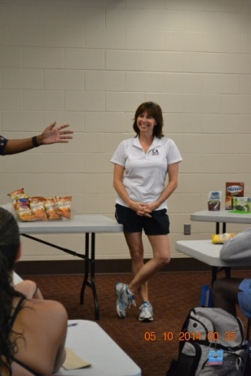
During the lunch session, Ms. Lisa Money, a dietician from the University of South Carolina, counseled the athletes about nutrition. She outlined the right foods to eat before and after practice and swim meets in order to maximize performance. She had an open question and answer session after her presentation.

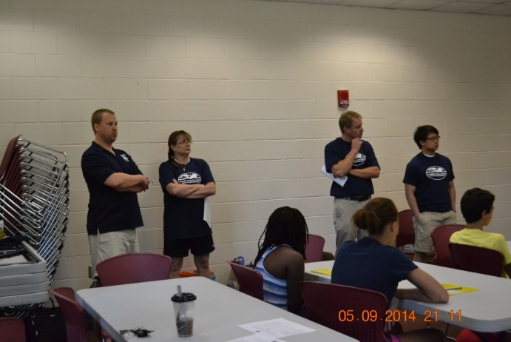

Camp Staff listens to a presentation during a classroom session.

