Max Kenneth Wolff
Date of birth March 14 1997
The SC Swimming Diversity/Inclusion committee would like to introduce one of our most impressive members of the SC Swimming family. Mr. Max Kenneth Wolff who swims for the Coastal Aquatic Club (CAC) in Myrtle Beach, SC. Max has competed with the CAC for five years and three years with the St. James varsity swim team. Max was apart of the 2013 South Carolina Zone swim team and competed in 100M butterfly, 100 backstroke, and mix 11-18 100M freestyle.
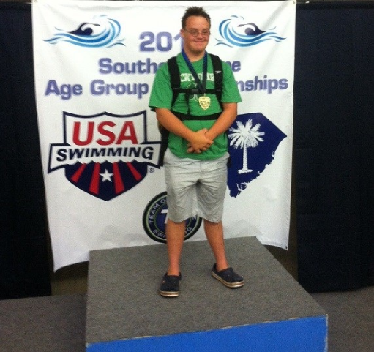
He practices a minimum of three days a week and attends most meets that CAC participates in. He is a freshman at Saint James High school in Murrells Inlet, SC. He loves swimming and it is great exercise for him.
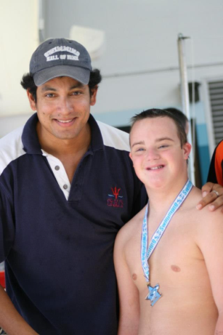
Max has three sisters that also swim with CAC Ana 15, Kater 13 and Jane 8. Max posed for a picture with his coach Fabio Mauro of Coastal Aquatic Club. Max is also involved with the boy scouts. He camps out about once a month and some of the camp outs involve hiking up to ten miles round trip. Max carries his own backpack and about half the time he is on his own because his dad isn't always able to go. I think Max’s ability to hike is related directly to the strength he has built through swimming. Max attends Surfside United Methodist Church and participates with the youth group in many church activities. Max has responsibilities around the house and is in charge of all garbage/ recyclables, empting the dishwasher, switching the laundry, and unloading the groceries from the car. He also works at his father's restaurant bussing tables serving food or drinks to the tables. He also at times prepares salads and pizzas. He hates being in charge of running the dish washing machine but he does that also. Max has been raised to be independent and responsible.

