USA SWIMMING 2021 OFFICIAL & OTHER REGISTRATION APPLICATION
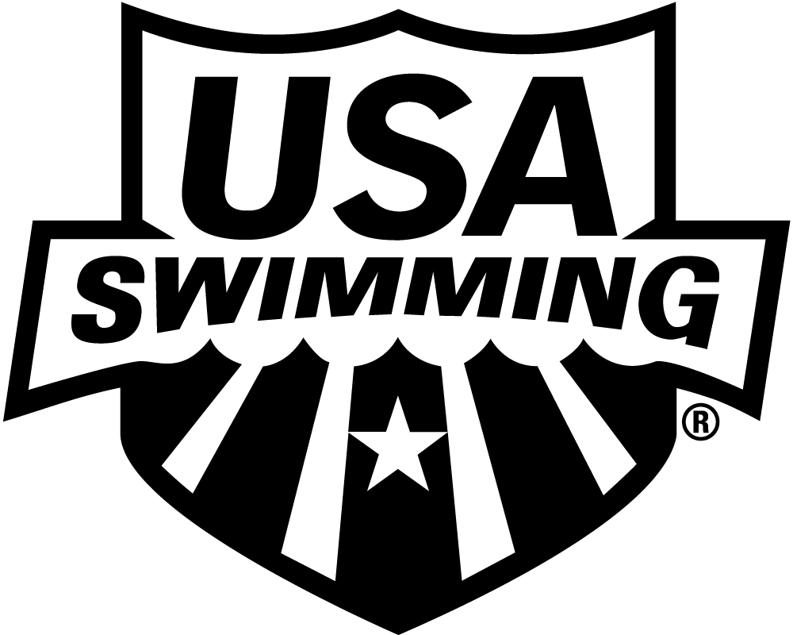
LSC: SOUTH CAROLINA SWIMMING

PLEASE PRINT LEGIBLY COMPLETE ALL INFORMATION TO ENSURE THAT CONTACT INFORMATION IS CORRECT AND UP TO DATE:

LAST NAME LEGAL FIRST NAME MIDDLE NAME

Have you ever been a member of USA Swimming under a different last name? If yes, please provide that name:
Previously registered with USA Swimming? Yes No If registered in a different LSC, which LSC:

PREFERRED NAME DATE OF BIRTH (MO/DAY/YR) SEX (M-F) CLUB CODE CLUB NAME

(Bill, Beth, Scooter, Liz, Bobby) (Required) If not affiliated with a club, enter “Unattached”

MAILING ADDRESS

CITY STATE ZIP CODE

–

AREA CODE TELEPHONE NO. AREA CODE TELEPHONE NO. EXTENSION AREA CODE TELEPHONE NO.

HOME WORK MOBILE

E-MAIL ADDRESS

IF ANY OF THE ABOVE INFORMATION CHANGES DURING THE YEAR – PLEASE NOTIFY YOUR LSC REGISTRATION/MEMBERSHIP PERSON OF THE CHANGES

RACE AND ETHNICITY (OPTIONAL): You may check up to two choices
Q. Black or African American R. Asian
S. White T. Hispanic or Latino
U. American Indian & Alaska Native V. Some Other Race
W. Native Hawaiian & Other Pacific Islander
CITIZENSHIP/FINA:
U.S. Citizen: Yes No
Are you a member of another FINA federation: Yes No
If Yes, which federation: ___________________________________________

Check if you would like to learn more about the USA Swimming Foundation’s initiatives
Check if you would like to receive the electronic USA Swimming Newsletter

MEMBERSHIP CODE: Check all that apply
Certified Official (Starter, Stroke & Turn, Meet Referee, Administrative, etc.) Requires a Background Check & Athlete Protection Training

Other (Chaperone, Meet Director, Meet Manager, etc.) Requires a Background Check & Athlete Protection Training
NON-ATHLETES BGC at www.usaswimming.org/backgroundcheck APT at www.usaswimming.org/apt

CONCUSSSION PROTOCOL TRAINING (OFFICIALS) Courses from the Center for Disease Control and Prevention (CDC) or the National Federation of State High School Associations (NFHS), as well as individual states’ required courses will satisfy the USA Swimming requirement.

: Courses from the Center for Disease Control and Prevention (CDC) or the National Federation of State High School Associations (NFHS), as well as individual states’ required courses will satisfy the USA Swimming requirement.

By becoming a member of USA Swimming, I hereby agree to abide by the rules, regulations and Code of Conduct of USA Swimming.
I acknowledge that when I learn of facts that give reason to suspect that a child has suffered an incident of abuse, including sexual abuse, I must report to law enforcement within 24 hours pursuant to The Protecting Young Children from Sexual Abuse and Safe Sport Authorization Act.
I acknowledge that I have reviewed and agree to abide by rules and regulations of the Minor Athlete Abuse Prevention Policy and I have completed
Athlete Protection Training. Note: If joining USA Swimming for the first time, you will not be able to complete Athlete Protection Training until your membership has been processed.

________________________________________________________________________________________________________
Signature Date
By signing this application I verify that the above is true and correct.

MAIL APPLICATION
MAKE CHECK PAYABLE TO:

2021 REGISTRATION FEE
June 1, 2020 through December 31, 2021
USA Swimming Fee + LSC Fee = TOTAL DUE

Individual $64.00 + $10.00 = $74.00
Life $1,000.00 + $10.00 = $1,010.00
South Carolina Swimming

South Carolina Swimming, Inc.
PO Box 460
Six Mile, SC 29682-0460

MAIL CHECK & PAYMENT TO:

