2013-2014 SES Age Group Chair Report (Short Course)
Table of content
Page 1:
Coach’s education resources
SES District Championships report
Page 2:
Short Course Southeastern Championships review
USA Swimming Virtual Club Championships ranking
Page 3:
Zones report

Information compiled by Steven Murry
sjmurry@yahoo.com

Coaches education resources
Coaches Education Opportunities
- 2014 ASCA World Clinic: held in Jacksonville FL Sep 8-14th 2014
  - Link to ASCA clinics can be found at http://swimmingcoach.org/portfolio/2014-asca-world-clinic/
- USA Swimming 2014 Aquatic Sports Convention: held in Jacksonville, Florida 09/16 - 20/2014
  - Link to USA Swimming Clinic can be found at: http://www.usaswimming.org/DesktopDefault.aspx?TabId=1528&Alias=Rainbow&Lang=en
USA Swimming Online
- Other continuing education for coaches can be found at the following USA Swimming website: http://www.usaswimming.org/DesktopDefault.aspx?TabId=1692&Alias=Rainbow&Lang=en
Review of 2013 U.S. Aquatics Convention
- 2014 Southern Zone Age Group Championships will be July 29 - August 2, 2014 with Open Water on August 3, 2014.
- Zones will be held in San Antonio, TX, hosted at the Northside Aquatics Center. More information on the site can be found here: https://www.teamunify.com/Home.jsp?team=stnsalp

2014 SES District Championships Report

District Host Club | Team
East | BAY
West | XCEL
South | GPAC
Central | AUB

8 & Under team scores | Men | Women
East | MCC | MCC
West | XCEL | XCEL
South | NA | NA
Central | NA | NA

8 & Under Highpoints
East | Team | Score
Hafner, Alina | TNAQ | 69
Berry, Ryan R | MCC | 66
West | Team | Score
Carter, Abby G | XCEL | 54
Nicholas, Spencer J | XCEL | 54
South | Team | Score
NA
NA
Central | Team | Score
NA
NA

2014 Short Course SES Championships
Age Group Champions
Division/Place | 1st Place Team | 2nd Place Team | 3rd Place Team
9-10 Girls | XCEL | NAC | MTSC
9-10 Boys | NAC | CMSA | XCEL
11-12 Girls | NAC | MTS | TNAQ
11-12 Boys | TNAQ | XCEL | NAC

High Point Winners
Division/Place | High Point Champion (Team)
9-10 Girls | Xian, Stephanie( BAY)
9-10 Boys | Conrad, Stephen (CMSA)
11-12 Girls | Nelson, Ella (NAC)
11-12 Boys | Evans, Kobe (TNAQ)

Virtual Club Championships
Short Course 2013-2014 (Top 25)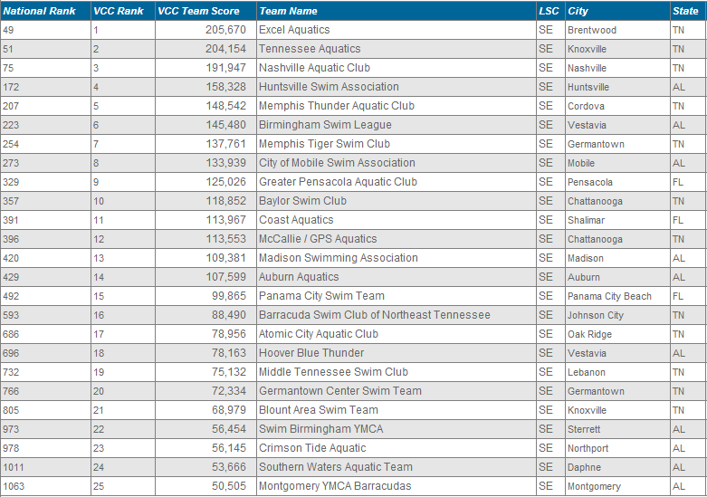

Zones Report

- Southeastern Swimming will be flying from Nashville into San Antonio TX on Monday July 28th.
- Head Coach for the 2014 Zone team: Nick Lambert (BSL).
  - This will be Nick’s 4th year as a member of the Zone Team Coaching Staff. We are excited to have Nick’s leadership and experience as we head into the 2014 summer.
- Applicants for the assistant coaching staff position are currently being reviewed and finalized.

