2012-2013 Age Group Chair Report
Coaches Education Opportunities
- 2013 ASCA World Clinic: held in New Orleans on September 3-8
- Link to ASCA clinics can be found at http://www.swimmingcoach.org/Members/index.asp
USA Swimming Online
- Other continuing education for coaches can be found at the following USA Swimming website: http://www.usaswimming.org/DesktopDefault.aspx?TabId=1692&Alias=Rainbow&Lang=en
Review of 2013 U.S. Aquatics Convention
- 2014 Southern Zone Age Group Championships will be July 29 - August 2, 2014 with Open Water on August 3, 2014.
- Zones will be held in San Antonio, TX, hosted at the Northside Aquatics Center. More information on the site can be found here: https://www.teamunify.com/Home.jsp?team=stnsalp

2013 Short Course SES Districts
Districts Host Clubs
DISTRICTS
East |  | SCAC
West |  | XCEL
South |  | GPAC
Central |  | CTA

2013 Short Course SES Championships
Age Group Champions
Division/Place | 1st Place Team | 2nd Place Team | 3rd Place Team
9-10 Girls | NAC | PACK | MTS
9-10 Boys | XCEL | NAC | HSA
11-12 Girls | HSA | BSL | MTS
11-12 Boys | HBT | XCEL | MTS
12 & Under Girls | HSA | BSL/MTS | NAC
12 & Under Boys | XCEL | NAC | CMSA
12 & Under Total | HSA | NAC | BSL

High Point Winners
Division/Place | High Point Champion (Team)
9-10 Girls | Kallie Chelsvig (NAC)/Marybeth Monk (HSA)
9-10 Boys | Mason Mathias (BSL)
11-12 Girls | Riley Gaines (XCEL)
11-12 Boys | Ryan Gorman (MTAC)

LSC/SE Records
- 11-12 Girls: Huntsville Swim Association- SE- 1:39.78
  - Campbell, Devin/Melton, Kobie/Hu, Alison/Weakley, Regan
- 11-12 Girls: Huntsville Swim Association- SE- 1:51.46
  - Melton, Kobie/Hu, Alison/Campbell, Devin/Weakley, Regan

- 8 & Under 200 Free Relay- 2:15.43- Carteaux, M./Burnett, C./Donho, L./Harris, W.- XCEL -04/16/2013
- 10 & Under 500 Free 5:33.78 Mary Monk HSA 3/7/2013 NC ESSZ Age Group
- 10 & Under 50 Back 29.58 Mary Monk HSA 3/7/2013 NC ESSZ Age Group
- 10 & Under 100 Back 1:03.39 Mary Monk HSA 3/7/2013 NC ESSZ Age Group

2013 Long Course Southeastern Championships
Age Group Champions
Division/Place | 1st Place Team
9-10 Girls | PACK
9-10 Boys | XCEL
11-12 Girls | HSA
11-12 Boys | MTS

High Point Winners
Division/Place | High Point Champion (Team)
9-10 Girls | Emily Ivey (PACK)
9-10 Boys | Manson Mathias (BSL)
11-12 Girls | Kobie Melton (HSA)
11-12 Boys | Wen Zhang (DDST)

LSC/SE Records
- 11-12 200 Free Relay - Huntsville Swim Association-SE - 1:55.55R
  - Hu, Alison/ Davis, Taylor/ Monk, Marybeth/ Melton, Kobie
- 8 & Under 200 Free Relay 2:29.77 M. Carteaux, O. Donoho A. Carter, E. Harris XCEL 2013 Stars & Stripes
- 8 & Under 200 Medley Relay 2:50.27 E. Harris, M. Carteaux O. Donoho, A. Carter XCEL 2013 Stars & Stripes
- 8 & Under 200 Medley Relay 2:53.97 S. Nicholas, J. Hickson A. Shackell, J. Carrico XCEL 2013 Stars & Stripes

2013 Southern Zone Age Group Championships
 | 2013 Zone Team
 | Woman’s Team
11-12 Girls | 13-14 Girls | Senior Girls
Allison Hu | Sarah Margaret Cimino | Maggie Melhorn
Kobie Melton | Mallory Underwood | Brooke Ferrara
Abby Williamson | Kylie Vandervier | Jessica Wingo
Melanie Moczadlo | Riley Gaines | Maggie Stovall
Haley Burt | Rachel Cunningham | Caroline Boone
Mary Beth Monk | Meredith Geyer | Ali Lapps
Audrey Mckinnon | Margaret Carey | Bailey Flynn
Kallie Chelsvig | Alyssa Hale | Jessica Green
 | Men’s Team
11-12 Boys | 13-14 Boys | Senior Boys
Wen Zhang | Elijah Patrick | Russel Noletto
Wilson Mccraw | Eric Whisenant | Zachary Harting
Grady Leopard | Caleb Harrington | John Smith
Jake Marcum | Seth Kyriakidis | Wil Barton
Jacob Kiemeyer | James Courtney | Owen Sanders
Austin Kinsler | Christian Berry | Sean Kirwan
Kobe Evans | Owen Devine | Byron Grant
Drake Amick | Patrick Dunne | Chris Butler

Coaching Staff
- Age Group Chair/ Zone Trip Administrator
Cheryl Schoenberger (MTS)
- Zone Championship Head Coach:
Tyler Kerns (CMSA)
- Assistant Coaches:
Nick Lambert (BSL); Steven Murry (XCEL); Allison Brol (HSA); Felipe Cortes (GST)
Chaperones
  - Clayton Burt
  - Cindy Geyer
  - Katy Leopard
  - Elise Mckinnon
  - Rebekah Patrick

Individual Champion List
  - Vandevier, Kiley (100 Back/200 Back)
  - Cunningham, Rachel (100 Breast)
  - Cimino, Sarah Margaret (100 Fly)
  - Underwood, Mallory (200 IM)
  - Stovall, Maggie (100 Free)
  - Ferrara, Brooke (100 Back)
  - Flynn, Bailey (200 Fly)
  - Patrick, Elijah (100 Fly/200 Fly)
  - Noletto, Russell (200 Free/1500 Free)
  - Harting, Zach (100 Fly/200 Fly)
Relay Champion List
- (200 FR-R) Hu, Alison/ Melton, Kobie/ Williamson, Abby/ Burt, Haley MEET RECORD
- (200 FR-R) Geyer, Meredith/ Underwood, Mallory/ Cimino, Sarah Margaret/ Gaines, Riley MEET RECORD
- (200 MD-R) Vandevier, Kiley/ Cunningham, Rachel/ Cimino, Sarah Margaret/ Underwood, Mallory MEET RECORD
- (400 MD-R) Vandevier, Kiley/ Cunningham, Rachel/ Cimino, Sarah Margaret/ Gaines, Riley
- (200 FR-R) Ferrara, Brooke/ Stovall, Maggie/ Boone, Caroline/ Wingo, Jessica
- (400 FR-R) Ferrara, Brooke/ Wingo, Jessica/ Boone, Caroline/ Stovall, Maggie

Team Scores
Combined Team Scores - Through Event 408

1. Ga Zone 962
2. Florida Zone Team 870.5
3. Southeastern Swimming Zone Tea 790.5
4. North Carolina Swim Team 641.5

Women - Team Rankings - Through Event 408

1. Florida Zone Team 473.5
2. Southeastern Swimming Zone Tea 447.5
3. Ga Zone 432
4. North Carolina Swim Team 381

Men - Team Rankings - Through Event 408

1. Ga Zone 530
2. Florida Zone Team 397
3. Southeastern Swimming Zone Tea 343
4. Team Kentucky 332

Meet Review and Report
- The meet invitation was unclear about Junior National Qualifiers. Some teams took advantage of this mistake, and brought Junior National Qualifiers on their Zone Teams.
- The disabled swimmers were scored disproportionately in comparison to the rest of the athletes; this caused some teams to have a clear advantage over other teams.

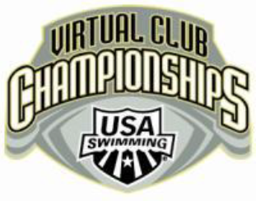
2012-2013 Long Course (Top 25)
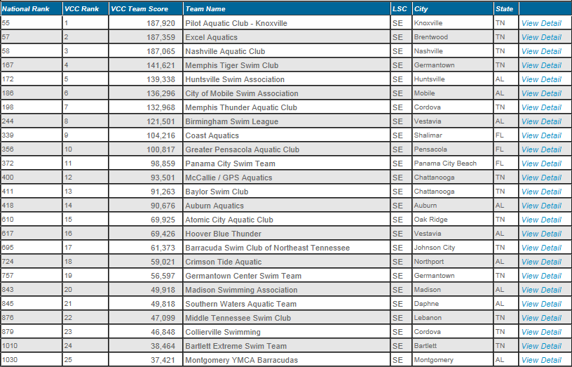

Short Course 2012-2013 (Top 25)
