“Just Keep Swimming...” (2018 version)
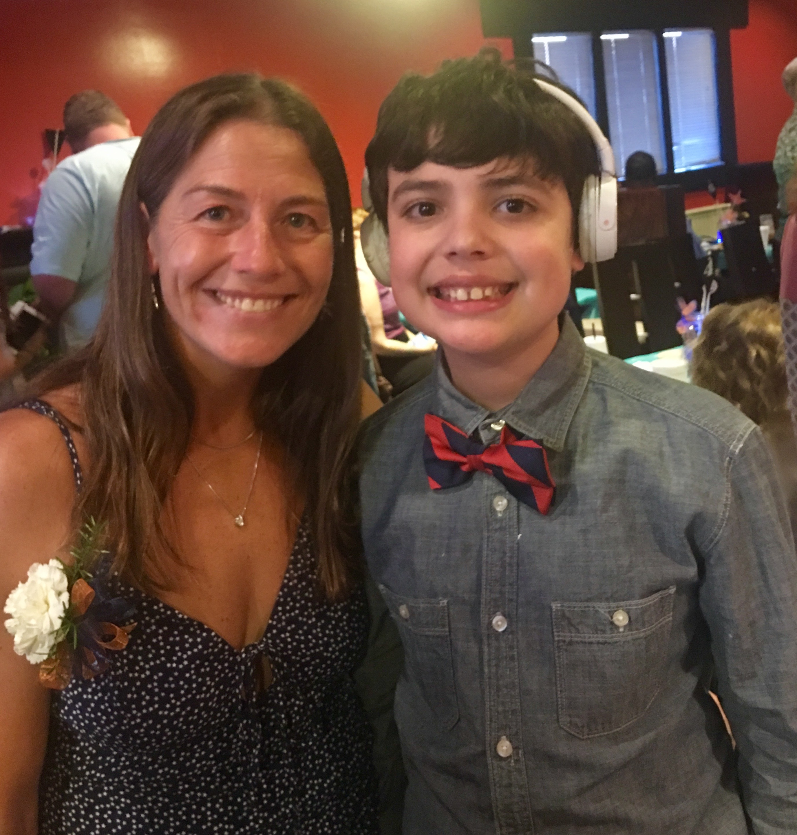

Regular followers know that Matthew swims with Seastars Aquatics in Pensacola. Seastars Aquatics is a one-of-a-kind swim team, literally, one-of-a-kind, for low-income or special needs swimmers in a training environment. If you qualify, swim team is a free program funded by private lesson revenue, grants and public support. You can’t really begin to appreciate Seastars from afar, you have to be a part of it, you have to watch it , you have to hear it, you have to feel it, it’s like nothing I’ve been a part of before. Coach Robin, the head coach and one of the founders, and her coaching staff are real-life miracle workers. They take children who literally will not even get in the water and transform them into competitive swimmers. They continue to amaze me with their work on, and off, the pool deck, and I am so grateful for the role they play in Matthew’s life.

This time last year, we were just happy for Matthew to be swimming regularly, a lesson and a practice a week. The main objective was to get him exercise and for him to be safe in and around the water. As his skills developed under Coach Robin, our expectations grew a bit. Perhaps he would swim some summer league meets or Special Olympics, eventually once he was legal in his strokes he might even swim a USA Swimming Meet, just like his older siblings, or as he says “like Walker.” Robin pulls out all the stops when working with her swimmers, she meets them where they are, she’s creative, she finds their motivation. One of the drills Matthew loves is to swim with a traffic cone tied to his waist with fins on. He loves the sensory feedback that drill provides. I love how creative Robin is in her teaching techniques. Somehow she treats every swimmer on the team equally and fairly while meeting them where they are with just what they need to be successful, which is about 57 different places. Success doesn’t mean winning in the traditional sense here, it means “winning” in the best sense, winning at Seastars Aquatics means becoming a better version of oneself.

I always preach about presuming competence to teachers, to my family, to anyone who will listen, “we should presume competence in our kids until they prove otherwise.” If I’m honest, and I try to be honest with you all, even when I’m not honest with myself. I haven’t always followed this mantra with Matthew and swimming. I was reluctant for him to participate in a USA Swimming meet, because I was afraid of failure, afraid he wouldn’t be able to do it, afraid I would cry, just afraid. Robin insisted we sign up for a meet in January, “just the 50 free” she said. “It’s the first event on Friday, “ she said. “He can do this!”

Reluctantly I signed him up and she worked tirelessly with him to get him ready. Coach Robin ensured his accommodations were in place. He could start from the water, she could prompt his start with a touch, he could be in an outside lane. All the pieces were in place for success, but I was still worried. When the day came, I was nervous for him (and me). Coach Robin took him to the blocks and I found my spot to watch. I asked a friend to videotape because I knew my hands wouldn’t be steady. My eyes welled with tears as I watched Walker’s GPAC family and Matthew’s Seastars family line up on both ends of the pool to cheer him on. He did it, he raced the 50 freestyle legally in a USA Swimming meet. There were lots of tears from me and our family friends and there was immense pride from all of our swimming family and there was a little guilt in my heart for not encouraging him to try it sooner.

The next week at practice, he received a ribbon for a best time. He was so proud standing on that pool deck, smiling for the camera, that was all the affirmation I needed to continue encouraging him to swim. Fast forward to March and he swam in his second meet, 50 freestyle. Coach Robin prepared him to swim faster, to try to swim a best time, she practiced “racing” with him and guess what? He swam a best time by 10 seconds and again there were tears and pride. He says “I’m swimming like Walker”, yes Matthew, you are.
Last night, Seastars hosted its first swim banquet in its thirteen year history. I wish you could have been there to celebrate with us, my words will never do it justice. I wish every donor or sponsor or grantor that ever gave even a dollar to the program could have peeked in the window to see their impact of their donations. Their contributions are changing lives every single day. The banquet was a beautiful melding of swimmers, families, and coaches celebrating the amazing achievements of swimmers doing things many of their parents never dreamed they would accomplish. Young swimmers next to older ones, non-verbal children sitting with those who never stop talking, swimmers from different backgrounds, races, and abilities celebrating their accomplishments together over tacos and cake. Seastars’ swimmers don’t just learn how to swim, they learn valuable life lessons about setting goals, working hard, sharing and maintaining a positive attitude through it all. We recognized athletic success, community service, sportsmanship, perseverance, leadership and attendance. We laughed and we cried. We shared a meal, like a family. We came together as a community and leaned in to celebrate Seastars and all it stands for and guess what it stands for so much more than swimming. #matthewsstory #seastars

