How do I become
an official for
USA Swimming?

You’ll need to become a
member of USA Swimming.
A new official will have to attend
A clinic, take an official’s test
which is available on line,
work as an apprentice to get
on the job training, and
then … have fun!

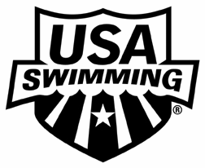

We’re looking forward
to seeing you on deck!

Contact____________________________
at__________________________________
to become an official for
USA Swimming

Five Reasons to Become
an Official
You’ll be working with the greatest group of volunteers in all sports.

You’ll be close to the action. The bleachers aren’t that comfortable anyway!

High satisfaction; low pay.

It’s a great way to meet future
Olympians—unless you already
have one in your home

Great food in hospitality, and you can’t beat the price!

