*We need help getting a better understanding of our Disability Athlete in SES. If you have a disability swimmer please encourage them to fill out an outreach registration form. It is only $5 instead of the $72 this year. They must provide documentation on disability, but we have a very skewed count in our LSC. When doing registrations if you notice the Disability box has been checked offer the option of Outreach.
*We need to be sending 6 swimmers 11-18 to Zones. In 2018 we had 3 apply and 2 attend
*SES and SEASTARS had 2 disability athletes, Anthony and Dolon, compete in Southern Age Group Zones in Midland TX. SES won 3rd place overall and the boys team just missed 1st by less than 10 points. Our Disability athletes collectively earned 37 points for SES. They had tons of best times and a learning and growing experience that is immeasurable. A huge thanks to Tim, Dolon’s Dad, for Chaperoning, videotaping, and helping all 50 swimmers. Go, SES!
*In USA Swimming’s eyes Diversity and Inclusion will now umbrella under Safe Sport: Outreach, Gender, Race, Disability, Transgender, etc. Most LSC’s are encouraged to set aside 1% of their budget to help with Diversity and Inclusion efforts. Southeastern Swimming is WAY behind nationally in both Diversity and Inclusion Efforts
* Hey Robin, I’m looking to get the word out about the Fred Lamback Disability meet in your LSC. Is that something that you could help us blast out or post somewhere? Thank you, Here’s the link on the GA Swimming site too: https://www.teamunify.com/Home.jsp?team=gsasl
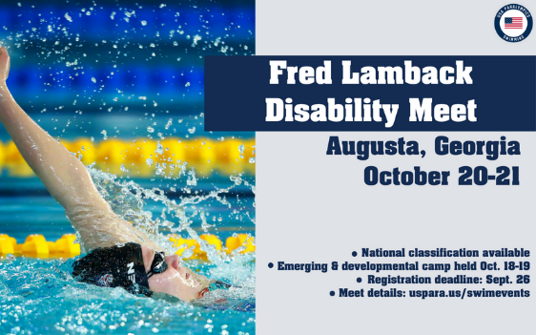
* GLENDA ORTH, DISABILITY CHAIRWOMAN for the Southern Zone
glenda.orth@comcast.net
*https://www.teamunify.com/lscszgs/UserFiles/File/Disability%20Swimming%20Coach%20Resources.pdf
* https://www.teamunify.com/lscszgs/UserFiles/File/Get%20Involved%20-%20Officials%20(Disability).pdf

