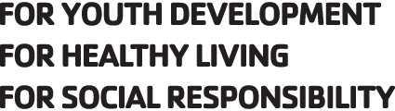
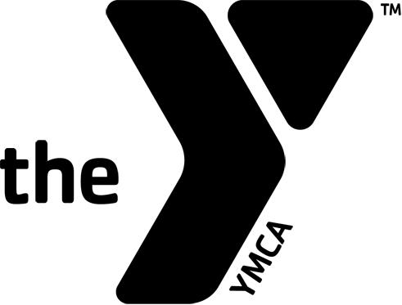

YMCA of Calhoun County Blue Dolphins Head Swim Coach

YMCA
YMCA of Calhoun County

Location
Anniston, Alabama

Job Description:
We are seeking an experienced swim coach to provide leadership as we continue to build on the success this team has experienced in the past several years. We are an established team and our current enrollment is 55 swimmers.

The Head Coach will be prompt, dependable and mature. They will be responsible for the wellbeing and safety of all team members, for organizing team schedules and swim meets, providing leadership and mentoring to assistant coaches and volunteers, communicating with parents, writing and conducting daily practices, designing an appropriate training strategy, goal setting with all swimmers, attending swim meets, attending educational swim clinics and seminars, growing the team and group roster. There will be some expectancy around community involvement and fundraising.

An essential role for the coach is to be a positive role model to team members and a “swim team and YMCA ambassador” within the community where they engage the local high schools to develop their programs and the community at large for fundraising. The head coach will be energetic, driven and passionate and be willing to create an atmosphere in which swimmers can thrive. They must desire to build on an established program with professionalism, integrity, and confidence. Knowledge of Team Unify and Team Manager is preferred but not required. The head coach is an essential part of the mission of the Y and will lead the recruitment of new swimmers into the program and strengthening the community through youth development, healthy living and social responsibility.

QUALIFICATIONS
- Candidates must have a background in competitive swimming either as a coach or swimmer, and have strong communication and relationship building skills with swimmers, parents, and coaches and excellent organizational skills. 2-3 years of coaching experience with various ages is preferred.
- ASCA Level 2 experience is preferred but not required.
- Candidates should possess or be willing to obtain current USA Swimming coach certifications in good standing and pass all required background checks.
- In 30 Days be willing to obtain CPR for the Professional Rescuer, AED and First Aid certifications required.
- Applicant must have excellent teaching skills with expert knowledge of training and stroke development
- All hires will be required to pass a drug test, background check and complete YMCA prerequisites for employment
RESPONSIBILITIES
Applicant duties will include, but are not limited to:

- Able to manage all groups by developing a coordinated training plan for all groups
- Ability to develop a coaching staff and evaluate performance and training needs for the staff.
- Develop and manage the learn to swim and summer camp programs as developmental for the team.
- Develop the YMCA Masters Swimming program
- Active work with Community involvement and Fundraising for the YMCA as well at the team.
- Able to communicate with parents.
- Attending meets throughout the season.
- Act in the best interests of the program within the Southeastern LSC
- Promote the team philosophy and foster a positive and friendly practice environment for athletes in the water consistent with the YMCA Mission.
Job Type
Wage commensurate with experience

Shift Hours
Hours may vary based on the needs of the program

How to Apply
Please submit cover letter, resume and 3 references
Apply by email:
shaneruffin@ymcacalhoun.org
Or
YMCA of Calhoun County*P.O. Box 1649*Anniston Alabama 36202
Attn: Shane Ruffin

Application Deadline
10/31/2017

