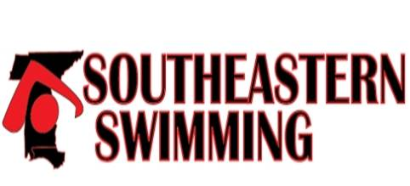

Southeastern Swimming
Club Incentive and Recognition

Southeastern Swimming provides incentives and recognition to member clubs for achievements earned each swim season.

Categories:
USA-S Club Recognition Program

USA-S Club Excellence Program
Virtual Club Rankings
Swimmers Completing IMXtreme Program
Swimmers at National/Junior National Championship Meets
Number of Officials as a percentage of membership

Team that have swimmers that make USA All-American status

Teams that have swimmers that make the SES All-Star teams

Club Coaches that are named to USA National teams

Club Coaches that have swimmers that make USA National Team s

The top teams in each category will be recognized at the annual LSC Meeting and published on the web page.

Beginning Fall 2017

