USA SWIMMING – Southeastern Swimming 2020 - 2021 ORGANIZATION APPLICATION
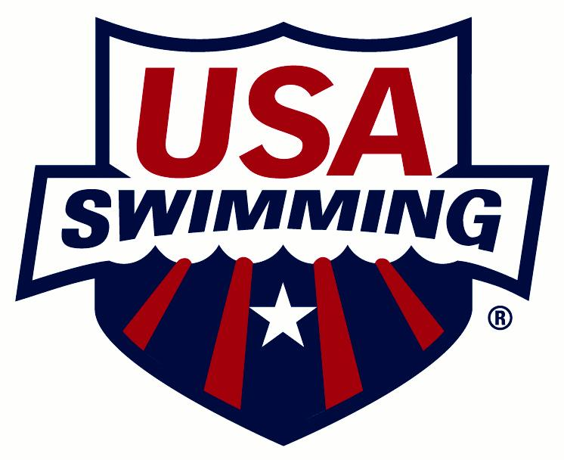
Organizational membership is only available for those entities that are actively involved in hosting USA Swimming activities.

ORGANIZATION CODE: ___________ ORGANIZATION NAME:
ARE YOU AFFILIATED WITH A USA SWIMMING CLUB? Yes No
IF YES, CLUB CODE: ___________ CLUB NAME:
PLEASE CHECK ONE:
NEW ORGANIZATION RENEWING ORGANIZATION
(Organization is defined as a group without athletes and coaches. Insurance is only provided for activities which have been approved by USA Swimming’s Risk Management Director or insurance broker, Risk Management Services. After approval, Risk Management Services can issue a certificate of insurance. Please contact Sandi Blumit (ext. 12) or Lori Sabato (ext. 19) at 1-800-777-4930. Seasonal clubs cannot be organizations.)
FIRST YEAR AS A USA SWIMMING ORGANIZATION:
NEAREST MAJOR CITY: ORGANIZATION WEB SITE:

PRIMARY CONTACT PERSON:
CONTACT:
POSITION (President, Director, etc.):
ADDRESS:
CITY: STATE: ZIP:
HOME PHONE: BUSINESS: MOBILE:
FAX: EMAIL:

PRIMARY PURPOSE OF YOUR ORGANIZATION:
- BOOSTER CLUB
- SWIM LEAGUE
- OTHER
DO YOU PLAN TO RUN FUNDRAISERS? YES NO
DO YOU PLAN TO RUN SWIM MEETS? YES NO

REGISTRATION DATE
REGISTRATION DATE: (For LSC Office Use Only)

If any of the above information changes, please notify your LSC Registration Chair.

