USA SWIMMING – 2022 ORGANIZATION APPLICATION
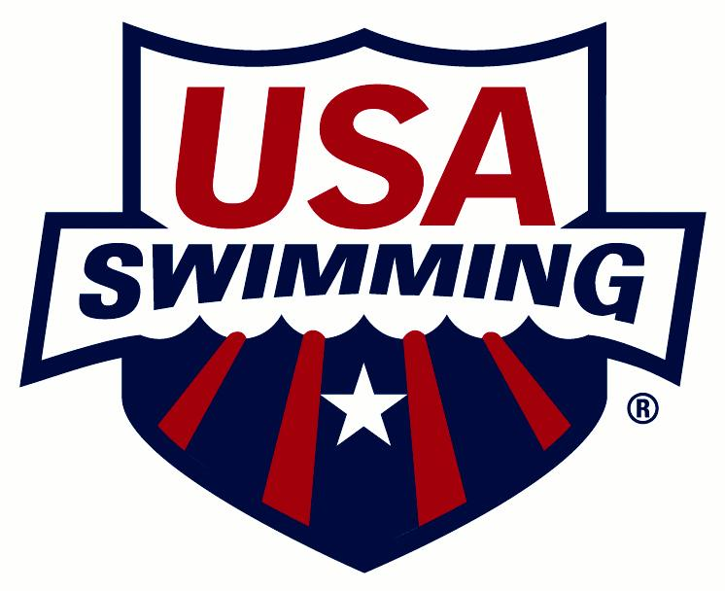
Organizational membership is only available for those entities that are actively involved in hosting USA Swimming activities.

ORGANIZATION CODE: ___________ ORGANIZATION NAME:
ARE YOU AFFILIATED WITH A USA SWIMMING CLUB? Yes No
IF YES, CLUB CODE: ___________ CLUB NAME:
PLEASE CHECK ONE:
NEW ORGANIZATION RENEWING ORGANIZATION
(Organization is defined as a group without athletes and coaches. Insurance is only provided for activities which have been approved by USA Swimming. Please contact membership@usaswimming.org. After approval, Risk Management Services can issue a certificate of insurance. Please contact Sandi Blumit (ext. 12) or Lori Sabato (ext. 19) at 1-800-777-4930 at Risk Management Services for assistance. Seasonal clubs cannot be organizations.)
FIRST YEAR AS A USA SWIMMING ORGANIZATION:
NEAREST MAJOR CITY: ORGANIZATION WEB SITE:

PRIMARY CONTACT PERSON:
CONTACT:
POSITION (President, Director, etc.):
ADDRESS:
CITY: STATE: ZIP:
HOME PHONE: BUSINESS: MOBILE:
FAX: EMAIL:

PRIMARY PURPOSE OF YOUR ORGANIZATION:
- BOOSTER CLUB
- SWIM LEAGUE
- OTHER
DO YOU PLAN TO RUN FUNDRAISERS? YES NO
DO YOU PLAN TO RUN SWIM MEETS? YES NO

REGISTRATION DATE
REGISTRATION DATE: (For LSC Office Use Only)
SES Office Address:
SES Office
8607 Marlin Pl Panama City Beach, FL 32408

If any of the above information changes, please notify your LSC Registration Chair.

