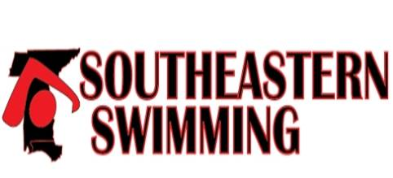

Southeastern Swimming
Club Incentive and Recognition

Southeastern Swimming provides incentives and recognition to member clubs for achievements earned each swim season.

Categories:
USA-S Club Recognition Program - on the club web page

USA-S Club Excellence Program – on the club web page
Virtual Club Rankings – on the club web page
Swimmers Completing IMXtreme Program – link on the club web page.
Swimmers at National/Junior National Championship Meets - on Senior report
Number of Officials as a percentage of membership – have to figure out

Team that have swimmers that make USA All-American status – on the swimmer’s page

Teams that have swimmers that make the SES All-Star teams – on the All-star page

Club Coaches that are named to USA National teams – on the coach’s page

Club Coaches that have swimmers that make USA National Teams – on the senior administrative report

