Southeastern Swimming

Operational Risk Report

August 2020

COVID-19
The Operational Risk committee has been very active as a result of the current pandemic. Some of the more notable items include:
- Return to Operations Plan
- Insurance negotiations to include non-standard practice locations and scenarios (i.e., use of Zoom for dryland, other water locations)
- Extension of CPR/Water practicum safety training due date until the end of 2020 (online portion must be completed). This will be monitored for future adjustments as needed.

Report of Occurrence (ROO)
The number of reports filed is down overall from years past, presumably due to reduced training and meets starting in March. Combined data for all LSCs through the end of June showed that the majority of incidents were reported during practice and occurred at the start and turn end of the pool. Head strikes continued to be the most reported issue.
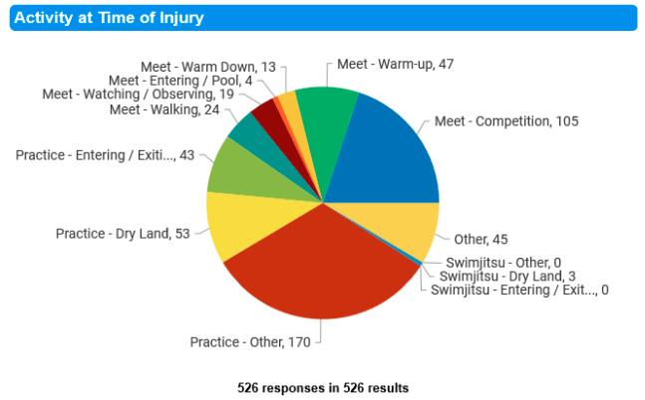
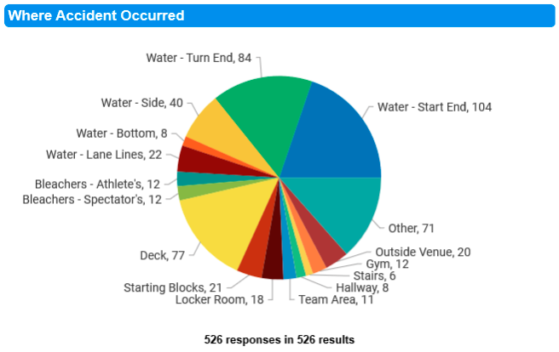
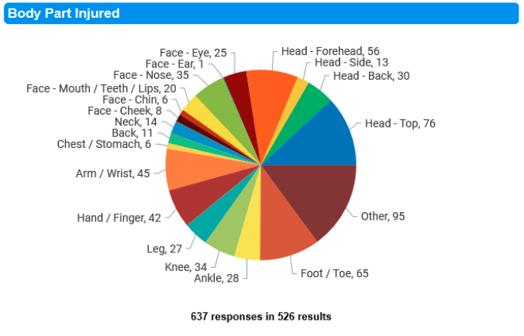
Reports of Occurrence received from SES involved mainly head strikes and back issues. The number of reports received was very low, which may be a result of the reduction in operations. Recent ROO reports received since the resumption of training have mainly been head strikes. It was assumed this was a result of athletes adjusting to swimming with one to two per lane.

It is important to note that a ROO should be completed and filed as soon as possible as this is the mechanism to connect the individual with the proper person for USAS insurance purposes.

Crisis Communication Plan
The Operational Risk Committee was asked to develop a plan that includes various situations and scenarios. Many of these had previously been developed and will be pulled together with additional relevant scenarios (e.g., exposure mitigation plan).

Air Quality
I was asked to chair a task force to examine various indoor and outdoor air quality issues. One of the Operational Risk Committee members just concluded a pilot study on chloramine exposure at meets. Recent wildfires have raised concerns for both outdoor and indoor air quality concerns. This task force will review current federal, state, and local requirements to close under various conditions, will examine the results of the pilot study, and will endeavor to provide practical, sensible and affordable recommendations to improve air quality for facility management.

