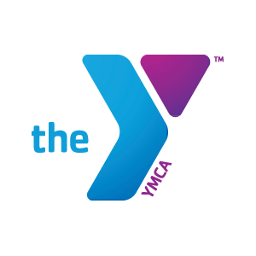

Head Swim Coach
Reports to: Executive Director
Salary Range: 35,568-38,000
FLSA Status: Exempt
Benefits: The YMCA of Greater Montgomery offers an amazing benefit package which includes health and dental insurance; competitive paid vacation time; 10% company paid retirement; and life and disability insurance.

The YMCA of Greater Montgomery Barracudas has been the premier swim team in the River Region since 1978. We provide youth the opportunity to participate in a year-round competitive USA/YMCA Swimming sports team that is dedicated to building athletes who are committed, have strong character and show great attitude. These are the same characteristics we seek in our Head Coach position.
The Head Swim Coach will guide the YMCA of Greater Montgomery’s year-round competitive swim program (100 swimmers ages 6-18).
Know How/Education/Experience:
- Applicant must have a strong background in competitive swimming, both as an athlete and as a coach.
- Applicant must have experience coaching swimmers at a national level or higher.
- Combination of three or more years related to experience, training, and education
- Bachelor's degree preferred
- Experience in registration and team software such as Teamunify, Touchpad, or Hytek preferred
- Must possess excellent communication skills

Licenses and Certifications:
Coach's certifications, including but not limited to, USA Swimming certifications and Principles of YMCA Swim Coaching preferred. ASCA membership, First Aid and CPR, Pool Operator, Lifeguarding, and Water Safety Instructor certifications preferred.

Principal Responsibilities:
- Responsible for all aspects of the competitive swim program.
- Develop and supervise training plans and schedules for the participants that will optimize their potential.
- Promotion and recruitment of swim team participants.
- Responsible for YMCA of Greater Montgomery Summer Swim League
- Hire, supervise, and train coaching staff. Work with assistant coaches to develop and administer appropriate training plans.
- Recruit and train volunteers.
- Assist with Registration for participants.
- Schedule, plan, host, and staff swim meets.
- Develop Swim Lesson Training Program and Curriculum.
- Responsible for fiscal management, which includes creating and maintaining budget.
- Responsible for fundraising.
- Responsible for High School Swimming Program with area High Schools.
- Responsible for the Masters Swim Program.
- Organize and work with the swim team parent committee.
- Work with other YMCA professionals to utilize their facilities.
- Teach lifeguarding classes.

Please submit a cover letter, resume and four letters of reference with contact information to:

Mona Martin
V. P. of Human Resources and Leadership Development
YMCA of GREATER MONTGOMERY
880 S. Lawrence Street
Montgomery, AL 36104
(P) 334 229 0018 (F) 334 593 8733
(E) mmartin@ymcamontgomery.org

