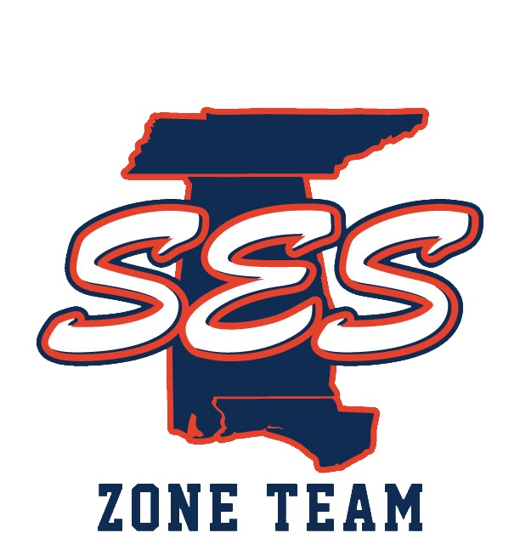
To: Southeastern Swimming Coaches/Parents

From: Caroline Bentley, Age Group Chair, SES

Date: June 18, 2019

Re: Age Group Zones Swimmers’ Application
____________________________________________________________

Age Group Zones is being held this year in Cary, NC. The trip is July 28 - August 4. The cost of the trip is $700. We will take the top 8 swimmers from SES in the 11-12 and 13-14 age groups. We will also select disabilities swimmers from these age groups.

Applications are now being taken for swimmers in these age groups. The link to apply is below and can also be found on the Southeastern Swimming home page (https://www.teamunify.com/Home.jsp?_tabid_=0&team=szsslsc) as well as the Southeastern Swimming Zone Team home page (https://www.teamunify.com/Home.jsp?_tabid_=0&team=sezone)

The link to apply is below - we will accept applications through Friday, July 19th at midnight. (Link to SES Zones Application and Information)

The link:

Thank you for your interest in this great trip!

