How to find the correct port for Meet Manager
- Once you connect the timing console and Meet Manager, do the following:
From the Run>Interfaces>Timer>Open/Close serial port. You will need to input a number between 0 and 60 for the port number. Most likely, there will already be a number in the space from the last meet. Before changing the number, “test communications” by clicking the test communication link. If it comes back as passed, there is no further action. If it does not pass, first check the cables to make sure they are tightly secured. If they are secured, you will need to identify the port number.
- To identify port number, type in “Device Manager” in Windows 10 as shown below:
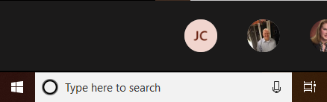

- Device Manager will then appear. Look for the entry that states Ports (Com & LPT)
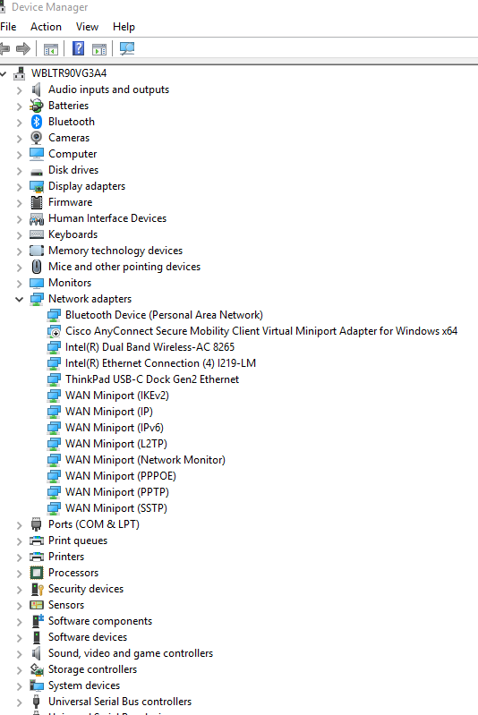

- If Ports (Com & LPT) is not visible, go to View at the top of the page, and on the pull-down menu, click “show hidden devices”.
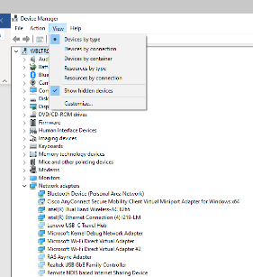

- Click the arrow next to Ports (Com & LPT) and expand. Take note of the com port in the next line. In this case, it is 3. Place 3 in the port number in Meet Manager and test communications. Communications should now pass. If not, check the cable connections. Once communications pass, you can send the meet file to the timing console.
