austin swim club
September Invitational Meet
ASC and ATAC
September 19, 2015

Sanction #: STA-15-79cm
Held under the sanction of USA Swimming

Venue: Austin Aquatics and Sports Academy
5513 Southwest Parkway
Austin, TX 78735
Map

Facility: If there was a competition for the fastest outdoor pool in Texas, we would want in, and we would demand lane four going into finals. This uniquely formatted meet will be conducted in the fastest eight 25yard lanes of our 20 available lanes. Waves will be squelched by the monstrous 6 inch Competitor lane lines allowing each swimmer to get their hand (or hands plural for fly and breast) onto the Colorado Timing touchpads with the least hydro-interference planet earth has to offer. Times will be recorded via Hytek’s Meet Manager.

Our pool is an outdoor facility with shade structures on two sides of the pool deck for coaches, officials, and athletes. Spectators will not have access to these two sides of the pool. We highly encourage sunscreen, especially for those that train indoors throughout the year. Partially shaded bleacher seating is available for 150 spectators on a first come, first reserve basis. Grass area will be available to accommodate the athletes and overflow of spectators. Chairs are welcome in this area. Tents are available behind the pool, outside of the fenced area.

We respectfully ask that spectators please only crowd around the pool deck when they are cheering for their child. Parents found on the concrete pool deck, not cheering, will be asked to time…as the two roles are similar in pool geographical positioning yet very different in support shown towards the athletes.

Our pool is a twenty-lane pool.
Warm down throughout the duration of the meet will be available in the ten lanes nearest to the building (north side). The meet will be held in the eight lanes furthest from the building (south side). The two lanes in-between will be blocked off during the competition.

Meet held in eight lanes.
Two “buffer” lanes.
Warm up and warm down in ten lanes

Facility
Parking: Coaches, Officials, and Volunteer parking available at the facility parking lot. Athlete drop off is allowed.
Address: 5513 Southwest Parkway
Austin, TX 78735 Map

Athlete and Spectator Parking at Adjacent Parking Garage – Textron Systems
Address: 5301 Southwest Parkway
Austin, TX 78735 Map

Water Depth: The minimum water depth, measured in accordance with Article 103.2.3, is 7
feet 1 inch at the start end and the turn end is 7 feet 1 inch measured for a distance of
1.0 meter to 5.0 meters from both end walls.

Course
Certification: The competition course has not been certified in accordance with 104.2.2C(4).

Facility Map:

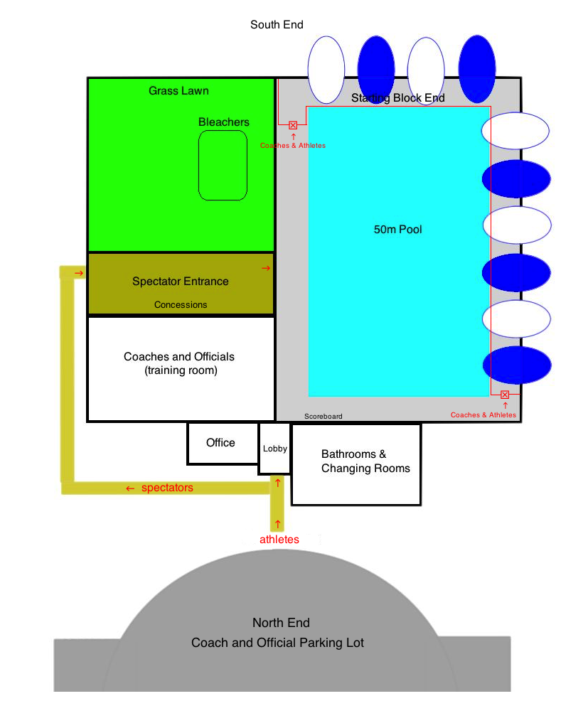

Sanction: Held under the sanction of USA Swimming. This meet has been sanctioned by South Texas Swimming and current USA Swimming rules and any relevant sections of the South Texas Policies & Procedures Manual will apply. Conduct of the sanctioned event shall conform in every respect to all technical and administrative rules of USA Swimming.

Liability: In granting this sanction it is understood and agreed that USA Swimming, Inc., South Texas Swimming, Inc. (STSI), the Austin Swim Club, the Austin Aquatics and Sports Academy, and all meet officials shall be free from any liabilities or claims for damages arising by reason of injuries to anyone during the conduct of the event. Damage to the facility, when proved, will cause the offending swimmer, if unattached, or the offending swimmer's club, if attached, to be held accountable for repairs.

USA Swimming
Registration: All swimmers, coaches, and officials participating in this competition must be currently 2015 registered with USA Swimming. All should also be prepared to present their USA Swimming ID Card as proof of their registration to the Meet Director or designee at any time. Swimmers who 1) late enter when possible; 2) need to be late-entered because of clerical errors by the entering team or the meet host; or 3) are not entered in this meet and choose to enter time trials, if offered, will be required to present their USA Swimming ID card (or a coach may present the club’s official, watermarked roster from the USA Swimming club portal). Current national and LSC regulations do not allow for exceptions to these policies.
South Texas Swimming does not allow on-deck USA Swimming registrations.

Meet Format: This is an open meet to all athletes registered with USA Swimming. Number of Athletes will be capped at 250. Our goal is to see some fast swimming, enjoy some great racing, and still have time for everyone to enjoy a majority of the weekend with family and friends. Heats will be seeded slowest to fastest and mixed gender with no lane separation between genders, to promote racing other athletes based solely on entry time. All events will start on the South end of the pool.

Heats will be timed finals seeded (the fastest 8 swimmers in the final heat) two days prior to the start of the meet. We reserve the right to conduct flyover starts if we feel that this is needed to limit the duration of the meet and can be effectively communicated to all of the coaches and athletes.

Nonconforming times will not be accepted.

The meet director reserves the right to conduct flyover starts or change warm-up/session start times depending on meet size.

This is an invitational meet open only to member of ASC and ATAC.

Inclement
Weather: In the event that inclement weather is expected for the weekend of the meet, the coaches of the attending teams will discuss the best plan for any needed changes to the event timeline. All updates will be provided on the event page here.

Qualifying
Times: There are no qualifying times for the meet.

Age up Date: The age of the swimmer will be his/her age on September 19, 2015.

Entry
Restrictions: Athletes may enter up to 5 total events for the day.

The following applies to all events:
There is no qualifying time and NT – “No Times” will be accepted, but for the sake of good racing we encourage all coaches to make their best estimation. Please convert all times to Short Course Yards.

Entry
Deadline: Entries Open on September 2, 2015, 2015 at noon. Entries will close at noon on September 7, 2015, once the 250-swimmer cap is reached, or to stay within the four-hour rule or another time limit. Whichever comes first.

Entry
Procedures: All teams must submit entries using Hy-Tek Team Manager or its equivalent to the Entries Chair. Email is the preferred method of delivery; if you need to submit entries in another format, please contact the Entries Chair to make other arrangements. Please rename the entry file to clearly identify the meet name and your club code. Include a Meet Entry Report of your entries, listing the swimmer, USA Swimming ID, and entries by swimmer name. Please rename the Meet Entry Report using your club code and the report name (such as ASC_EntriesByAthlete.pdf).

Athletes who wish to attend, independent of their team, may email their full name (as registered with USA Swimming), USA Swimming ID, team abbreviation, LSC, and entry times to the Entries Chair.

When submitting files to the Entries Chair, please include the name, email address, and phone number of the person submitting the entries. If you do not receive an email confirmation, your entries were not received.

Entry Fees: $16.75 per event. This covers the $15.50 event registration fee plus the STSI splash fee of $1.25 per event.

Please include the Meet Entry Fee Report with your payments. Entry fees must be received by the start of the meet or your entries will be removed from the meet. Refunds will not be given for any reason.

Make checks payable to:
Austin Aquatics and Sports Academy

Send checks to:
Austin Aquatics and Sports Academy
5513 Southwest Parkway
Austin, TX 78735

Deck/Late
Entries: Deck Entries will be accepted no later than 8:30 am.

Entries Chair: | Meet Director: | Meet Admin: | Meet Referee:
Martha Hansen | Margo Newcomer | Roland Smits | Trey Prinz
512.276.2324 | 512.276.2324 | 512. 415.7314 | 512.633.4851
martha@austinswimclub.org | admin  @austinswimclub.org | roland@patriotdetection.com | Trey.Prinz@netapp.com

Cell Phone
Restrictions: The presence or use of cell phones, smart phones, or any other devices capable of producing audio recordings and/or photographic or video images in locker rooms, restrooms, or changing areas is strictly and specifically prohibited at all times. There are no exceptions to this policy. Violators are subject to disqualification from the meet, disbarment from the facility, and arrest.

Unaccompanied
Swimmers: Any swimmer entered in the meet must be certified by a USA swimming member-coach as being proficient in performing a racing start or must start each race from within the water. When unaccompanied by a member-coach, it is the responsibility of the swimmer or the swimmer’s legal guardian to ensure compliance with this requirement. If your athlete will not be accompanied by a coach, please notify the meet director and the host club will ensure your child is properly accounted for.

Swimmer
Photographs
and Videos: There may be one or more photographers and/or videographers on deck at this meet. In the event such personnel are present, parents or guardians of swimmers under the age of 18 who do not wish to have photos or videos of their athletes made are required to contact the Meet Director prior to the beginning of warm-ups. Photographers and videographers are strongly encouraged to stay out of the area immediately behind the starting blocks, but if present are specifically prohibited from making shots during the start phase of any race.

Deck
Changing: Changing into or out of swimsuits other than in locker rooms or other designated areas is prohibited.

Special
Needs: Please notify the Meet Director in advance of this event with the name and age of any member on your team who needs assistance to enter the building. The facility staff will make reasonable accommodations for swimmers coaches, or spectators who wish to enter and use our facility. In any meet sanctioned or approved by South Texas Swimming, Inc., which may include one or more swimmers with visual, hearing, mental, or physical disabilities; the judging of such competitors shall be in strict accordance with the current USA Swimming Rules and Regulations, i.e., Article 105. A disability is defined as a PERMANENT physical or mental impairment that substantially limits one or more major life activities. Coaches and/or athletes must notify the Meet Referee before the event begins if they are to be considered to be judged under Article 105.

Officials: All currently (2015 or 2016) certified and in-training USA Swimming officials are cordially invited to participate. All deck officials must be registered with USA Swimming for 2015 or 2016 and have a current Background Check and Athlete Protection Course acknowledged by USA Swimming. Deck officials are required by rule to prominently display both their USA Swimming ID card and LSC credentials while on deck as an official. Please email the Meet Referee prior to the meet with your availability and current certifications. Please report to the Meet Referee at least one hour prior to the scheduled start time of any session to receive your assignments. The wearing of name tags is strongly encouraged.

Timers: Backup timers will be provided by the host club.
Please note: The front row of the bleachers will be reserved for 1 friend/family member of any timing volunteers. If member’s of your club are interested in timing simply email the meet director. Vacancies will be filled on a first come, first serve basis.

Awards: No Awards will be given.

Results: Results can be found online here or through Meet Mobile. We will do our best to promptly update the results.

Daily
Schedule: Warm-ups will be conducted in accordance with the current STSI Safety Guidelines and Warm-up Procedures attached to this meet announcement. Changes will be sent out by the meet director along with the heat sheet 2 days prior to the meet and will also be posted at the clerk of course the day of the meet. Starts/Dives will run from in one direction, starting from the starting block side.
Session One:
- Coaches meeting: 8:30am
- Warm Up: 9:00am-9:40am
  - Lanes 1-8 open
- Dives: 9:40am-9:55am
  - Lanes 2 & 7, one way
- Session Starts: 10:00am
- Time trials will not be held.

* The warm up for the afternoon sessions (sessions 2 & 4) will begin immediately after the conclusion of preceding morning session. The exact time can be found on the Austin Swim Club events page on September 19th, 2015 and will also be emailed to participating teams.

** Warm-up and Cool-Down during the meet – Please see the order of events below as the pool will be open to all athletes during the designated breaks.

Order of Events
Distances are in Short Course Yards

Session One: Saturday September 19th, 2015 Start: 10:00am
Warm Up: 9:00am-9:40am Dives: 9:40am-9:55am
Event # | Gender | Distance | Stroke | Age | Male Standard | Female Standard
1 | Mixed | 50 | Butterfly | 12&U | NA | NA
2 | Mixed | 100 | Butterfly | Open | NA | NA
3 | Mixed | 50 | Backstroke | 12&U | NA | NA
4 | Mixed | 100 | Backstroke | Open | NA | NA
5 | Mixed | 50 | Breaststroke | 12&U | NA | NA
6 | Mixed | 100 | Breaststroke | Open | NA | NA
7 | Mixed | 50 | Freestyle | 12&U | NA | NA
8 | Mixed | 100 | Freestyle | Open | NA | NA
9 | Mixed | 100 | I.M | 12&U | NA | NA
10 | Mixed | 200 | I.M. | Open | NA | NA
11 | Mixed | 200 | Freestyle | Open | NA | NA

Hotel
Information: La Quinta Inn & Suites Austin Southwest at Mopac
4424 South Mopac Expwy
Austin, TX 78735
(512) 899-3000

Extended Stay America Austin - Southwest
5100 US Hwy. 290 W
Austin, TX 78735
(512)892-4272

Holiday Inn Express & Suites Austin Sw - Sunset Valley
4892 Hwy 290
Sunset Valley, TX 78735
(512) 891-9500

Hampton Inn Austin/Oak Hill
6401 Hwy 290
Austin, TX 78735
(512) 891-7474

SOUTH TEXAS SWIMMING, Inc.

Safety Guidelines and Warm-up Procedures

A. WARM-UP PROCEDURES

I. Assigned Warm-up Procedures (Prelims)
a. Warm-up lanes and times will be assigned to competing teams based on number of entrants.
b. All warm-up activities will be coordinated by the coach(es) supervising that lane.
c. Dive sprints may be done only under the direct supervision of the coach.

II. Open Warm-up Procedures (Finals)

LANE USE
POOL | PUSH/PACE | DIVES/SPRINTS | GENERAL WARMUP
8 Lanes | 1 and 8 | 2 and 7 | 3 through 6
6 Lanes | 1 and 6 | 2 and 5 | 3 and 4

a. The first half of the assigned warm-up time shall be general warm-up for all lanes.
b. Push/Pace lanes will push off one or two lengths from starting end.
c. Sprint lanes are for diving from blocks or for backstroke starts in specified lanes at designated times—one way only.
d. Dive sprints may only be done under the direct supervision of the coach.
e. There will be no diving in the general warm-up lanes—circle swimming only.
f. No kickboards, pull buoys, or hand paddles may be used.

III. Safety Guidelines
a. Coaches are responsible for the following:

1. Instructing swimmers regarding safety guidelines and warm-up procedures as they apply to conduct at meets and practices.

2. Actively supervising their swimmers throughout the warm-up sessions, at meets, and all practices.

3. Maintaining as much contact with their swimmers AS POSSIBLE, both verbal and visual, throughout the warm-up period.
b. The host team will be responsible for the following:
1. A minimum of four marshals who report to and receive instructions from the Meet Referee and/or Director shall be on deck during the entire warm-up session(s).
2. Marshals will have the authority to remove from the deck for the remainder of a warm-up session, any swimmer or coach found to be in violation of these procedures.
3. The host team shall provide signs for each lane at both ends of the pool, indicating their designated use during warm-ups.
4. Warm-up times and lane assignments will be published in the meet information and posted at several locations around the pool area and the following statement will appear in the meet information: “South Texas Swimming Safety Guidelines and Warm-up Procedures will be in effect at this meet.”
5. An announcer will be on duty for the entire warm-up session to announce lane and/or time changes and to assist with the conduct of the warm-up.
6. Hazards in locker rooms, on deck, or in areas used by coaches, swimmers, or officials will be either removed or clearly marked.

B. MISCELLANEOUS NOTES

I. Backstrokers will ensure that they are not starting at the same time as a swimmer on the blocks. Swimmers shall not step up on the blocks if there is a backstroker waiting to start.

II. Swimmers shall not jump or dive into the pool to stop another swimmer on a recalled start.

III. Swimmers are required to exit the pool on completion of their warm-up to allow other swimmers adequate warm-up time. The pool is not for visiting or playing during the warm-up session.

IV. Warm-up procedures will be enforced for any breaks scheduled during the competition.

V. No hand paddles, fins, or kickboards may be used at any time during general, specific, or between warm-ups unless approved by the Meet Referee.

NOTE: Host Clubs, with the consent of the Meet Referee, may modify the time schedule or recommended lane assignments depending on pool configuration, number of swimmers, or other considerations; so long as safety considerations are not compromised. Any such changes will be announced and/or prominently posted in the pool area.

STSI Safety Guidelines and Warm-up Procedures last Revised 9/30/2013

