Waterloo Swimming
Waterloo BB and Slower Independence Meet
Sunday, July 2nd, 2017
(Invite for WLOO, ATAC, GOLD, TXLA Capped at 200 swimmers)

Date: Sunday, July 2, 2017. Warm-Up 1:00m; Meet begins 2:00pm

Entry
Deadline: Entries must be received by Wednesday, June 21, 2017 at noon (12:00pm) CST

Sanction #: Held under the sanction of USA Swimming
USA Swimming Sanction: STA-17-54cm

Venue: Waterloo Swim Center
12332 Ranch Road 620 N, Building C
Behind Bush’s Chicken and Public Storage
Austin, TX 78750
512-401-3404
(Note: Parking is limited at the swim center…see details in Facility)

Facility: Eight (8) lane 50-meter racing course with one (1) lane warm-up/down available.
A copy of Pool certification and measurement is on file with USA Swimming
Infinity starting system and Dolphin timing system will be used
Meet Management is latest HY-TEK version Meet Manager
Seating for participants will be on deck.
Seating for spectators will be in viewing room or through open windows (pending weather conditions). If weather permits tents and chairs will be permitted in certain parking spaces for participants and spectators.
No gum and red drinks are permitted on site.
Dressing and locker rooms available on site.
No tobacco, alcohol or firearms are permitted on site.
*** Parking is limited. Please carpool with others. If Waterloo’s lot is full, you will be directed to park on the Shenandoah Baptist Church field behind Waterloo Swim Center and walk through the field. The neighborhood street that the field is located on is Jackson Drive. Please DO NOT park in Shenandoah Baptist Church or at Bush’s Chicken parking lots***

Water Depth: The minimum water depth, measured in accordance with Article 103.2.3, is 5 feet, 2 inches at the start end and the turn end is 8 feet measured for a distance of 1.0 meter to 5.0 meters from both end walls.

Course
Certification: The competition course has been certified in accordance with 104.2.2C(4). The copy of such certification is on file with USA Swimming.

Sanction: Held under the sanction of USA Swimming. This meet has been sanctioned by South Texas Swimming. Current USA Swimming rules and any relevant sections of the South Texas Policies & Procedures Manual will apply. All swimmers must be registered as athletes for 2017 with USA Swimming by the meet start date. Athletes who register with USA Swimming after the meet entry deadline may deck enter the meet only if they can present their 2017 USA Swimming registration card, or proof of membership using the USA Swimming Deck Pass app (or a coach may present the club’s official, watermarked roster from the USA Swimming club portal). South Texas Swimming does not allow on-deck USA Swimming registrations. Conduct of the sanctioned event shall conform in every respect to all technical and administrative rules of USA Swimming.

Liability: In granting this sanction it is understood and agreed that USA Swimming, Inc., South Texas Swimming, Inc. (STSI), Waterloo Swimming, Waterloo Swim Center, and all meet officials shall be free from any liabilities or claims for damages arising by reason of injuries to anyone during the conduct of the event. Damage to the facility, when proved, will cause the offending swimmer, if unattached, or the offending swimmer's club, if attached, to be held accountable for repairs.

USA Swimming
Registration: All swimmers, coaches, and officials participating in this competition must be currently (2017) registered with USA Swimming. No swimmer will be permitted to compete unless the swimmer is a member as provided in Article 302. All should also be prepared to present their USA Swimming ID Card as proof of their registration to the Meet Director or designee at any time.
Swimmers who 1) late enter when possible; 2) need to be late-entered because of clerical errors by the entering team or the Meet Host; or 3) are not entered in this meet and choose to enter time trials, if offered, will be required to present their USA Swimming ID card or proof of membership using the USA Swimming Deck Pass app (or a coach may present the club’s official, watermarked roster from the USA Swimming club portal). Current national and LSC regulations do not allow for exceptions to these policies.

Meet Format: This is an Invite meet for only those swimmers attached or unattached to Waterloo Swimming (WLOO), Austin Trinity (ATAC), Texas Gold (GOLD), and Longhorn Aquatics (TXLA).
This will be a timed finals meet for BB and Slower events.
All events will be swum fastest to slowest reserving the right to run flyover starts, except backstroke.
The Meet Director and Meet Referee reserve the right to include additional breaks between events.
The Meet Director and Meet Referee reserve the right to combine events or heats, by age group, gender, distance or stroke, as needed.

The Meet Director and Meet Referee reserve the right to modify the operations of the meet, depending upon the number of entries. The Swim Meet is capped at 200 swimmers. We reserve the right to cap the number of swimmers entered in order to stay within the four hour rule. Swimmers will be entered in the order entries are received

Time
Trials: No Time Trials

Qualifying
Times: BB or Slower times only.
The qualifying time standards for all individual events are the traditional dual-age group 2017-2020 USA Swimming National Motivational BB times or slower.

NT are acceptable but please enter a time…make your best guess on a time

Age up Date: The age of the USA Swimming swimmer will be his/her age on July 2, 2017.

Entry
Restrictions: An individual swimmer may enter a maximum of three (3) individual

Entry
Procedures: All USA Swimming teams must submit entries using Hy-Tek Team Manager or its equivalent to the Entries Chair, Daniel Alvarez (daniel@waterlooswimming.com). Email is the preferred method of delivery; if you need to submit entries in another format, please contact the Entries Chair to make other arrangements. Please rename the entry file to clearly identify the meet name and your club code. Include a Meet Entry Report of your entries, listing the swimmer, USA Swimming ID, and entries by swimmer name. Please rename the Meet Entry Report using your club code and the report name (such as WLOO_EntriesByAthlete.pdf)

USMS athletes must email entries to the Entries Chair, Daniel Alvarez (daniel@waterlooswimming.com).

When submitting files to the Entries Chair, please include the name, email address, and phone number of the person submitting the entries. If you do not receive email confirmation, your entries were not received.

Entry Fees: $11.25 per individual event (includes the STSI splash fee of $1.25 per splash)

Please include a Meet Entry Fee report with your payment. Entry fees must be received by Friday, June 23, 2017 or your entries will be removed from the meet. Refunds will not be given for any reason.

Make checks payable to: Waterloo Swimming
Send checks to: Waterloo Swimming
9121 Evening Primrose Path
Austin TX 78750

Late Entries: $15.00 per event
Late Entries are accepted up to Wednesday, June 28, 2017 only for open lanes – no new heats will be created.
Swimmers not previously entered in the meet must present their 2017 USA Swimming ID card to deck enter or proof of membership using their USA Swimming Deck Pass app (or a coach can present their club official, watermark roster from the USA Swimming club portal) to late enter.

Meet Staff: Entries Chair: Daniel Alvarez 512-401-3404 daniel@waterlooswimming.com
Meet Director: Daniel Alvarez 512-401-3404 daniel@waterlooswimming.com
Meet Referee: Roland Smits 512-415-7314 roland@patriotdetection.com
Admin: Monica Thomason 512-769-9677 monica.thomason@gmail.com

Drones: Per USA Swimming Rule 103.13, the operation of a drone, or any other flying apparatus, is prohibited over the venue (pools, athlete/coach areas, spectator areas and open ceiling locker rooms) any time athletes, coaches, officials and/or spectators are present.” Exceptions may be granted with prior written approval by the Vice President of Program Operations.

Cell Phone
Restrictions: Use of audio or visual recording devices, including a cell phone, is not permitted in changing areas, rest rooms or locker rooms. There are no exceptions to this policy. Violators are subject to disqualification from the meet, disbarment from the facility, and arrest.

Unaccompanied
Swimmers: Any swimmer entered in the meet must be certified by a USA Swimming member-coach as being proficient in performing a racing start or must start each race from within the water. When unaccompanied by a member-coach, it is the responsibility of the swimmer or the swimmer’s legal guardian to ensure compliance with this requirement.

Swimmer
Photographs
and Videos: There may be one or more photographers and/or videographers on deck at this meet. In the event such personnel are present, parents or guardians of swimmers under the age of 18 who do not wish to have photos or videos of their athletes made are required to contact the Meet Director prior to the beginning of warm-ups. Photographers and videographers are strongly encouraged to stay out of the area immediately behind the starting blocks, but if present are specifically prohibited from making shots during the start phase of any race.

Deck
Changing: Deck changes are prohibited.

Special
Needs: A disability is defined as a PERMANENT physical or mental impairment that substantially limits one or more major life activities.
Please notify Waterloo Swimming at 512-401-3404 by the entry deadline of this event with the name and age of any member on your team who needs assistance to enter the building. The facility staff will make reasonable accommodations for swimmers coaches, or spectators who wish to enter and use our facility. In any meet sanctioned or approved by South Texas Swimming, Inc., which may include one or more swimmers with visual, hearing, mental, or physical disabilities; the judging of such competitors shall be in strict accordance with the current USA Swimming Rules and Regulations, i.e., Article 105. Coaches and/or athletes must notify the Meet Referee before the event begins if they are to be considered to be judged under Article 105.

Any swimmer expecting to use in-water starts or require assistance exiting the pool after competition, please notify the Meet Director so accommodations can be made.

Officials: All currently certified and in-training USA Swimming officials are cordially invited to participate. All deck officials must be registered with USA Swimming for 2017 and have a current Background Check and Athlete Protection Course acknowledged by USA Swimming. Deck officials are required by rule to prominently display both their USA Swimming ID Card while on deck as an official. Please email the Meet Referee prior to the meet with your availability and current certifications. Please report to the Meet Referee at least one hour prior to the scheduled start time of any session to receive your assignments. The wearing of name tags is strongly encouraged.

Timers: WLOO will provide timers for this meet.

Awards: No awards will be provided.

Daily
Schedule: Warm-ups will be conducted in accordance with the current STSI Safety Guidelines and Warm-up Procedures attached to this meet announcement. Separate lane(s) will be provided for USMS swimmers during pre-meet warm-up.

Coach’s Meeting: 12:45pm
Warm-Ups: 1:00pm
One Way Starts/Pace Lanes: 1:30pm
Officials Meeting: 1:00pm
Clear Competition Pool: 1:50pm
Meet Start Time: 2:00pm

Order of Events
Distances are in Long Course Meters (LCM)

Sunday, July 2, 2017 / 2:00pm

Girl’s Event # | Stoke and Distance | Age Group | Boy’s Event #
1 | 400 Freestyle | Open | 2
3 | 100 Backstroke | Open | 4
 | Break | Break
5 | 50 Butterfly | 12-Under | 6
7 | 200 Butterfly | Open | 8
9 | 100 Breaststroke | Open | 10
11 | 200 Freestyle | Open | 12
13 | 200 Individual Medley | Open | 14
 | Break | Break
15 | 50 Backstroke | 12-Under | 16
17 | 100 Butterfly | Open | 18
19 | 200 Backstroke | Open | 20
21 | 50 Freestyle | Open | 22
23 | 200 Breaststroke | Open | 24
 | Break | Break
25 | 50 Breaststroke | 12-Under | 26
27 | 100 Freestyle | Open | 28
29 | 400 Individual Medley | Open | 30
31 | 800 Freestyle | Open | 32

Break scheduled on the time timeline above will be a minimum of 10 minutes in length.
The Meet Referee may at his/her discretion add breaks between events depending on the timeline.

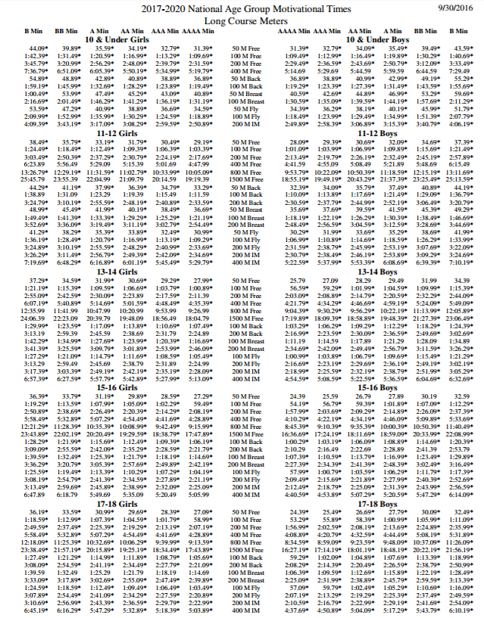

SOUTH TEXAS SWIMMING, Inc.

Safety Guidelines and Warm-up Procedures

A. WARM-UP PROCEDURES

I. Assigned Warm-up Procedures
a. Warm-up lanes and times will be assigned to competing teams based on number of entrants.
b. All warm-up activities will be coordinated by the coach(es) supervising that lane.
c. Dive sprints shall occur from only the designated end of the pool, swimmers must exit on the opposite end of the pool, and may be done only under the direct supervision of the coach.

II. Open Warm-up Procedures

LANE USE
POOL | PUSH/PACE | DIVES/SPRINTS | GENERAL WARMUP
10 Lanes | 1 and 10 | 2 and 9 | 3 through 8
8 Lanes | 1 and 8 | 2 and 7 | 3 through 6
6 Lanes | 1 and 6 | 2 and 5 | 3 and 4

a. The first half of the assigned warm-up time shall be general warm-up for all lanes.
b. Push/Pace lanes will push off one or two lengths from starting end.
c. Sprint lanes are for diving from blocks or for backstroke starts in specified lanes at designated times and from the designated end. Swimmers must exit the pool on the opposite end.
d. There will be no diving in the general warm-up lanes—circle swimming only.
e. No kickboards, pull buoys, or hand paddles may be used.

III. Safety Guidelines
a. Coaches are responsible for the following:

1. Instructing swimmers regarding safety guidelines and warm-up procedures as they apply to conduct at meets and practices.

2. Actively supervising their swimmers throughout the warm-up sessions, at meets, and all practices.

3. Maintaining as much contact with their swimmers AS POSSIBLE, both verbal and visual, throughout the warm-up period.
b. The host team will be responsible for the following:
1. A minimum of four marshals who report to and receive instructions from the Meet Referee and/or Director shall be on deck during the entire warm-up session(s).
2. Marshals will have the authority to remove from the deck for the remainder of a warm-up session, any swimmer or coach found to be in violation of these procedures.
3. The host team shall provide signs for each lane at both ends of the pool, indicating their designated use during warm-ups.
4. Warm-up times and lane assignments will be published in the meet information and posted at several locations around the pool area and the following statement will appear in the meet information: “South Texas Swimming Safety Guidelines and Warm-up Procedures will be in effect at this meet.”
5. An announcer will be on duty for the entire warm-up session to announce lane and/or time changes and to assist with the conduct of the warm-up.
6. Hazards in locker rooms, on deck, or in areas used by coaches, swimmers, or officials will be either removed or clearly marked.

B. MISCELLANEOUS NOTES

I. Backstrokers will ensure that they are not starting at the same time as a swimmer on the blocks. Swimmers shall not step up on the blocks if there is a backstroker waiting to start.

II. Swimmers shall not jump or dive into the pool to stop another swimmer on a recalled start.

III. Swimmers are required to exit the pool on completion of their warm-up to allow other swimmers adequate warm-up time. The pool is not for visiting or playing during the warm-up session.

IV. Warm-up procedures will be enforced for any breaks scheduled during the competition.

V. No hand paddles, fins, or kickboards may be used at any time during general, specific, or between warm-ups unless approved by the Meet Referee.

NOTE: Host Clubs, with the consent of the Meet Referee, may modify the time schedule or recommended lane assignments depending on pool configuration, number of swimmers, or other considerations; so long as safety considerations are not compromised. Any such changes will be announced and/or prominently posted in the pool area.

STSI Safety Guidelines and Warm-up Procedures last Revised 10/9/2016

