austin swim club

Austin Swim Club
2017 ASC Snowman Scramble
A Short Course Yards Timed Final Event
December 17, 2017

Sanction: STA-17-107
Held under the sanction of USA Swimming.

Venue: Austin Aquatics and Sports Academy
5513 Southwest Parkway
Austin, Texas 78735
Map

Facility: Tired of slow swimming in a slow pool. With band aids and gobs of hair passing you by? Austin Swim Club has the answer. With 8 of the fastest racing lanes in the great state of Texas, ASC invites you to compete in the 2017 ASC September Splash. Waves will be squelched by the monstrous 6 inch Competitor lane lines allowing each swimmer to get their hand(s) onto the Colorado Timing touchpads with the least hydro-interference planet earth has to offer. Times will be recorded via Hy-Tek’s Meet Manager software.

Austin Aquatics and Sports Academy is an outdoor facility with shade structures on two sides of the pool deck for coaches, officials, and athletes. Spectators will not have access to these sides of the pool. We highly encourage sunscreen. Partially shaded bleacher seating is available for 150 spectators on a first come, first serve basis. Grass area will be available to accommodate the athletes and overflow of spectators. Chairs are welcome in this area. Tents are available behind the pool, outside the fenced area.

Our pool is a twenty-lane, short course yards pool. Warm down throughout the duration of the meet will be available in the ten lanes nearest the building (north side). The meet will be held in the eight lanes furthest from the building (south side). The two lanes in-between will be blocked off during the competition. See diagram:

Meet held in eight lanes.
Two “buffer” lanes.
Warm up and warm down in ten lanes.

Facility
Parking: Coaches, Officials, and Volunteer parking available at the facility parking lot. Athlete drop off is allowed:
5513 Southwest Parkway
Austin, Texas 78735
Map

Athlete and spectator parking at adjacent parking garage – ARM Building
5515 Southwest Parkway
Austin, Texas 78735

Water Depth: The minimum water depth, measured in accordance with Article 103.2.3, is 7 feet 1 inch at the start end and the turn end is 7 feet 1 inch measured for a distance of 1.0 meter to 5.0 meters from both end walls.

Course
Certification: The competition course has not been certified in accordance with 104.2.2C(4)

Sanction: Held under the sanction of USA Swimming. This meet has been sanctioned by South Texas Swimming and current USA Swimming rules and any relevant sections of the South Texas Policies & Procedures Manual will apply. All swimmers must be registered as athletes for 2017 or 2018 with USA Swimming by the meet start date. Athletes who register with USA Swimming after the meet entry deadline may deck enter the meet only if they can present their 2017 or 2018 USA Swimming registration card or proof of membership using the USA Swimming Deck Pass app (or a coach may present the club’s official, watermarked roster from the USA Swimming club portal. Conduct of the sanctioned event shall conform in every respect to all technical and administrative rules of USA Swimming.

Liability: In granting the sanction it is understood and agreed that USA Swimming, Inc., South Texas Swimming, Inc. (STSI), the Austin Swim Club (ASC), the Austin Aquatics and Sports Academy (AASA), and all meet officials shall be free from any liabilities of claims for damages arising by reason of injuries to anyone during the conduct of the event. Damage to the facility, when proved, will cause the offending swimmer, if unattached, or the offending swimmer’s club, if attached, to be held accountable for repairs.

USA Swimming
Registration: All swimmers, coaches, and officials participating in this competition must be currently (2017 or 2018) registered with USA Swimming. No swimmer will be permitted to compete unless the swimmer is a member as provided in Article 302. All should also be prepared to present their USA Swimming ID Card as proof of their registration to the Meet Director or designee at any time. Swimmers who 1) late enter when possible; 2) need to be late-entered because of clerical errors by the entering team or the meet host; or 3) are not entered in this meet and choose to enter time trials, if offered, will be required to present their USA Swimming ID Card or proof of membership using the USA Swimming Deck Pass app (or coach my present the club’s official, watermarked roster from the USA Swimming club portal). Current national and LSC regulations do not allow for exceptions to these policies. South Texas Swimming does not allow on-deck USA Swimming registrations.
Meet Format: This meet is an open meet to all athletes. Number of athletes will be capped at 500 or when the 4 hour time limit is reached and entered as entries are received. All events will be mixed gender events and seeded by entry time, not gender. There will be no lane separation of gender, and heats will be seeded fastest to slowest. Events will be swum combined but scored separately as 10 & Under, 11-12, and 13-14. All events will start on the South end of the pool.

Heats will be timed finals seeded (8 fastest swimmers in the final heat) two days prior to the start of the meet. Deck entries will be entered only as to fill empty lanes.

The meet director reserves the right to combine heats or events as needed and the right to conduct flyover starts or change warm-up/session start times depending on meet size.

Inclement
Weather: In the event that inclement weather is expected for the weekend of the meet, the coaches of the attending teams will discuss the best plan for any needed changes to the event timeline, potentially postponing the meet until later in the day when inclement weather has passed.

Qualifying
Times: There are no qualifying times.

Age
Restrictions: Swimmers must be 14 years of age or younger.

Age Up Date: The age of the swimmer will be his/her age on December 17, 2017.

Entry
Restrictions: Athletes may enter a maximum of 5 individual events.

There is no qualifying times and NT – “No Times” will be accepted, however, for the sake of good racing we encourage all coaches to make their best estimation.

Entry
Deadline: Entries will close at noon on Friday, December 15, 2017 at 4:00 pm, once the 500 swimmer cap is reached, or to stay within the four-hour rule. Whichever comes first.

Entry
Procedures: All USA Swimming teams must submit entries using Hy-Tek Team Manager or its equivalent to the Entries Chair, Martha Hansen ( Martha@austinswimclub.org ). Email is the preferred method of delivery; if you need to submit entries in another format, please contact the Entries Chair to make other arrangements. Please rename the entry file to clearly identify the meet name and your club code. Include a Meet Entry Report of your entries, listing the swimmer, USA Swimming ID, and entries by swimmer name. Please rename the Meet Entry Report using your club code and the report name (such as ASC_EntriesByAthlete.pdf)

Athletes who wish to attend, independent of their team, my email their full name (as registered with USA Swimming), USA Swimming ID, team abbreviation, LSC, and entry times to the Entries Chair.

When submitting files to the Entries Chair, please include the name, email address, and phone number of the person submitting the entries. If you do not receive email confirmation, your entries were not received.

Time Trials: There will be no time trials for this event.

Entry Fees: $9.25 per individual event. This includes the $1.25 South Texas Swimming splash fee. There will be an athlete surcharge of $2.00 per swimmer.

Please include the Meet Entry Fee Report with your payments. Entry fees must be postmarked by Thursday, December 14, 2017 or your entries will be removed from the meet. Please send only one check per team location. Refunds will not be given for any reason.

Make checks payable to:
Austin Aquatics and Sports Academy

Send checks to:
Austin Aquatics and Sports Academy
5513 Southwest Parkway
Austin, Texas 78735

Deck
Entry Fees: $20.00 per event. This includes the $1.25 South Texas Swimming splash fee.

Deck/Late
Entries: Please scratch any event a swimmer does not plan on swimming the next day. Deck entries will only be accepted for open lanes. No new heats will be created. There is not a penalty for failing to scratch an event; this is simply a courtesy to the other swimmers to eliminate the empty lane.

Meet Referee: Roland Smits 512.415.7314 roland@patriotdetection.com

Admin Official: Lalli Halm 512.292.3806 mandchalm@sbcglobal.net

Head Coach: Brendan Hansen 512.276.2324 Brendan@austinswimclub.org

Meet Director: Nate Chessey 512.276.2324 natec@austinswimclub.org

Entries Chair: Martha Hansen 512.276.2324 Martha@austinswimclub.org

Cell Phone
Restrictions: Use of audio or visual recording devices, including a cell phone, is not permitted in changing areas, rest rooms, or locker rooms. There are no exceptions to this policy. Violators are subject to disqualification from the meet, disbarment from the facility, and arrest.

Racing Start
Proficiency
(Unaccompanied
Swimmers): Any swimmer entered in the meet must be certified by a USA Swimming member-coach as being proficient in performing a racing start or must start each race from within the water. When accompanied by a member-coach, it is the responsibility of the swimmer or the swimmer’s legal guardian to ensure compliance with this requirement. If your athlete will not be accompanied by a coach, please notify the meet director and the host club will ensure your child is properly accounted for.

Swimmer
Photographs
And Videos: There may be one or more photographers and/or videographers on deck at this meet. In the event such personnel are present, parents or guardians of swimmers under the age of 18 who do not wish to have photos or videos of their athletes made are required to contact the Meet Director prior to the beginning of warm-ups. Photographers and videographers are strongly encouraged to stay out of the area immediately behind the starting blocks, but if present are specifically prohibited from making shots during the start phase of any race.

Drones: Per USA Swimming Rule 103.13, the operation of a drone, or any other flying apparatus, is prohibited over the venue (pools, athlete/coach areas, spectator areas and open ceiling locker rooms) any time athletes, coaches, officials and/or spectators are present.” Exceptions may be granted with prior written approval by the Vice President of Program Operations.

Deck
Changing: Deck changes are prohibited.

Special Needs: Please notify the Meet Director, Nate Chessey 512.276.2324, in advance of this event with the name and age of any member on your team who needs assistance to enter the building. The facility staff will make reasonable accommodations for swimmers, coaches, or spectators who wish to enter and use our facility. In any meet sanctioned or approved by South Texas Swimming, Inc., which may include one or more swimmers with visual, hearing, mental, or physical disabilities; the judging of such competitors shall be in strict accordance with the current USA Swimming Rules and Regulations, i.e., Article 105. A disability is defined as a PERMANENT physical or mental impairment that substantially limits one or more major life activities. Coaches and/or athletes must notify the Meet Referee before the event begins if they are to be considered to be judged under Article 105.

Officials: All currently certified and in-training USA Swimming officials are cordially invited to participate. All deck officials must be registered with USA Swimming for 2017 or 2018 and have a current Background Check and Athlete Protection Course acknowledged by USA Swimming. Deck officials are required by rule to prominently display both their USA Swimming ID Card and LSC credentials while on deck as an official. Please email the Meet Referee prior to the meet with your availability and current certifications. Please report to the Meet Referee at least one hour prior to the scheduled start time of any session to receive your assignments. The wearing of name tags is strongly encouraged.

Timers: Teams should come prepared with volunteer timers if called upon.

Awards: No awards will be given at this meet.

Results: Results can be found on Meet Mobile.

Daily
Schedule: Warm-ups will be conducted in accordance with the current STSI Safety Guidelines and Warm-up Procedures attached to this meet announcement. Upon approval by all coaches, changes will be sent out by the Meet Director along with the heat sheet 2 days prior to the meet and will also be posted at the Clerk of Course the day of the meet. Starts/Dives will run from in one direction, starting from the starting block side.

Sunday Warm Up: 9:00 am Clear Pool: 9:50 Start: 10:00 am

Coaches Meeting: If the Meet Director and Meet Referee find it necessary to have a coaches meeting an announcement will be made stating the time and meeting place during warm-ups.

Hotel
Information: La Quinta Inn & Suites Austin Southwest at Mopac
4424 South Mopac Expwy
Austin, TX 78735
(512) 899-3000

Extended Stay America Austin - Southwest
5100 US Hwy. 290 W
Austin, TX 78735
(512) 892-4272

Holiday Inn Express & Suites Austin SW - Sunset Valley
4892 Hwy 290
Sunset Valley, TX 78735
(512) 891-9500

Hampton Inn Austin/Oak Hill
6401 Hwy 290
Austin, TX 78735
(512) 891-7474

2017 ASC Snowman Scramble: Order of Events
All events will be swum in SCY

SESSION ONE

EVENT NUMBER | EVENT
1 | 12 & Under 100 IM
2 | 14 & Under 50 Free
3 | 14 & Under 100 Fly
4 | 12 & Under 50 Breast
5 | 14 & Under 100 Back
6 | 14 & Under 200 Free
7 | 14 & Under 100 Breast
8 | 12 & Under 50 Back
9 | 14 & Under 100 Free
10 | 12 & Under 50 Fly
11 | 14 & Under 200 IM
12 | 14 & Under 1650 Free
Events will be swum combined but scored separately as 10 & Under, 11-12, and 13-14.

Facility Map:
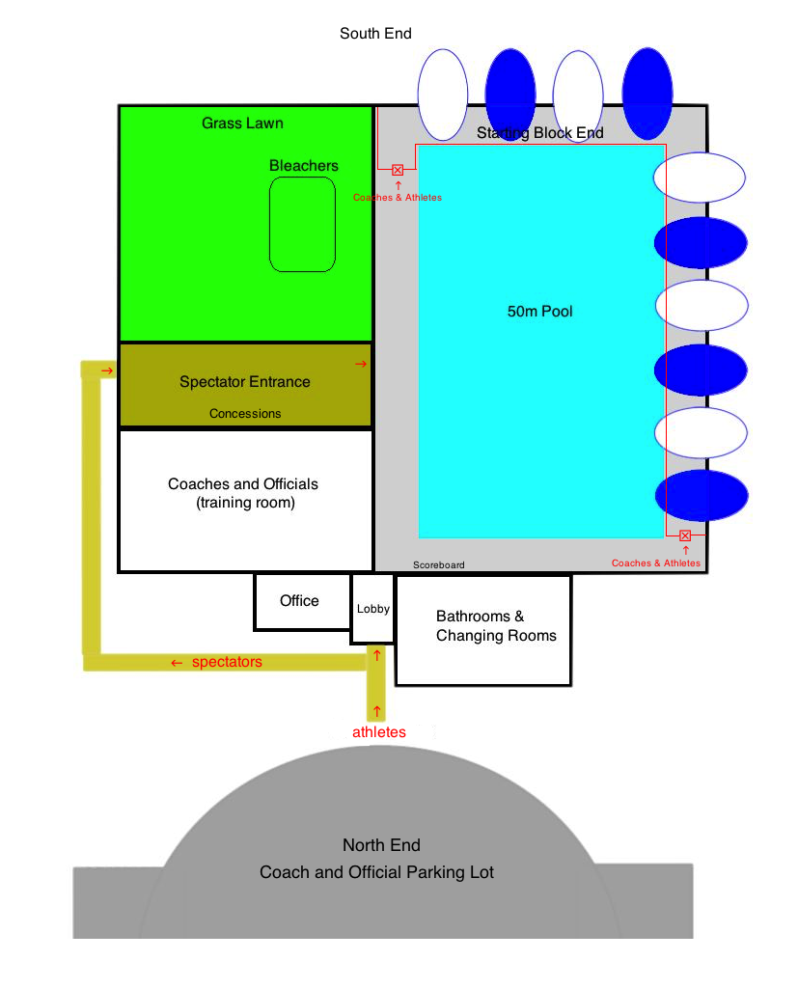

SOUTH TEXAS SWIMMING, Inc.

Safety Guidelines and Warm-up Procedures

A. WARM-UP PROCEDURES

I. Assigned Warm-up Procedures
a. Warm-up lanes and times will be assigned to competing teams based on number of entrants.
b. All warm-up activities will be coordinated by the coach(es) supervising that lane.
c. Dive sprints may be done only under the direct supervision of the coach.

II. Open Warm-up Procedures

LANE USE
POOL | PUSH/PACE | DIVES/SPRINTS | GENERAL WARMUP
8 Lanes | 1 and 8 | 2 and 7 | 3 through 6
6 Lanes | 1 and 6 | 2 and 5 | 3 and 4

a. The first half of the assigned warm-up time shall be general warm-up for all lanes.
b. Push/Pace lanes will push off one or two lengths from starting end.
c. Sprint lanes are for diving from blocks or for backstroke starts in specified lanes at designated times—one way only.
d. Dive sprints may only be done under the direct supervision of the coach.
e. There will be no diving in the general warm-up lanes—circle swimming only.
f. No kickboards, pull buoys, or hand paddles may be used.

III. Safety Guidelines
a. Coaches are responsible for the following:

1. Instructing swimmers regarding safety guidelines and warm-up procedures as they apply to conduct at meets and practices.

2. Actively supervising their swimmers throughout the warm-up sessions, at meets, and all practices.

3. Maintaining as much contact with their swimmers AS POSSIBLE, both verbal and visual, throughout the warm-up period.
b. The host team will be responsible for the following:
1. A minimum of four marshals who report to and receive instructions from the Meet Referee and/or Director shall be on deck during the entire warm-up session(s).
2. Marshals will have the authority to remove from the deck for the remainder of a warm-up session, any swimmer or coach found to be in violation of these procedures.
3. The host team shall provide signs for each lane at both ends of the pool, indicating their designated use during warm-ups.
4. Warm-up times and lane assignments will be published in the meet information and posted at several locations around the pool area and the following statement will appear in the meet information: “South Texas Swimming Safety Guidelines and Warm-up Procedures will be in effect at this meet.”
5. An announcer will be on duty for the entire warm-up session to announce lane and/or time changes and to assist with the conduct of the warm-up.
6. Hazards in locker rooms, on deck, or in areas used by coaches, swimmers, or officials will be either removed or clearly marked.

B. MISCELLANEOUS NOTES

I. Backstrokers will ensure that they are not starting at the same time as a swimmer on the blocks. Swimmers shall not step up on the blocks if there is a backstroker waiting to start.

II. Swimmers shall not jump or dive into the pool to stop another swimmer on a recalled start.

III. Swimmers are required to exit the pool on completion of their warm-up to allow other swimmers adequate warm-up time. The pool is not for visiting or playing during the warm-up session.

IV. Warm-up procedures will be enforced for any breaks scheduled during the competition.

V. No hand paddles, fins, or kickboards may be used at any time during general, specific, or between warm-ups unless approved by the Meet Referee.

NOTE: Host Clubs, with the consent of the Meet Referee, may modify the time schedule or recommended lane assignments depending on pool configuration, number of swimmers, or other considerations; so long as safety considerations are not compromised. Any such changes will be announced and/or prominently posted in the pool area.

STSI Safety Guidelines and Warm-up Procedures last Revised 9/30/2013

