Pre-Employment Screening Program Summary
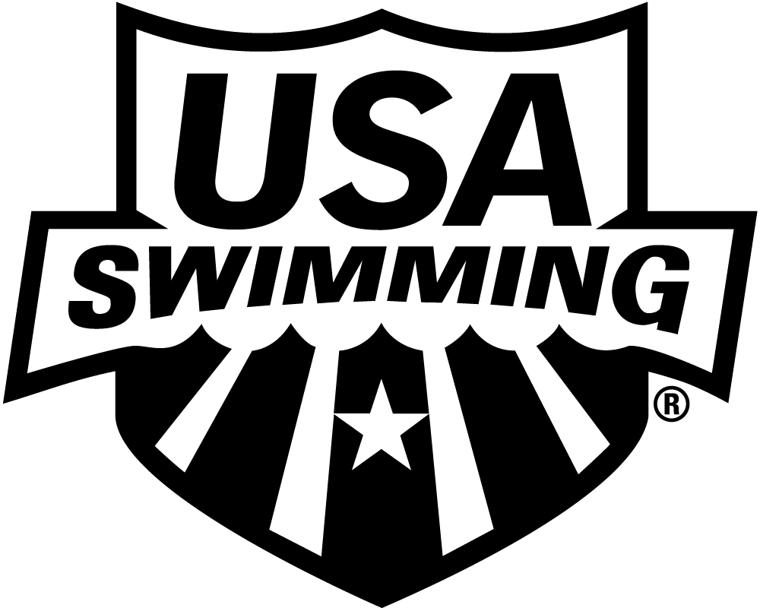

General Information
At the 2010 USAS Convention the USA Swimming House of Delegates approved a series of rules regarding the Athlete Protection Program. One of these measures was Article 502.6.8 which requires clubs to comply with USA Swimming’s Pre-Employment Screening program. The new requirement is effective August 31, 2011. This document is intended to explain the new program and provide clubs with the information related to the pre-employment screening requirement.
Purpose
Clubs are responsible for hiring and supervising their own coaches and staff, and managing their own volunteers. USA Swimming does not hire, supervise, or manage a club’s employment relationship with its coaches, staff, or volunteers, as that is an independent responsibility of the club. The pre-employment screening program requires clubs to certify to USA Swimming that they have conducted certain pre-employment checks for covered individuals. Note that USA Swimming’s Background Check Program is a criminal record search and is not a substitute for a club conducting appropriate pre-employment inquiries. Clubs should carefully check references and previous employers and verify information provided by the applicant using available screening resources.
Requirement
Under Article 502.6.8 of the USA Swimming rulebook, all clubs are required to comply with the USA Swimming Pre-Employment Screening Procedures for New Employees for all new employees, hired after August 31, 2011, who are required to be USA Swimming members under Article 305.4 and 502.6.3.
Required Pre-Employment Screening Procedures
This section describes the required components of the Pre-Employment Screening program.
As a condition of membership in USA Swimming, member clubs are required to conduct the following pre-employment screens on their new employees who are required to be USA Swimming members by USA Swimming rules.
- Past Employment Reference Checks or Verifications. Where there have been multiple employers, minimum of the 3 most recent employers.
- Education Verification (highest held)
- State Motor Vehicle Report Examination
The club should carefully review and evaluate the information gathered as part of making a final decision to offer employment to a candidate. The screening process should be completed before the employee is officially hired and begins employment.
Additional Recommended Screening Procedures
In addition to the three screening procedures outlined above, the program originally approved by the Board of Directors includes some additional recommended screening procedures. Implementation of the recommended pre-employment screening procedures is delayed until September 30, 2011 to give the USA Swimming Board of Directors a chance to review the entire program at the USAS Convention on September 13-17, 2011. Only the required screening procedures outlined in the previous section will be effective August 31, 2011.
Recommended Providers
USA Swimming has identified three nationally-recognized companies that can assist clubs with fulfilling the requirements of the Pre-Employment Screening program. These companies are accredited consumer reporting agencies that have agreed to provide the required services at preferred pricing for USA Swimming clubs. In addition to providing the required services, these companies are able to assist clubs with fulfilling mandated employer obligations related to the screening process.
The three providers recommended by USA Swimming are:
- Acxiom (Cleveland, OH)
- BackgroundChecks.com (Dallas, TX)
- Frasco Profiles (Burbank, CA)
Although recommended by USA Swimming, clubs are not required to use these vendors as there are several options available for implementing the Pre-Employment Screening Program.
- Clubs can choose to work with any of the three recommended companies;
- Clubs may also utilize another consumer reporting agency of their choice; or
- Clubs can use a provider to gather some of the information and rely on their own resources for gathering other information. For example, a club might choose to contact employment references themselves while utilizing a vendor to verify education and obtain a motor vehicle report.
To learn more about each company and their services, please view the PDF promotional flyers and/or the links to each vendor’s website as provided on the Pre-Employment Screening landing page on the USA Swimming website. The USA-S website landing page link is: www.usaswimming.org/preemploymentscreens.
The provider link will take clubs to the vendor website and a special landing page for the pre-employment screening program. The vendor’s landing page provides all necessary information and access to required forms for clubs to create an account and initiate service with that vendor. Regardless of what provider the club uses, USA Swimming is not a party to the relationship and, therefore, cannot be responsible for the services provided.
Cost
The cost of the three required screening procedures – past employment reference checks, education verification, and state motor vehicle report examination – will include the provider’s base fee for each service plus any additional fees charged by employment reference services, educational institutions, or states. The following chart provides an outline of the range of potential fees that clubs may pay for each candidate that is screened:
Employment References: $6.45 - $6.95 provider fee plus $0 - $12.50 additional fee
Education Verification: $6.45 - $6.95 provider fee plus $0 - $21.00 additional fee
Motor Vehicle Report: $1.95 - $3.00 provider fee plus $2.00 - $15.00 state fee *
*Three states – Hawaii, Oklahoma, and Rhode Island –charge higher fees for motor vehicle reports. In these states, the total cost could be higher than the range provided above.
For example , a club that chooses to use a provider to do an education verification and a motor vehicle report could pay about $8.45 in base fees plus up to another $36.00 in additional fees. Specific cost information is available on the provider landing pages.
Key Program Details
- The Pre-Employment Screening program requirement goes into effect on August 31, 2011. After that date, clubs must conduct the three required pre-employment screening procedures for all new employees who must be non-athlete members of USA Swimming.
- Clubs are responsible for complying with applicable laws regarding obtaining an applicant’s authorization to request information from various sources to evaluate their suitability for employment at the club. The recommended vendors will provide the necessary consent form.
- In order to utilize screening services, clubs will establish an account with the screening provider of their choice. USA Swimming is not a party to these transactions.
- Clubs are not required to use one of the recommended service providers.
- Clubs are also not required to contract for services that they would rather perform themselves, but remain subject to applicable regulations governing certain data, such as motor vehicle reports.
- The recommended companies will provide the required screening procedures ‘a la carte.’ Clubs can order the services of their choice from the vendor of their choice. The recommended companies also provide access to compliance information and federal- and state-mandated employer obligations.
- As the employer, it the club’s responsibility to evaluate the screening information and utilize that information to make a hiring decision that reflects the club’s values and standards. USA Swimming does not mandate employment criteria, evaluate candidates or screening information under this program, or provide advice to clubs regarding their hiring decisions or supervision responsibilities.
- In order to comply with the pre-employment screening program, a club representative must certify on the annual club membership application that the club is conducting pre-employment screening as required by Article 502.6.8 in the USA Swimming rulebook. Failure to certify and sign this section of the club application form will result in the club application being rejected.
- As the employer, clubs may be subject to a variety of federal and state regulations governing the protection and maintenance of employee records. Clubs should consult human resource professionals to establish appropriate policies to safeguard employee records. Nothing in USA Swimming’s program should be interpreted as a mandate or warranty in this area.
- USA Swimming assumes no responsibility for a club’s compliance with this rule or any applicable state, local, or federal duties relating to a club’s status as an employer or supervisor of staff, coaches, or volunteers. Compliance with USA Swimming’s Program is not a guaranty that a club’s pre-employment screening is adequate or complete, and the obligation remains solely on clubs to screen, hire, supervise and manage its employees and volunteers, regardless of their additional status as USA Swimming members. USA Swimming is not responsible for the content of external internet sites.
For More Information
Please refer to the Frequently Asked Questions available on the USA Swimming website at www.usaswimming.org/preemploymentscreens.
If you have additional questions after reviewing the FAQ document, please contact preemploymentscreening@usaswimming.org.

Created 8/30/11

