Monday July 26
Depart from the WVU Coliseum in Morgantown, WV 6:00 AM
Depart from the Walmart in Clarksburg, WV 6:45 AM (outer edge of parking lot next to road)
Depart University of Charleston in Charleston, WV 8:45 AM
Stop around Lexington, KY for meal.
Stop around Nashville, TN for meal.
Arrive Tupelo, MS
~If early enough we will go straight to the Tupelo Aquatic Center for practice, if not we will go straight to the hotel.

Tuesday July 27
Depart hotel and go to the Tupelo Aquatic Center at 11:30 AM.
Depart Tupelo Aquatic Center at the conclusion of competition and return to hotel. Time TBA.

Wednesday - Saturday July 28-31
Depart hotel and go to the Aquatic Center at 7:30 AM.
Depart Aquatic Center at conclusion of competition and return to hotel. Time TBA.
Depart hotel and go to the Aquatic Center at 3:30 PM.
Depart Aquatic Center at conclusion of competition and return to hotel. Time TBA.

Sunday August 1
Depart Tupelo, MS at 6:00 AM.
Stop around Nashville, TN for meal.
Stop around Lexington, KY for meal.
Arrive Charleston, WV for drop off at the University of Charleston in Charleston, WV.
Arrive Clarksburg, WV for drop off at the Walmart. (outer edge of parking lot next to road)
Arrive WVU Coliseum in Morgantown, WV for drop off.

Addresses
Tupelo Aquatic Center 692 North Veterans Blvd Tupelo, MS 38804
Fairfield Inn & Suites Marriott 3070 Tom Watson Rd. Tupelo, MS 38866
Walmart 550 Emily Dr, Clarksburg, WV 26301
University of Charleston 2300 MacCorkle Ave SE, Charleston, WV 25304
WVU Coliseum 3450 Monongahela Blvd. Morgantown, WV 26505

WVU Coliseum. The red X indicates the general pick up area. This is the lower lot where the old Natatorium used to be.
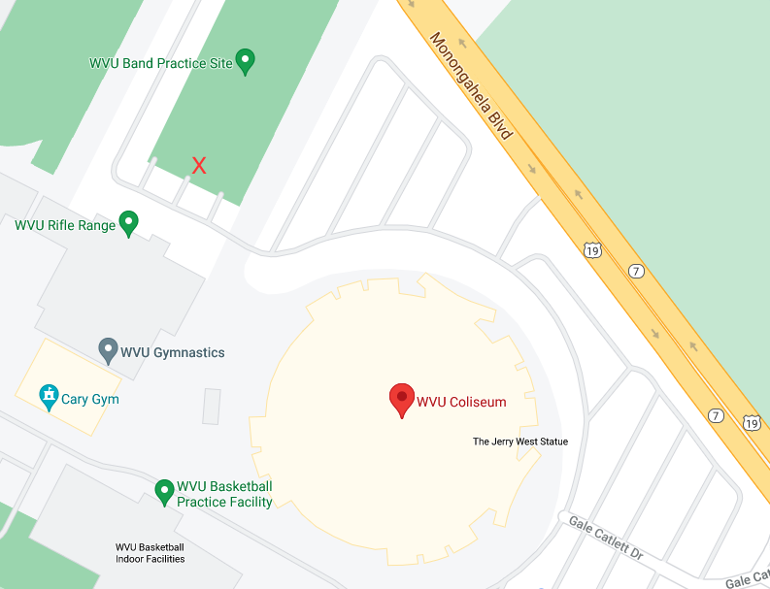

Walmart Clarksburg. The red X indicates the general pick up area. 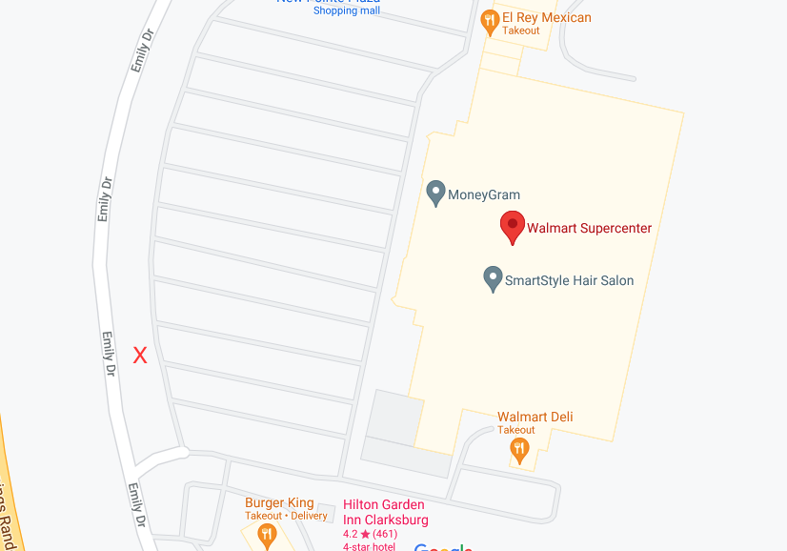

University of Charleston. The red X indicates the general pick up area. NOTICE… I did not put an X on the map because I’m not 100% sure where the bus will be able to park the easiest. More than likely near the Pharmacy School, but it will be at the driver’s discretion. Do Not Leave Cars at UC.
