**CHAMPIONSHIP T-SHIRT ORDER FORM**

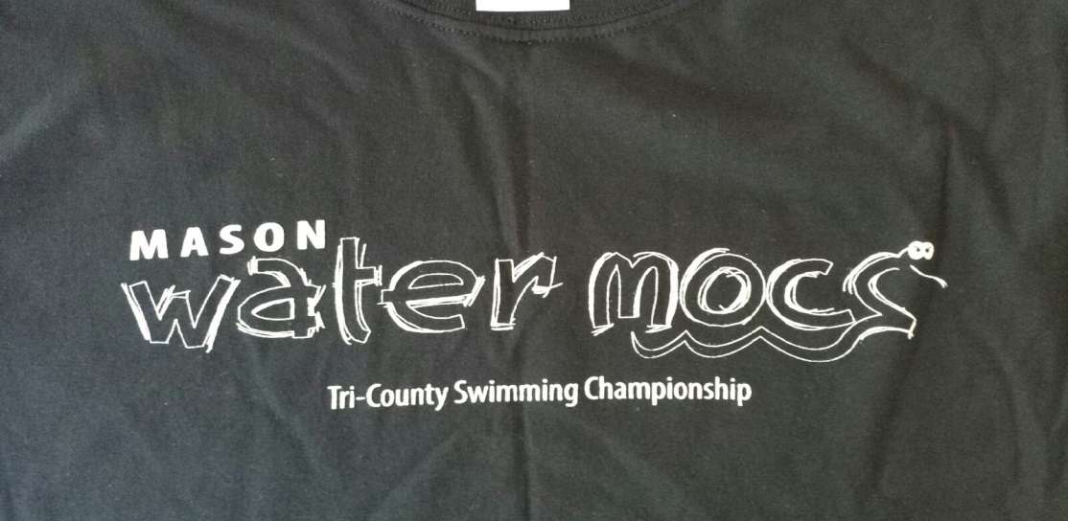

T-Shirt will be LIME GREEN with WHITE LOGO

$10 per T-shirt ORDERS DUE FRIDAY, JULY 18th

Swimmer’s Name: ______________________________________

T-Shirt Sizes: (please put number of shirts per size)

Youth X-Small: ____________ Adult Small: ________________

Youth Small: ______________ Adult Medium: _______________

Youth Medium: ____________ Adult Large: _________________

Youth Large: ______________ Adult X-Large: _______________

Adult 2X-Large (add. $2):_______

Total ($10 per shirt): _______________

**Please place order form with CASH payment in the CHAMPS T-SHIRT FOLDER at the OUTDOOR POOL BY THIS FRIDAY, JULY 18th!**