FINA FIGURE GROUPS 2013-2017

Senior, Junior and Age Group 16-17-18

COMPULSORY:
1 308 Barracuda Airborne Split 2.8
A Barracuda is executed to a submerged Back Pike Position with the toes just under the surface. A Rocket Split is executed.
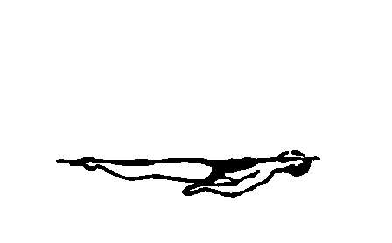 |  | 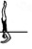 | 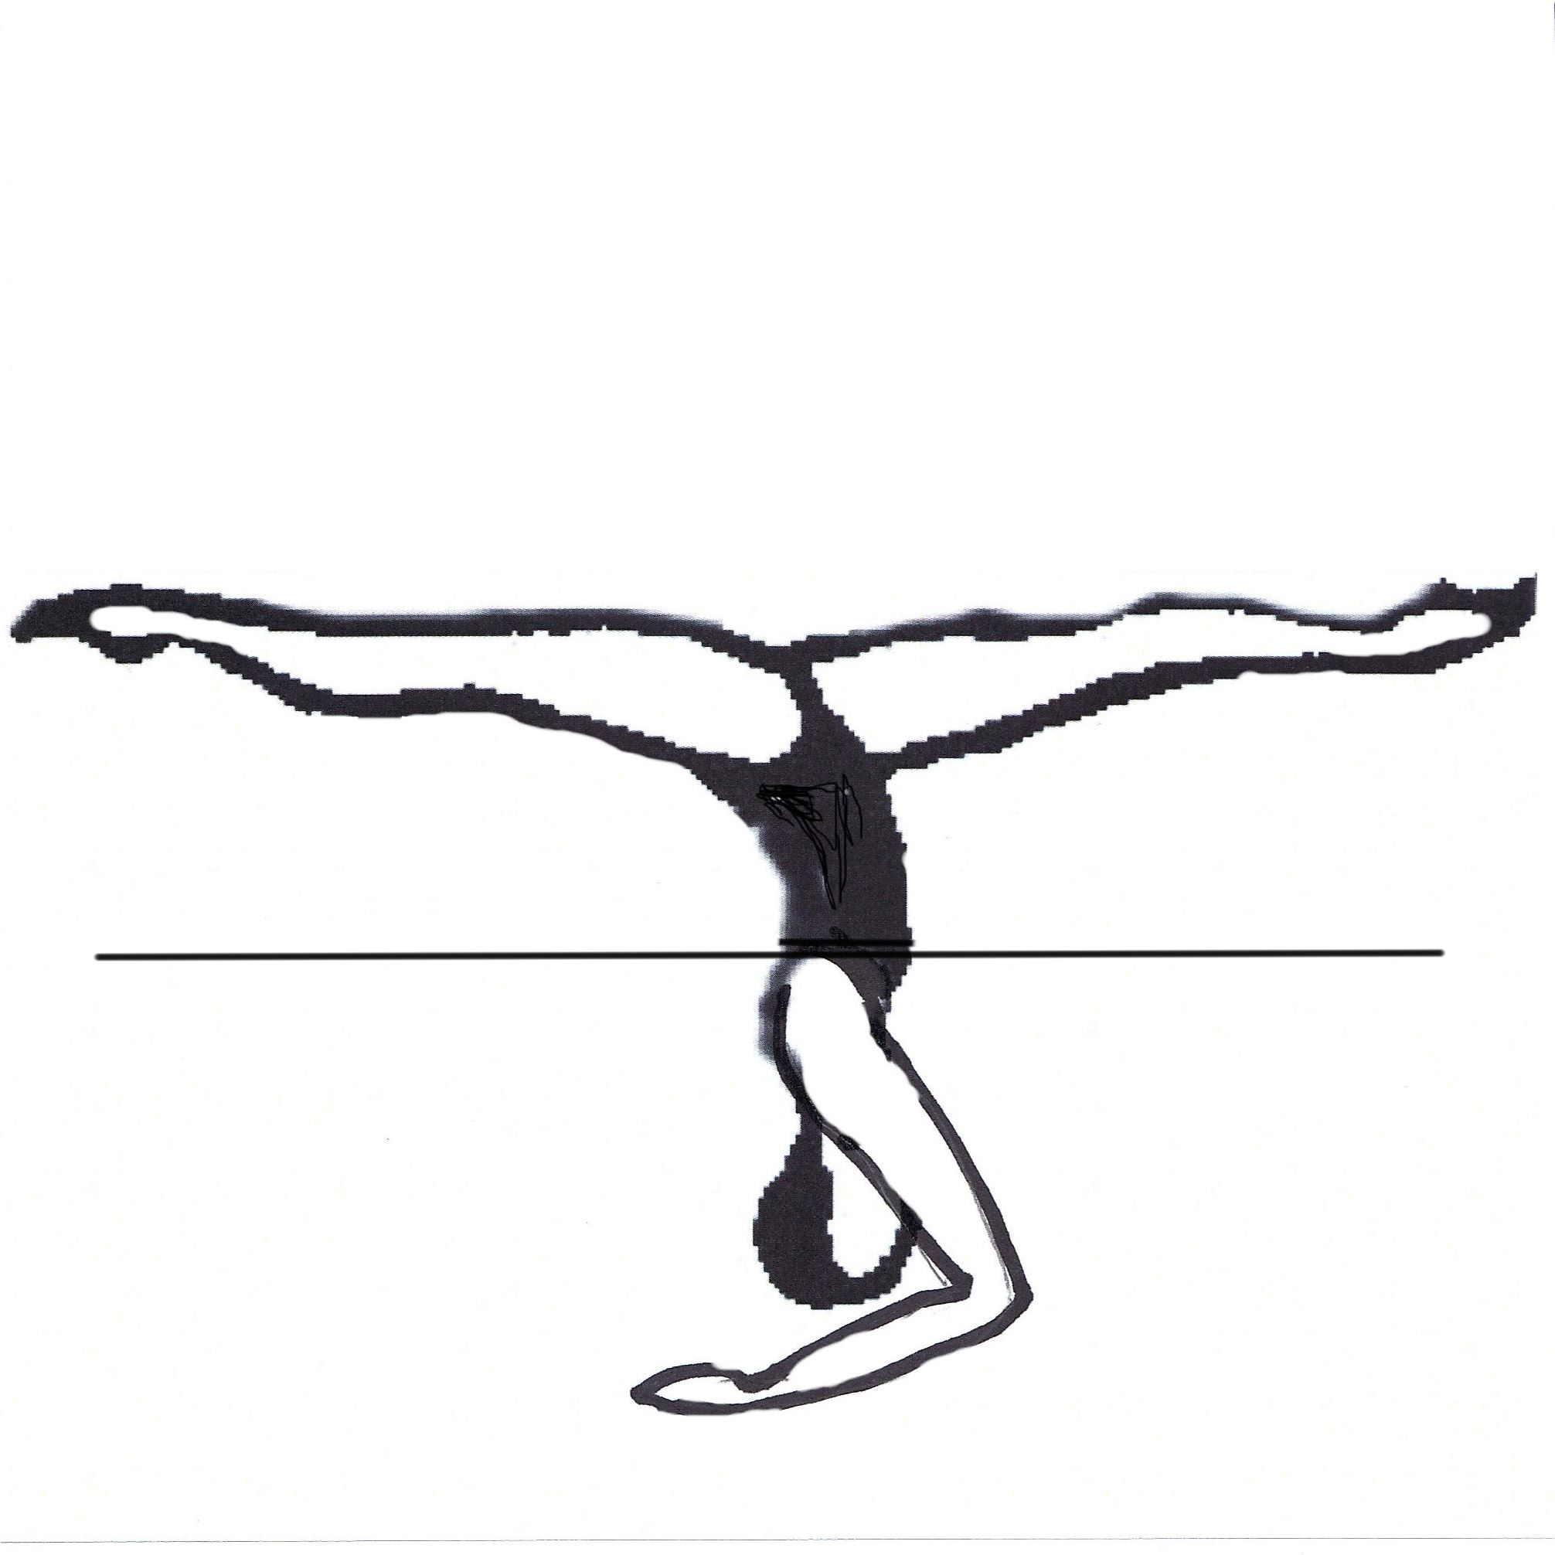 |  | 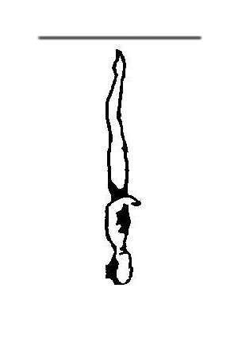 |  |  | Total
NVT= | 13.0 | 37.0 | 19.0 | 21.0 | 14.0 |  |  | 104
PV = | 1.25 | 3.56 | 1.83 | 2.02 | 1.35

2 355g Porpoise Twist Spin 2.6
From a Front Layout Position, a Front Pike Position is assumed. The legs are lifted to Vertical Position. The designated Twist or Spin is executed.
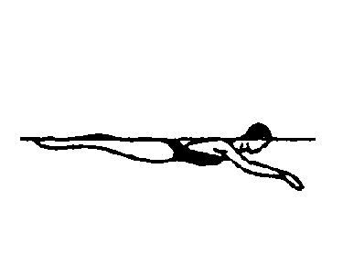 | 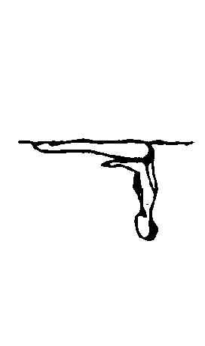 | 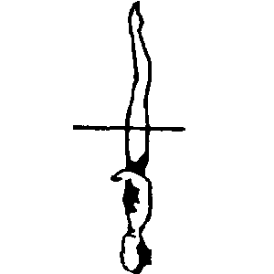 |  |  |  |  |  | Total
NVT= | 12.0 | 29.0 | 46.0 |  |  |  |  | 87
PV = | 1.38 | 3.33 | 5.29

OPTIONAL GROUPS

Group 1

3 330c Aurora Twirl 3.0
From a Front Layout Position a Somersault Front Pike is executed to a Submerged Ballet Leg Double Position. One leg rises vertically as the other moves along the surface to a Knight Position. The body rotates 180° to assume a Fishtail Position. The horizontal leg is lifted to Vertical Position. The designated Twist or Spin is executed. A Vertical Descent is executed.

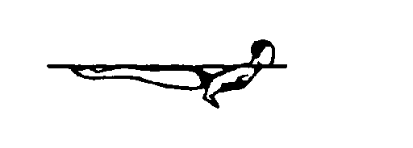 | 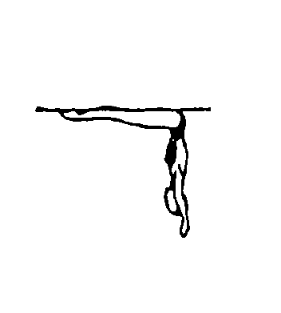 | 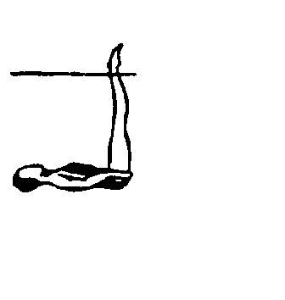 | 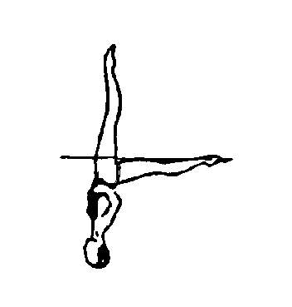 | 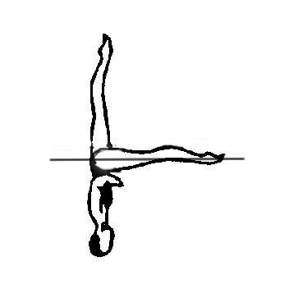 | 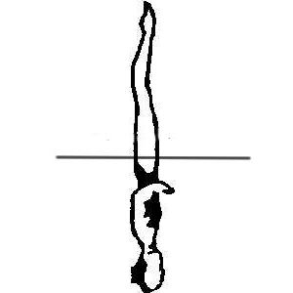 | 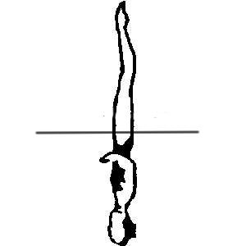 |  | Total
NVT= | 12.0 | 12.0 | 19.5 | 13.0 | 18.5 | 23.0 | 14.0 | 112
PV = | 1.07 | 1.07 | 1.74 | 1.16 | 1.65 | 2.05 | 1.25

4 154 London 2.8
A rapid Ballet Leg is assumed followed by a rapid partial Somersault Back Tuck, as both legs are drawn into a Tuck Position, until the shins are perpendicular to the surface. The trunk unrolls as the legs are straightened to assume a Vertical Position midway between the former vertical line through the hips and the former vertical line through the head and the shins. A Combined Spin of 360° is executed.
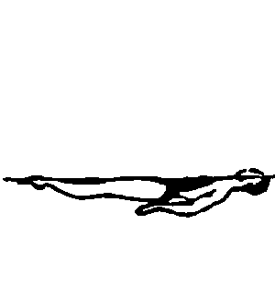 | 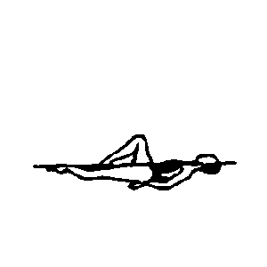 | 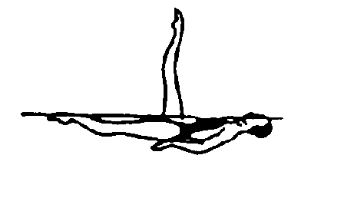 |  |  |  |  |  | Total
NVT= | 10.5 | 11.0 | 10.0 | 23.0 | 39.0 | 14.0 |  | 107.5
PV = | 0.98 | 1.02 | 0.93 | 2.14 | 3.63 | 1.3

Group 2

3 142 Manta Ray 2.8
A Flamingo is executed to a Surface Flamingo Position. As the body unrolls, the bent leg is extended horizontally to assume a Fishtail Position. The horizontal leg is lifted in a 180° arc over the surface of the water, as it passes vertical; the vertical leg is moved to assume a Bent Knee Surface Arch Position. The bent knee is straightened and with continuous motion, an Arch to Back Layout is executed.
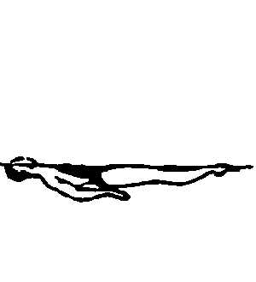 | 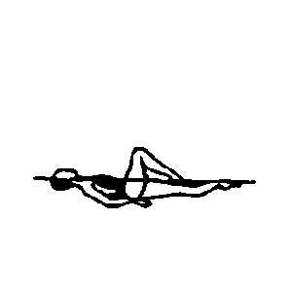 | 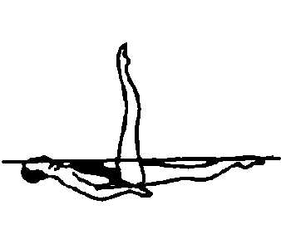 | 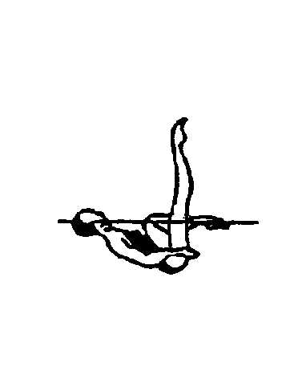 | 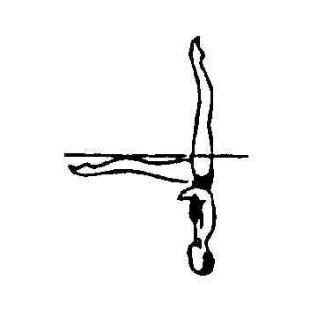 | 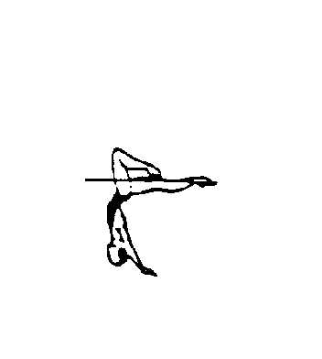 | 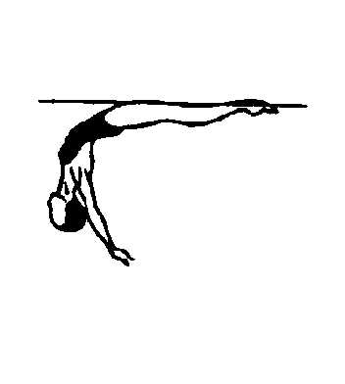 |  | Total
NVT= | 10.5 | 11.0 | 10.5 | 22.5 | 23.5 | 15.5 | 11.0 | 104.5
PV = | 0.86 | 0.91 | 0.86 | 1.85 | 1.93 | 1.28 | 0.91

4 343 Butterfly 2.9
From a Front Layout Position, a Front Pike Position is assumed. One leg is lifted to a Fishtail Position. The horizontal leg is rapidly lifted through an arc of 180° as the vertical leg is lowered to assume a Split Position, without hesitating a hip rotation of 180° is executed as the front leg is raised to assume a Fishtail Position. The horizontal leg is lifted to a Vertical Position at the same tempo as the initial actions of the figure. A Vertical Descent is executed.
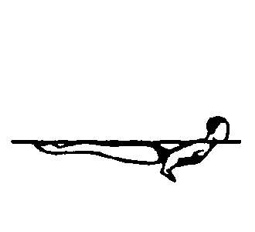 | 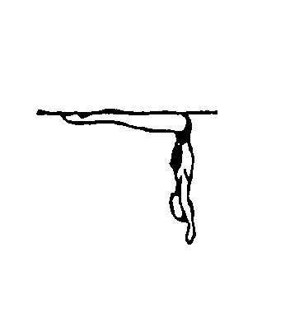 | 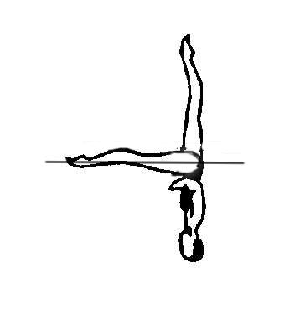 | 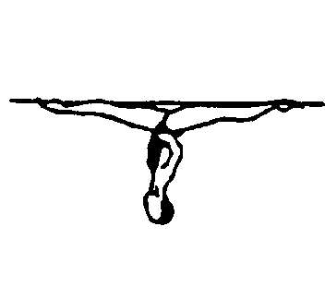 |  |  |  |  | Total
NVT= | 12.0 | 13.5 | 28.0 | 27.5 | 18.5 | 14.0 |  | 113.5
PV = | 1.06 | 1.19 | 2.47 | 2.42 | 1.63 | 1.23 |  | 2.94

Group 3

3 112f Ibis Continuous Spin (720º) 2.8
A Ballet Leg is assumed. Maintaining this position, the body is rotated backwards around a lateral axis through the hips to assume a Fishtail Position. The horizontal leg is lifted to a Vertical Position. The designated Twist or Spin is executed.
 |  |  | 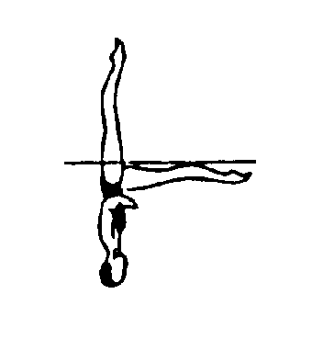 | 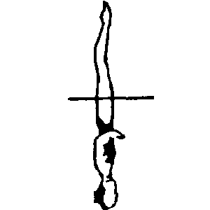 | 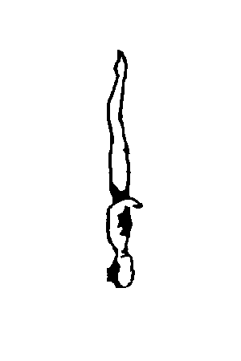 |  |  | Total
NVT= | 10.5 | 11.0 | 26.0 | 18.5 | 27.0 |  |  | 93
PV = | 1.13 | 1.18 | 2.80 | 1.99 | 2.90

4 325 Jupiter 2.8
From a Front Layout Position a Front Pike Position is assumed. One leg is lifted to a Fishtail Position. Maintaining the angle between the legs, the horizontal leg moves to vertical as the vertical leg simultaneously continues its arc to the surface to assume a Knight Position. Maintaining the vertical alignment of the body, the horizontal leg is moved in an 180⁰ arc at the surface of the water to a Fishtail Position. The horizontal leg is lifted to the Vertical Position. A Vertical Descent is executed.
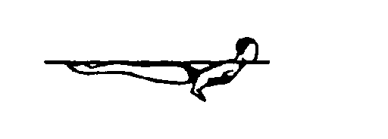 | 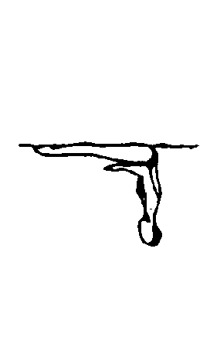 |  | 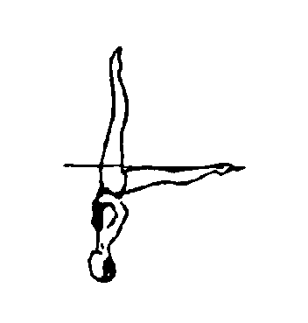 |  |  |  | Total
NVT= | 12.0 | 18.5 | 23.0 | 17.0 | 18.5 | 14.0 | 103
% = | 1.17 | 1.80 | 2.23 | 1.65 | 1.80 | 1.36 | 2.75

Age Group 13-14-15

COMPULSORY:

1 423 Ariana 2.2
A Walkover Back is executed to a Split Position. Maintaining the relative position of the legs to the surface, the hips rotate 180°. A Walkout Front is executed.
 | 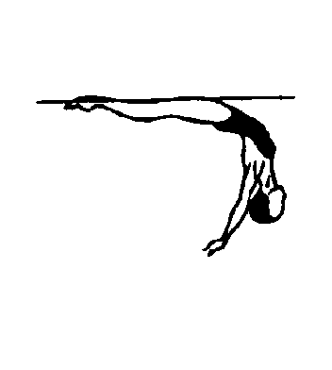 | 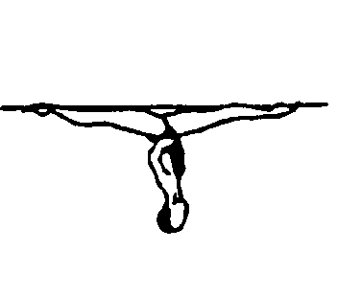 | 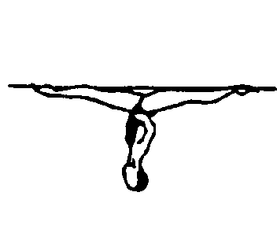 | 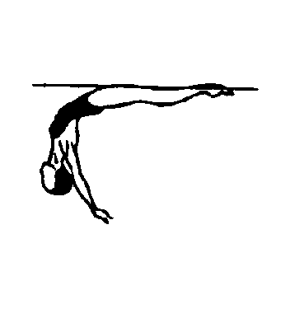 |  |  |  | Total
NVT= | 16.0 | 21.0 | 9.0 | 24.0 | 11.0 |  |  | 81
PV = | 1.98 | 2.59 | 1.11 | 2.96 | 1.36

2 301e Barracuda Spinning 360º 2.2
From a Back Layout Position, the legs are raised to vertical as the body is submerged to a Back Pike Position with the toes just under the surface. A Thrust is executed to Vertical Position. The designated Spin is executed at the same tempo as the Thrust to complete the figure. A Vertical Descent is executed at the same tempo as the Thrust.
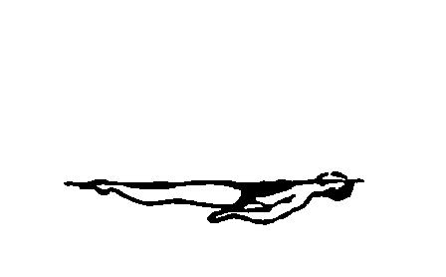 |  | 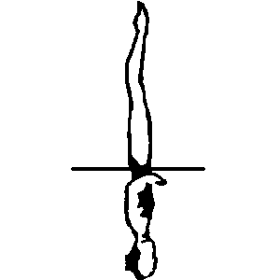 |  |  |  |  |  | Total
NVT= | 13.0 | 37.0 | 19.0 |  |  |  |  | 69
PV = | 1.88 | 5.36 | 2.75

OPTIONAL GROUPS

Group 1

3 342 Heron 2.1
From a Front Layout Position, a Somersault Front Pike is executed to a Submerged Ballet Leg Double Position. One leg is bent with the shin parallel to the surface and the mid-calf opposite the vertical leg, as the trunk moves toward the legs. A Thrust is executed to a Bent Knee Vertical Position, with the foot of the bent leg moving simultaneously to the inside of the vertical leg during the rise. A Vertical Descent is executed in a Bent Knee Vertical Position at the same tempo as the Thrust.
 |  |  |  | 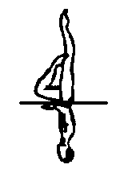 | 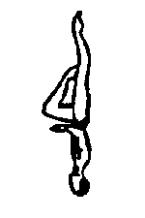 |  |  | Total
NVT= | 12.0 | 12.0 | 5.0 | 30.0 | 10.0 |  |  | 69
PV = | 1.74 | 1.74 | 0.72 | 4.35 | 1.45

4 115 Catalina 2.3
A Ballet Leg is assumed. A Catalina Rotation is executed. The horizontal leg is lifted to Vertical Position. A Vertical Descent is executed.
 |  |  | 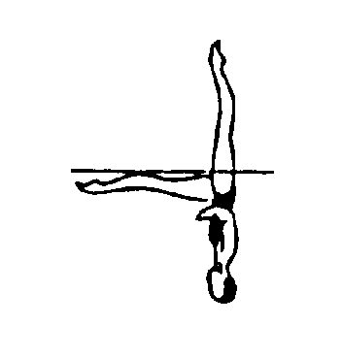 |  |  |  |  | Total
NVT= | 10.5 | 11.0 | 24.0 | 18.5 | 14.0 |  |  | 78
PV = | 1.35 | 1.41 | 3.08 | 2.37 | 1.79

Group 2

3 355h Porpoise Spin Up 180º 2.2
From a Front Layout Position, a Front Pike Position is assumed. The legs are lifted to Vertical Position. The designated Twist or Spin is executed. A Vertical Descent is executed
 |  |  |  |  |  |  |  | Total
NVT= | 12.0 | 29.0 | 14.0 | 19.0 | 14.0 |  |  | 88
PV = | 1.36 | 3.30 | 1.59 | 2.16 | 1.59

4 140 Flamingo Bent Knee 2.4
A Flamingo is executed to a Surface Flamingo Position. With the ballet leg maintaining its vertical position, the hips are lifted as the trunk unrolls while the bent leg moves to a Bent Knee Vertical Position. The bent knee is extended to Vertical Position. A Vertical Descent is executed.
 |  |  | 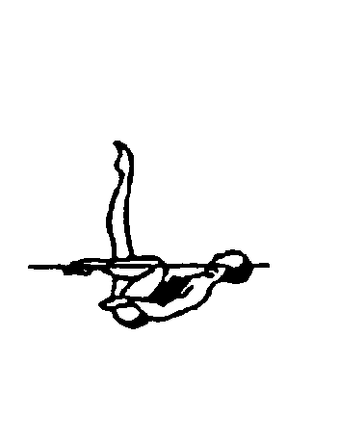 |  |  |  |  | Total
NVT= | 10.5 | 11.0 | 10.5 | 22.0 | 14.5 | 14.0 |  | 82.5
PV = | 1.27 | 1.33 | 1.27 | 2.67 | 1.76 | 1.7

Group 3

3 240a Albatross 1/2 Twist 2.6
With the head leading, a Dolphin is initiated until the hips are about to submerge. The hips, legs and feet continue to move along the surface, as the body rolls onto the face as it assumes a Front Pike Position. The legs are lifted simultaneously to a Bent Knee Vertical Position. A Half Twist is executed. The designated Twist is executed as the bent knee is extended to meet the vertical leg. A Vertical Descent is executed.
 |  | 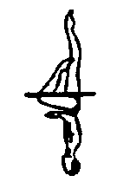 | 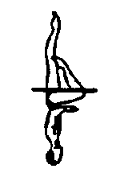 |  |  |  |  | Total
NVT= | 12.0 | 16.0 | 15.5 | 16.5 | 14.0 |  |  | 74
PV = | 1.62 | 2.16 | 2.09 | 2.23 | 1.89

4 346 Side Fishtail Split 2.0
From a Front Layout Position, a Front Pike Position is assumed. One leg is lifted to vertical as the body rotates 90° on its longitudinal axis to assume a Side Fishtail Position, and with continuous motion another 90° rotation is executed in the same direction as the vertical leg lowers to assume a Split Position. The legs are lifted to Vertical Position. A Vertical Descent is executed.
 |  |  |  |  |  |  |  | Total
NVT= | 12.0 | 23.0 | 16.0 | 14.0 |  |  |  | 65
PV = | 1.85 | 3.54 | 2.46 | 2.15

Age Group 12 and under

COMPULSORY:

1 101 Ballet Leg Single 1.6
A Ballet leg is assumed. The Ballet leg is lowered.
 |  |  |  |  |  |  |  | Total
NVT= | 10.5 | 11.0 | 11.0 | 10.5 |  |  |  | 43
PV = | 2.44 | 2.56 | 2.56 | 2.44

2 301 Barracuda 2.0
From a Back Layout Position, the legs are raised to vertical as the body is submerged to a Back Pike Position with the toes just under the surface. A Thrust is executed to Vertical Position. A Vertical Descent is executed at the same tempo as the Thrust.
 |  |  |  |  |  |  |  | Total
NVT= | 13.0 | 37.0 | 14.0 |  |  |  |  | 64
PV = | 2.03 | 5.78 | 2.19

OPTIONAL GROUPS

Group 1

3 439 Oceanita 1.9
A Nova is executed to a Surface Arch Bent Knee Position. The horizontal leg is lifted to the vertical as the bent knee is extended to assume a Vertical Position. A Vertical Descent is executed.
 | 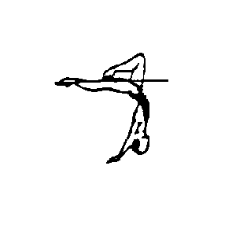 |  |  |  |  |  |  | Total
NVT= | 19.5 | 21.5 | 14.0 |  |  |  |  | 55
PV = | 3.55 | 3.91 | 2.55

4 362 Surface Prawn 1.4
From a Front Layout Position, a Front Pike Position is assumed. One foot is moved in horizontal arc of 180° at the surface to a Split Position. The legs are joined to assume a Vertical Position at the ankles. A Vertical Descent is executed.
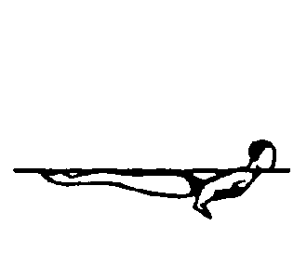 |  | 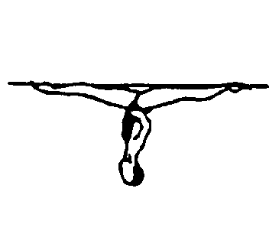 |  |  |  |  |  | Total
NVT= | 12.0 | 12.0 | 7.0 | 0.0 |  |  |  | 31
% = | 3.87 | 3.87 | 2.26 | 0.0 |  |  |  | 1.42

Group 2

3 311 Kip 1.8
From a Back Layout Position, a partial Somersault Back Tuck is executed until the shins are perpendicular to the surface. The trunk unrolls as the legs are straightened to assume a Vertical Position midway between the former vertical line through the hips and the former vertical line through the head and the shins. A Vertical Descent is executed.
 |  |  |  |  |  |  |  | Total
NVT= | 4.0 | 10.0 | 23.0 | 14.0 |  |  |  | 51
PV = | 0.78 | 1.96 | 4.51 | 2.75

4 360 Walkover Front 2.1
From a Front Layout Position, a Front Pike Position is assumed. One leg is lifted in a 180° arc over the surface to a Split Position. A Walkout Front is executed.
 |  | 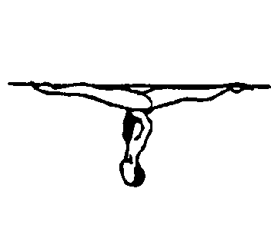 |  | 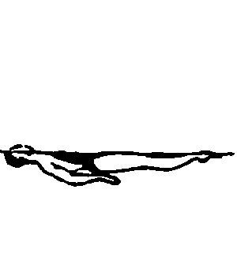 |  |  |  | Total
NVT= | 12.0 | 21.0 | 24.0 | 11.0 |  |  |  | 68
PV = | 1.76 | 3.09 | 3.53 | 1.62

Group 3
3 349 Tower 1.9
From a Front Layout Position, a Front Pike Position is assumed. One leg is lifted to a Fishtail Position. The horizontal leg is lifted to a Vertical Position. A Vertical Descent is executed.
 |  |  |  |  |  |  |  | Total
NVT= | 12.0 | 13.3 | 18.5 | 14.0 |  |  |  | 57.8
PV = | 2.08 | 2.30 | 3.20 | 2.42

4 406 Swordfish Straight Leg 2.0
From a Front Layout Position, the back arches as one leg is lifted in a 180° arc over the surface to a Split Position. A Walkout Front is executed.
 |  |  |  |  |  |  |  | Total
NVT= | 30.0 | 24.0 | 11.0 |  |  |  |  | 65
PV = | 4.62 | 3.69 | 1.69

