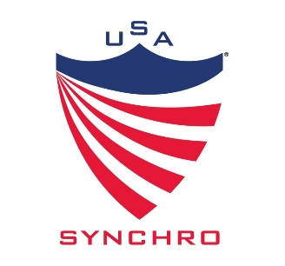
USA Synchro National Talent Camp
Athlete Application

Thank you for your interest in attending the 2016 USA Synchro National Talent Camp!
This is an exciting and fun opportunity to gain exposure, learn new skills, and become a better athlete. It is important to understand this is a training camp intended for high level, motivated athletes. Please fill out the application below to help National Talent Camp coaches and USA Synchro staff get to you know!

Athlete Name:

Athlete Date of Birth:

Club Affiliation:

Coach name and Email:

Week Preference: July 10th-16th 12 & Under Age Group
Circle 1st Choice July 17th-23rd 14-15 Age Group
Circle 2nd Choice July 24th-30th 13-14 Age Group

Top Figure Score from the 2015 season & Rank:
Have you participated in your countries National Team Trials: yes or no (if yes please explain)

Please discuss your synchro goals:

If selected to attend the camp, do you agree to the terms in the PowerPoint presentation speaking to Cost, Transportation, Locations, Facilities, etc, per USA Synchro website? Y or N
http://www.teamusa.org/usa-synchronized-swimming/national-teams/national-talent-program

Checklist of video footage of the following skills submitted with application via youtube or dropbox:
Ballet Leg Left & Right Vertical Right Side & Forward Ariana Rotation on Land & Water Barracuda Figure Bent Knee Vertical Left & Right Fishtail Position Left & Right
Athlete Signature __________________________________________________ Date _______________
Parent/Guardian Signature ___________________________________________ Date _______________

Submit application to Teagan Betancourt Email: teagan.betancourt@gmail.com

