Dryland – Day 1 (Saturday or Sunday)
Lay in streamline on back – hold 10 seconds
Sit up in streamline – reach for sky – eyes straight ahead, tummy tucked in – hold 20 seconds
Lay back in streamline - flutter kick – 30 seconds
Roll on stomach and streamline – hold 20 seconds
Superman – hold 15 seconds on each side
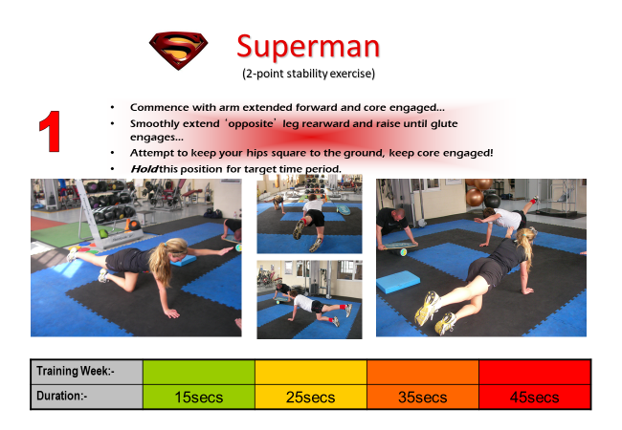
Push -ups – 10 – mountain climbers – 20 - (No Break in between) – no knees down
Leg lifts (hands at hips) – 15 – Windshield Wipers (legs straight up and from side to side – like a windshield wiper) – 10 (back and forth counts as 1)
Crunches - 10 x knees bent, feet on ground – 10 x legs off ground with knees bent– 10 x feet on ground, left elbow to right knee – 10 feet on ground, right elbow to left knee
Jumping Jacks – 25
Squats – 15
Squat jumps – 10 – into a streamline
Burpees – 5
Congratulations - DONE

