TECHNIQUE
- All the stretches are ‘dynamic’, ie movement based and should be performed in a
rhythmic fashion and never past the point of discomfort.
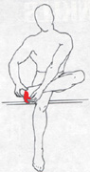 | 1. Assisted ankle inversion stretch  - Leg crossed, as pictured.  - Lightly support heel to stabilise foot  - Using hand, roll foot toward midline  - Work for 30 to 45secs per side  - Intensity of stretch can be increased at will
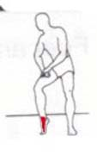 | 2. Anterior ankle stretch  - Toes planted, as pictured.  - Press toes, big toe particularly, into ground  - Raise heel maximally  - Keep weight distributed into big toe  - Work for 30 to 45secs per side
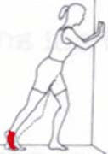 | 3. Deep wall Calf stretch  - Leg positioned, as pictured.  - Lightly support hands against wall  - Flex & extend leg whilst toes remain planted  - Flex for a second, then extend for a second etc  - Keep big toe firmly drilled into floor  - Work for 30 to 45secs per side
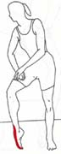 | 4. Foot & Ankle stretch  - Leg positioned, as pictured.  - Secure big toe to ground as an anchor point  - Push knee forward, ankle joint ‘open’  - Work for 30 to 45secs per side
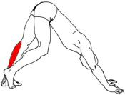 | 5. Sprint start calf stretch  - Leg positioned, as pictured.  - Working limb with knee at full extension  - Keep foot flat on working limb  - Hips raised maximally whilst foot secure  - Effectively, leaning back and forth to create stretch  - Work for 30 to 45secs per side
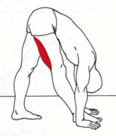 | 6. Forward flex hamstring stretch  - Leg slightly flexed, as pictured.  - Lightly extend arms to stabilise torso against floor  - Weight pushed into foremost foot  - Rear foot remains flat & knee flexed  - Work for 30 to 45secs per side

TECHNIQUE | swimming flexibility programme
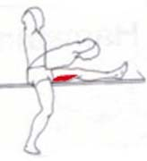 | 7. Elevated hamstring stretch  - Leg positioned, as pictured, against tabletop.  - Commence with upright posture & leg straight  - Lean forward, keeping toe upright  - Hold position for 1sec, sit-upright & repeat  - Work for 30 to 45secs per side
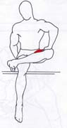 | 8. Seated external hip rotator  - Leg positioned, as pictured.  - Toe turned inward very slightly  - Press against flexed knee repetitively  - Stretches through groin and outer hip  - Work for 30 to 45secs per side
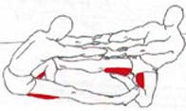 | 9. Partner hamstring stretch  - Positioned with partner as shown  - Both extend the same leg  - Light support at the wrists, partner leans back  - Work rhythmically, not overstretching  - 30 to 45secs per side
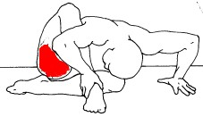 | 10. Seated deep hip and glute stretch  - Legs positioned as pictured.  - Start vertical, hips against wall, slowly lower  - Maintain contact with wall throughout  - Work for 30 to 45secs per side
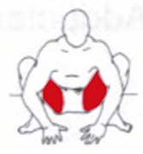 | 11. Crouching groin stretch  - Body positioned, as pictured.  - Feet remain flat and toes turned out  - Sink hips as low as possible  - Torso upright, eyes forward  - Work for 30 to 45secs
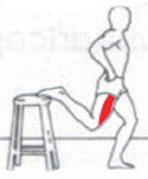 | 12 Quad and hip flexor stretch  - Leg flexed, as pictured.  - Lightly support hands against hips  - Torso upright throughout  - Slowly ‘sink’ on grounded leg  - Do not allow stretching leg to turn outward  - Work for 30 to 45secs per side

TECHNIQUE | swimming flexibility programme
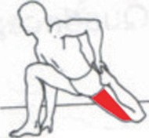 | 13. Hip flexor  - Positioned as pictured, heel to glute…  - Lean forward whilst hips pushed rearward  - Keep torso pointing forward, shoulders square  - Rhythmic rocking back and forth  - Work for 30 to 45secs per side
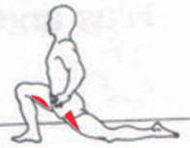 | 14. Deep quad, hip flexor and hamstring stretch  - Positioned as pictured, torso tall…  - Hips pushed forward, rear leg extended…  - Lean back and forth in a rhythmic fashion  - Work for 30 to 45secs per side
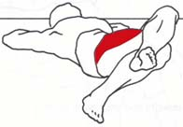 | 15. Dynamic IT band  - Positioned as shown, ankle crossed over knee  - Using ankle, draw opposite knee over midline  - Keep back and shoulders on ground  - Work for 30 to 45secs per side
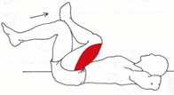 | 16. Dynamic glute and hamstring stretch  - Positioned as shown, ankle crossed over knee  - Draw knee in, causing stretch on opposite side  - Keep back and shoulders on ground  - Work for 30 to 45secs per side
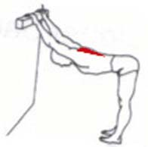 | 17. Supported lat stretch  - Body positioned, as pictured.  - Draw hips over heels  - Arms fully extended throughout  - Spine remains ‘long’, head & neck neutral  - Work for 30 to 45secs
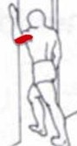 | 18. Pec stretch  - Front leg flexed, as pictured.  - Lean into doorway, elbow level with shoulder  - Transfer weight forward, hip rotates back and forth  - Work for 30 to 45secs per side
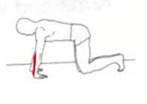 | 19. Grip release stretch  - Body positioned, as pictured.  - Fingers pointing rearward  - Transfer weight rearward, hands remain flat  - Work for 30 to 45secs

