Dryland # 5
- Lay on back in streamline – tighten up and press back towards ground - Sit up in Streamline – hold for 5 seconds (tummy tucked in and eyes straight ahead - legs straight throughout exercise)
Repeat 5 times without break
- Flutter kick with sit up - flutter kick for 10 seconds with arms in streamline – bend knees with feet on floor – sit up
Repeat 4 times without break
- Lay on back – arms off ground 12 inches, legs off ground 12 inches – hold for 1 minute

- V-Ups (Pikes) – 5 sets of 5 with 30 second rest in between each set
Lie on back – arms at sides – simultaneously raise both legs and lift torso reaching arms forward until they are nearly touching feet – maintain a flat back and try to form a perfect V shape with torso and lower legs
- Sit up with Leg lift – perform a sit up, with arms over head, perform a leg lift
Repeat 15 times
- Superman – start with arm forward and core engaged - smoothly extend ‘opposite’ leg rearward and raise until glute engages - attempt to keep your hips square to the ground - keep core engaged – hold for 15 seconds on each side - repeat

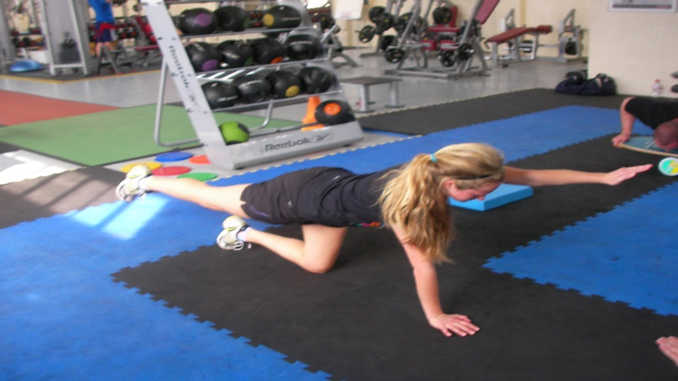

- Lay on stomach in streamline – raise hands 6 inches off ground – flutter kick for 1 minute
- Lay on back - pull back to ground – hold for 15 seconds
First time arms in streamline
Second time arms at side
Rest 30 seconds - repeat

- Lay on back – pull back to ground – pull knees up slowly and lower legs slowly at the same time as maintain a flat back – do not let feet touch ground
Repeat 5 times

- Planks – hold 30 seconds – rest 30 seconds - repeat

  - Front Plank – Arms flexed – slightly wider than shoulders – flat back – core engaged firmly – feet outside hip width – flex knees (not completely straight leg)
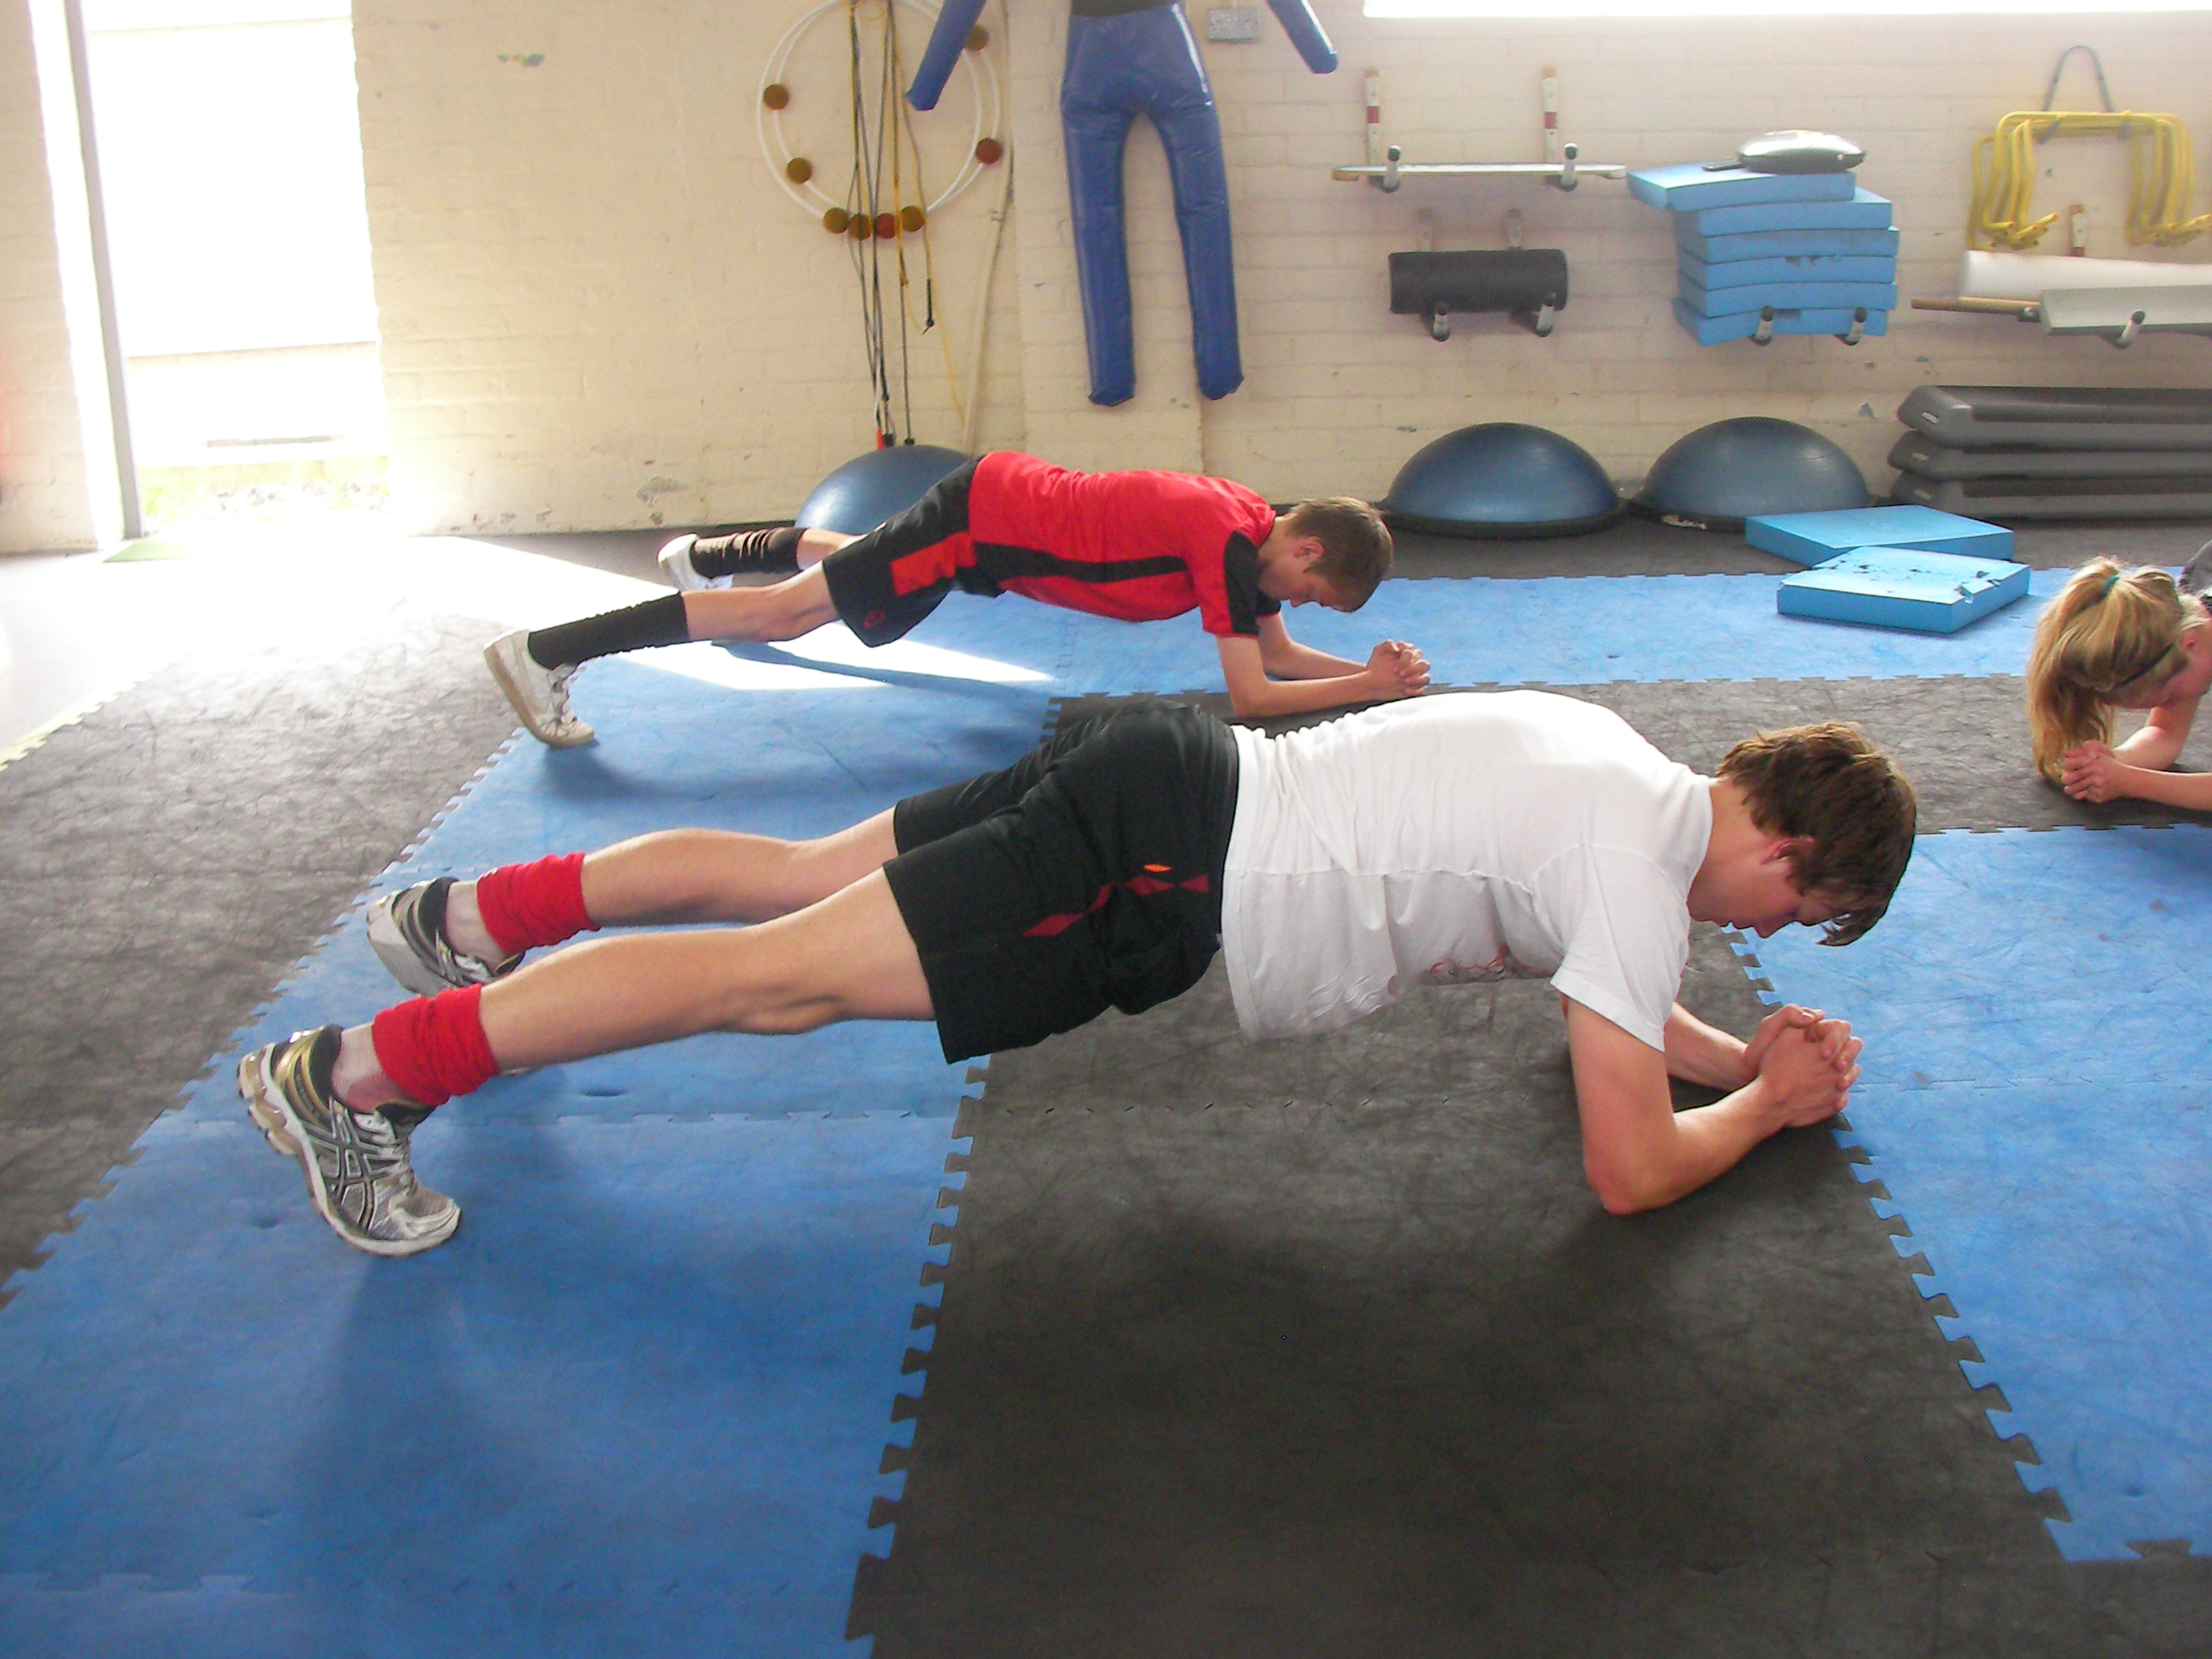
  - Back Plank – Elbows below shoulders – heels outside hip width – raise hips off floor engaging hips, glutes and hamstrings
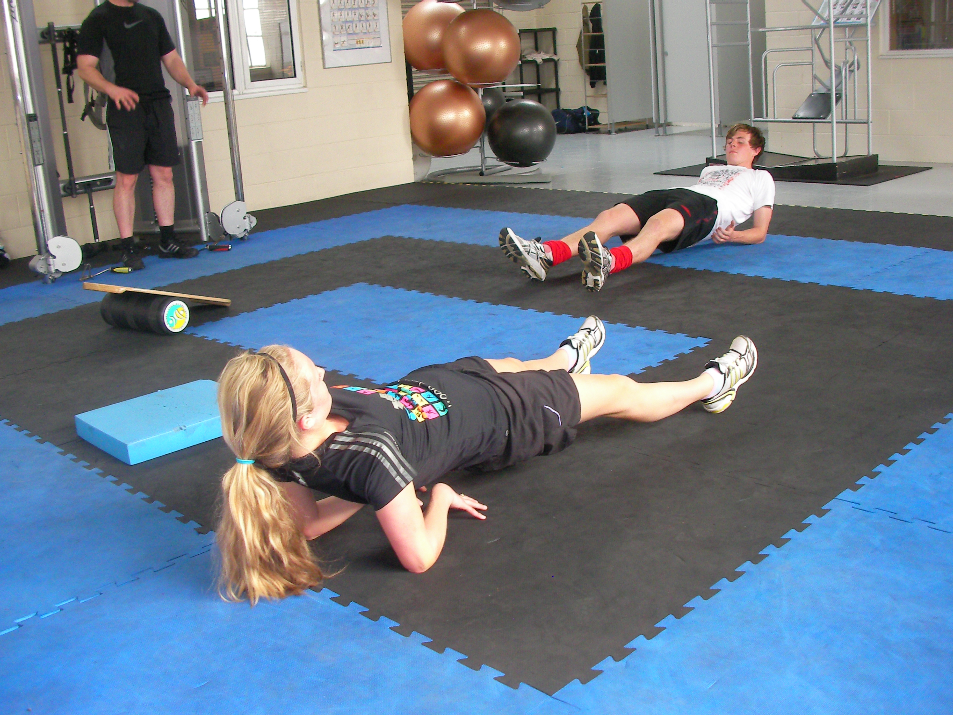
  - Side Plank (Modified) - start with elbow planted below shoulder – use knees as pivot point – raise hips from floor making sure to not roll forward or backward – make sure core is engaged throughout – switch sides

