ANNUAL CONSENT FOR
ATHLETIC TRAINING MODALITIES, MASSAGES, RUBDOWNS

PRINCE WILLIAM SWIM CLUB
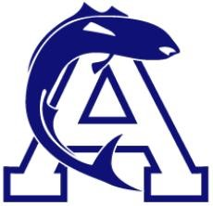

I, , as the parent/legal guardian of , a minor athlete, hereby authorize and consent for said minor athlete to receive athletic training modalities, massages and rubdowns for injuries for a time period of one year from the date of consent.
I understand the following guidelines apply for athletic training modalities, massages and rubdowns:
- All sessions must follow the One-on-One interactions policy as found in the Minor Athlete Abuse Prevention Policy.
- All sessions must have a second Adult Participant physically present for the treatment to occur.
- My minor athlete will be fully or partially clothed and their breasts, buttocks, groin and genitals will always be covered.
- A parent/legal guardian must be permitted to observe treatment except for situations where it occurs in a competition or training venue that limits credentialing.
I understand that my minor athlete or I can withdraw consent for athletic training modalities, massages or rubdowns at any time.

Parent/Legal Guardian Name Printed:
Parent/Legal Guardian Signature:

Date:

