CONSENT FOR
A DUAL RELATIONSHIP

PRINCE WILLIAM SWIM CLUB
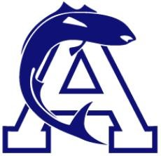

I, , as the parent/legal guardian of , a minor athlete, am advising (Organization Name) that the minor athlete has a dual relationship with , an Adult Participant. The dual relationship is as follows: .
With my signature below, I am consenting to the dual relationship exception for each area of the Minor Athlete Abuse Prevention Policy for a time period noted not to exceed one year from the date of this consent. I am aware that I can withdraw consent at any time.

Parent/Legal Guardian Name Printed:
Parent/Legal Guardian Signature:

Date:

