ANNUAL CONSENT FOR
IN-PROGRAM LODGING: ADULT PARTICIPANT AND MINOR ATHLETE

PRINCE WILLIAM SWIM CLUB
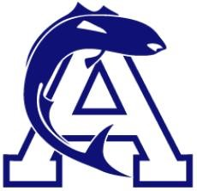

I, , as the parent/legal guardian of , a minor athlete, hereby authorize and consent that , an Adult Participant, who is not a coach, can share lodging arrangements with said minor athlete for all in-program lodging related to Prince William Swim Club for one year from the date of this consent. I understand that said Adult Participant will NOT share a hotel room or otherwise sleep in the same room with said minor athlete and all interactions will be observable and interruptible.
I am aware that I can withdraw consent at any time.

Parent/Legal Guardian Name Printed:
Parent/Legal Guardian Signature:

Date:

