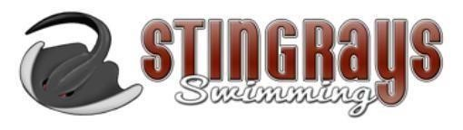
2019-2020 Stingrays Long Course Meet Schedule
Date | Meet Name/Description | Location | Meet Level
*May 1-3 | RAYS Helen Wang Sunflower Classic | JRSSC – Stafford, VA | All Levels/All Ages
May 16-17 | NOVA Freedom Splash | CSAC – Richmond, VA | All Levels/All Ages
May 28-31 | Speedo “Super” Sectional | CSAC – Richmond, VA | Qualifying Times –  Prelim/Finals
June 12-14 | TAC TYR Triangle Classic | TAC – Cary, NC | All Levels/All Ages –  Prelim/Finals
June 19-21 | QUAD Meet w/ SRVA, QUEST, YOTA and RAYS | CSAC – Richmond, VA | All Levels/All Ages –  Prelim/Finals
*July 10-12 | Summer Awards (RAYS) | JRSSC – Stafford, VA | All swimmers with times slower than qualifying times for AG & SR Champs
July 16-19 | Long Course Senior Champs | Liberty University – Lynchburg, VA | Qualifying Times –  Prelims/Finals
July 23-26 | Long Course Age Group Champs | CSAC – Richmond, VA | Qualifying Times –  Prelims/Finals
July 30-August 2 | USA Swimming’s Futures Champs | Ohio State University – Columbus, OH | Qualifying Times –  Prelims/Finals

All meets listed in red are meets hosted by the Stingrays. Parent volunteers will be required. For any away meets, the pool address will be provided within each Meet Announcement so you may make your own reservations. Team Meet Hotel Blocks will be on the website – www.swimrays.org – to use at your convenience.

