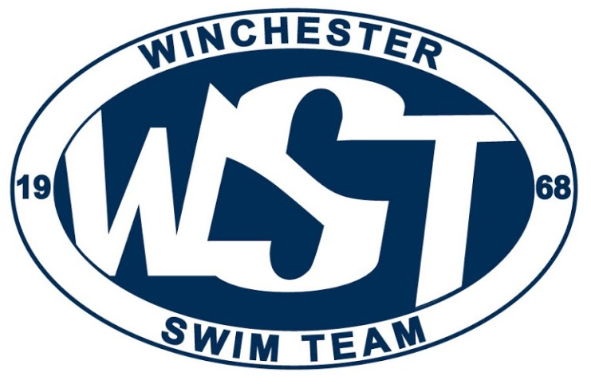
PO Box 3157
Winchester, VA 22604
winchesterswimteam.com
winchesterswimteam@outlook.com
Federal Tax ID: 20-2411904

Dear Valued Supporter,

The Winchester Swim Team (WST) is a 501 (c)3 non-profit youth sports organization. This past year we celebrated 50 years as a successful local youth program in the greater Winchester community. We have grown into a thriving USA Swimming sanctioned competitive swim team with more than 150 swimmers. Our swimmers train 2 to 6 days a week and compete year round. This commitment speaks volumes of the dedication from the swimmers, parents and volunteers who make up WST. Our swimmers travel to Richmond, Christiansburg, Harrisonburg, and several other regional facilities for three-day long competitions and we have been fortunate enough to even send swimmers to compete at the national level.
Once a year our swimmers get the chance to showcase their talent right here in our hometown. We host our annual WST Long Course Invitational Meet. As you can imagine this is an exciting event. It is also our team’s largest fundraiser that helps support our annual programming for our swimmers. Our Long Course Invitational is the only event that brings other USA Swimming sanctioned teams to the Winchester area. This year’s meet will be held June 21st-23rd. We will host over 600 swimmers, coaches, officials and their families over these days. It takes a community effort to host the meet and we would greatly appreciate your support of our team’s effort to continue the tradition of providing high quality swim training to youth in our community. We would greatly appreciate your consideration of the attached information regarding ways to help sponsor our Invitational Long Course Meet.
On behalf of the WST family, thank you for your consideration and support.

Sincerely,

Tanya Bodinetz
Winchester Swim Team Fundraising Coordinator
Email:
winchesterswimteam@outlook.com
Phone: 540-398-8857

Sponsorship Guide & Pledge Agreement

Sponsorship level (Please check one)
[ ] Meet
[ ] Gold
[ ] Silver
[ ] Bronze
Company Name: ________________________________
Contact: _______________________________________
Phone: ________________________________________
Email: _________________________________________
Please email your logo to: winchesterswimteam@outlook.com
Or please check below for permission to obtain logo from webpage

_______ We give permission for WST to obtain a copy of our logo from our webpage for sponsorship.
Thank you for your support!

Email to: winchesterswimteam@outlook.com
Or mail this form to:
WSTPO Box 3157
Winchester, VA 22604
Please make checks payable to WST
Federal Tax ID: 20-2411904
If you have any questions, please feel free to contact Tanya Bodinetz at:
C: 540-398-8857
E: Tanya Bodinetz: winchesterswimteam@outlook.com

