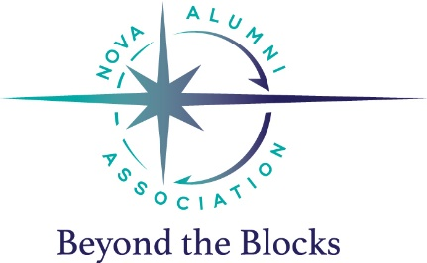
NOVA Alumni Association
Scholarship Recommendation Form

The applicant is being considered for a scholarship awarded by the NOVA of Virginia Aquatics Alumni Association. Applicants will be judged on the following criteria:

- Contributions to NOVA and the sport of swimming
- Contributions to the community
- Character qualities (including leadership, dedication, sportsmanship, integrity, and service)
- Other submitted information including a Personal Statement

He or she is asking for a recommendation that will highlight one or more of the areas above. Please share with us details of your relationship with the applicant as well as reasons why he or she should be selected.

The deadline for applicants to submit materials for consideration is 5 p.m., Friday, May 18, 2018. Please return this form, in a sealed envelope, either to the student, or to NOVA of Virginia Aquatics, Attn: Alumni Scholarship, 12207 Gayton Road, Richmond, VA 23238 prior to that date. Thank you.

Contact Information
Applicant Name | Click to enter text: Applicant’s Name
Your Name | Recommender’s Name
Your Home Phone | Home Phone
Your Cell Phone | Cell Phone
Your Email | Email
Your Title | Title
Your Organization | Organization
In what context do you know the applicant? | How do you know the applicant?
How long have you known the applicant? | How long have you known the applicant?
Your Recommendation
Please share with the selection committee why you think this applicant is deserving of this scholarship. Include details which speak to the selection criteria if possible. Please limit your recommendation to one to two typed pages.
Include your recommendation here

